CCNA NOTES AND LABS

LAB 2-

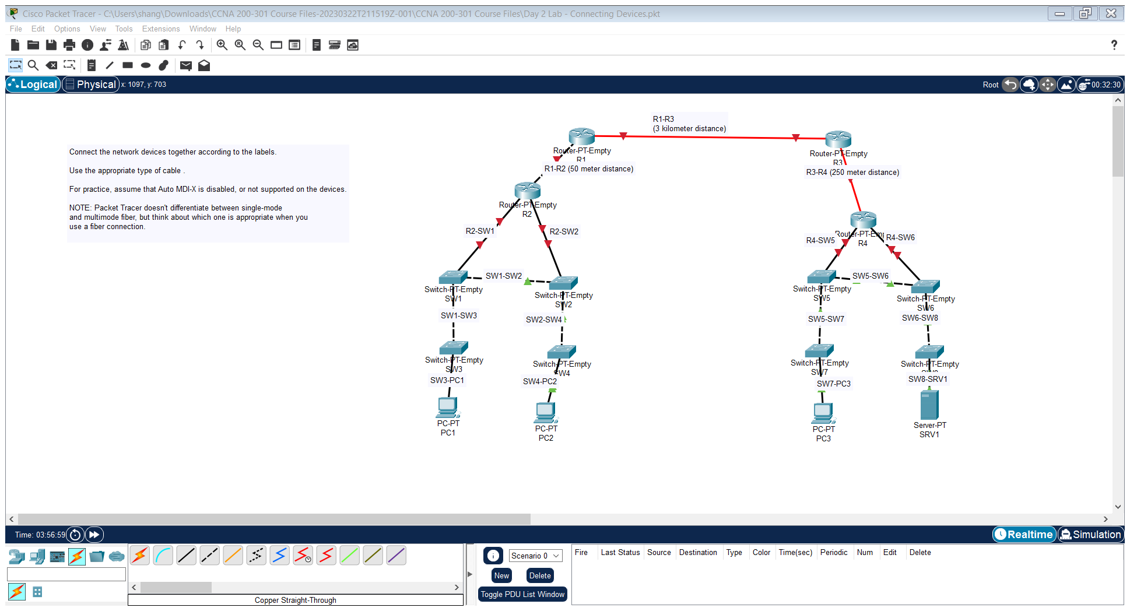

LAB 3-

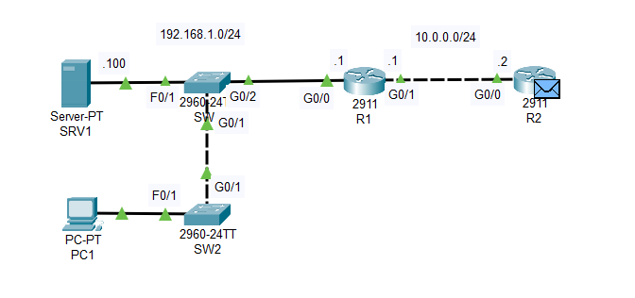

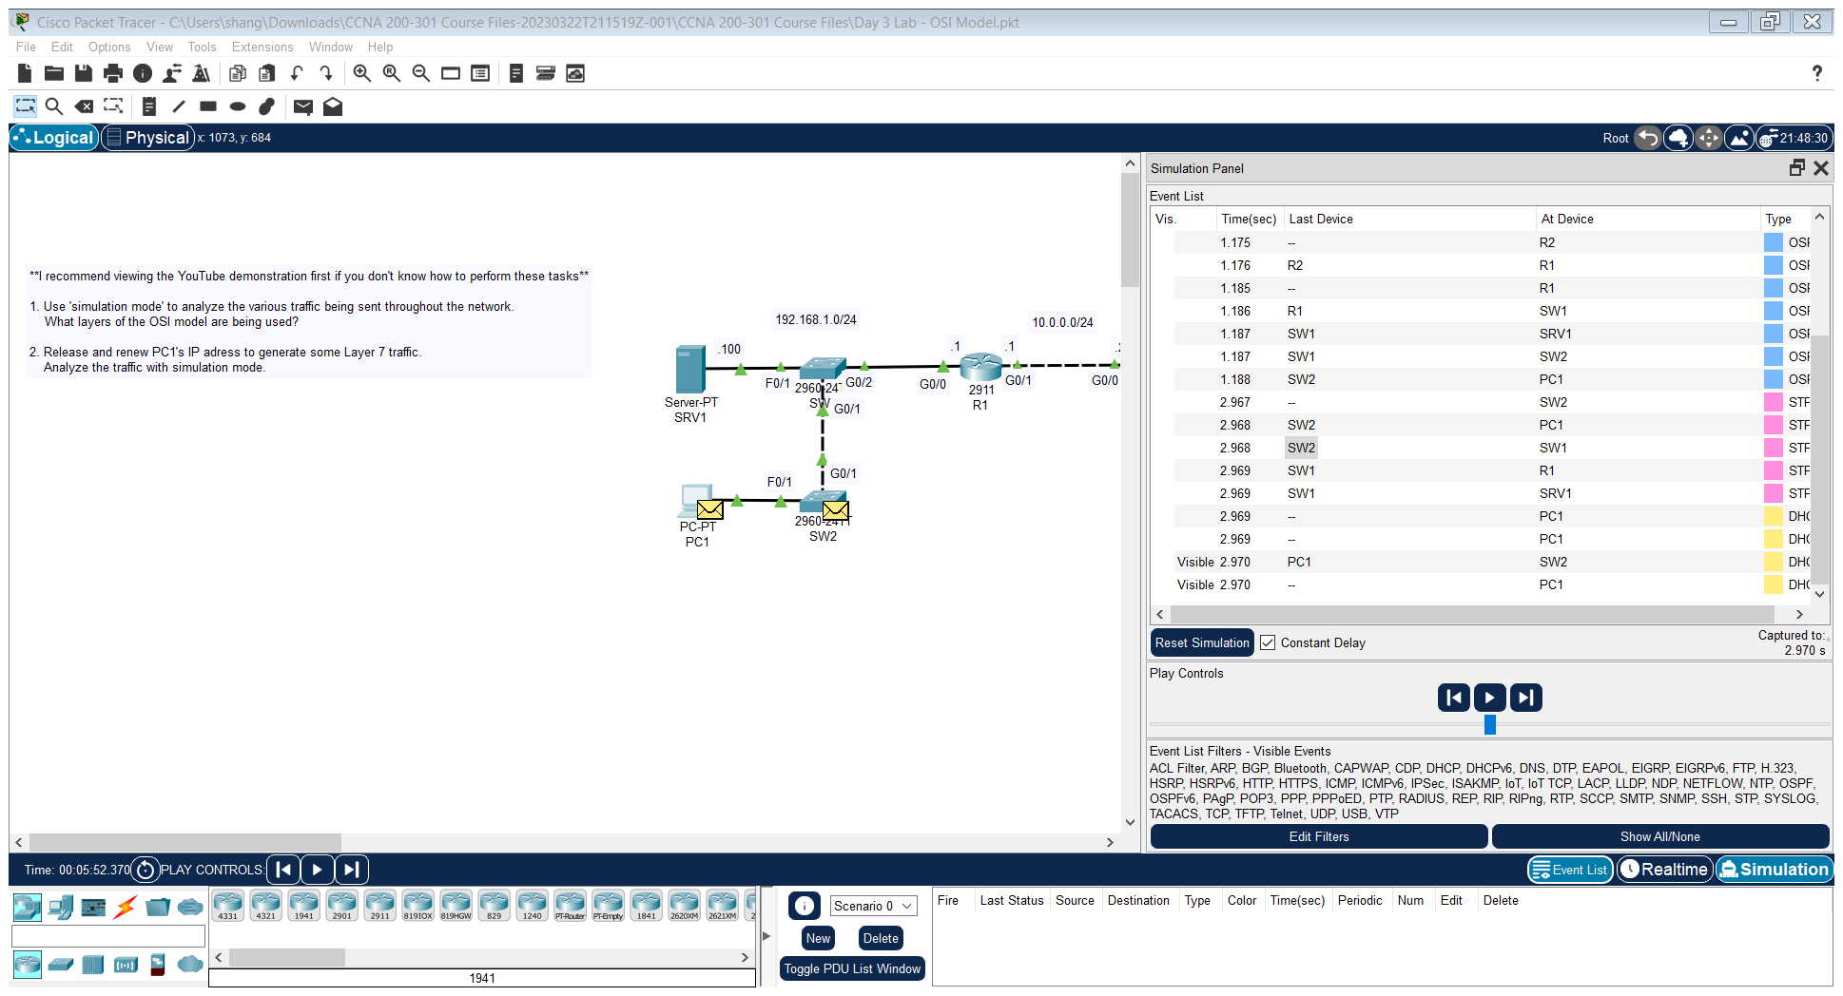

We shall look at traffic at a Layer 2 device that is switch and a Layer 3 device and then at a device which has information all the way up to the Application layer that is, end host.

Now to produce Layer 7 traffic, we will release the IP address of the host(configured via DHCP) and then reset it as DHCP is Layer 7 traffic.

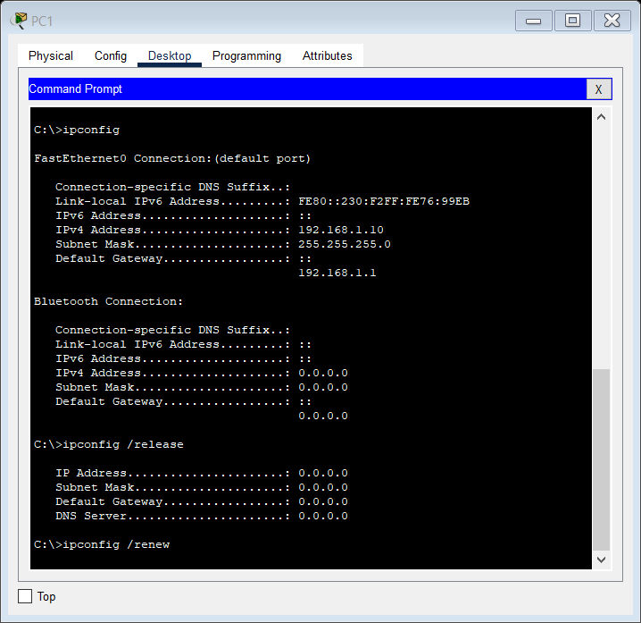

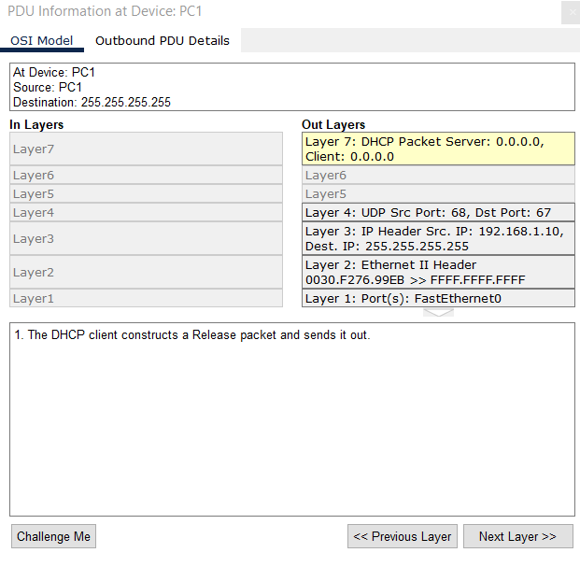

Layer 2 device switch traffic

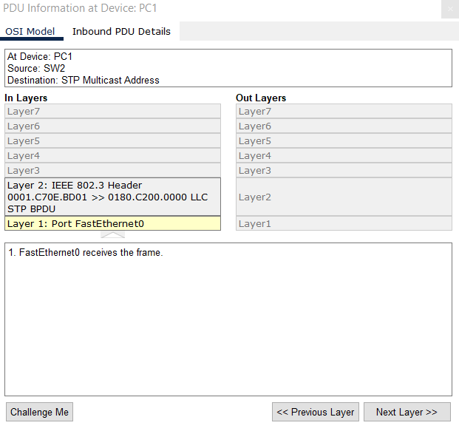

Layer 3 device Router R1 traffic:

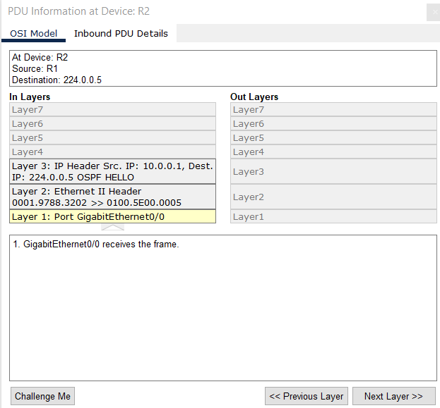

Some notes on Day 3 OSI model: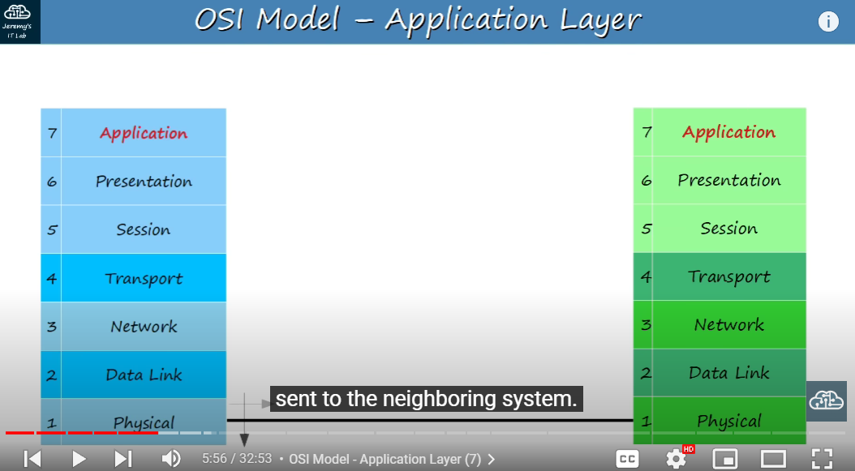

Let me explain how it does this. Here I have two OSI model stacks, representing two computers that will communicate with each other. The software application, maybe a web browser, interacts with Layer 7, the application layer, and wants to send some data to the system on the right. This data is processed through the OSI stack, each layer adding something to the original data. This is called ‘ENCAPSULATION’, because the original data is encapsulated inside this additional information which is added on. By the time it reaches the physical layer, it is electrical signals on a wire, and is sent to the neighboring system. Then, the neighboring system performs the opposite process, the additions of each layer are stripped off until the data reaches the application layer of the neighboring system. This process is called ‘de-encapsulation’, as the additional information is removed as the data is processed up the stack. Both the encapsulation and de-encapsulation processes are examples of ‘Adjacent-layer interaction’, interaction between the different layers of the OSI model. However, the communication between the application layers of the two different systems, is called same-layer interaction. This same-layer interaction between application Layers is what allows the application layer to perform its functions of identifying communication partners, synchronizing communications, etc.

The Application layer doesn’t contain the application itself but it contains the protocols that it uses to communicate that is HTTP, HTTPS.

DAY 4 notes:

Then I view the running configuration once more. However, since I was still in global configuration mode, I typed ‘do’ in front of the command.

This is a convenient trick that allows you to execute privileged exec mode commands like show running-config or show startup-config, in other configuration levels.

Also notice I used shortcuts, sh instead of show, and run instead of running-config.

Now you can see the enable secret in the running-configuration. Notice the number 5 before the encrypted password.

Number 5 indicates MD5 type encryption, which is much more secure than what we got with

the service password-encryption command. It can still be cracked, no password is invincible, but its much better.

Also notice that the enable password command remains, it isn’t replaced.

However, if both the enable secret and enable password commands are configured, the enable

password will be ignored, only the enable secret will be valid.

One final note, the ‘service password-encryption’ command has NO effect on the enable secret

command. The enable secret is always encrypted, whether or not you entered the service password-encryption

command. So, really you should always use the enable secret, instead of the enable password, as it is more secure.

LAB 4:

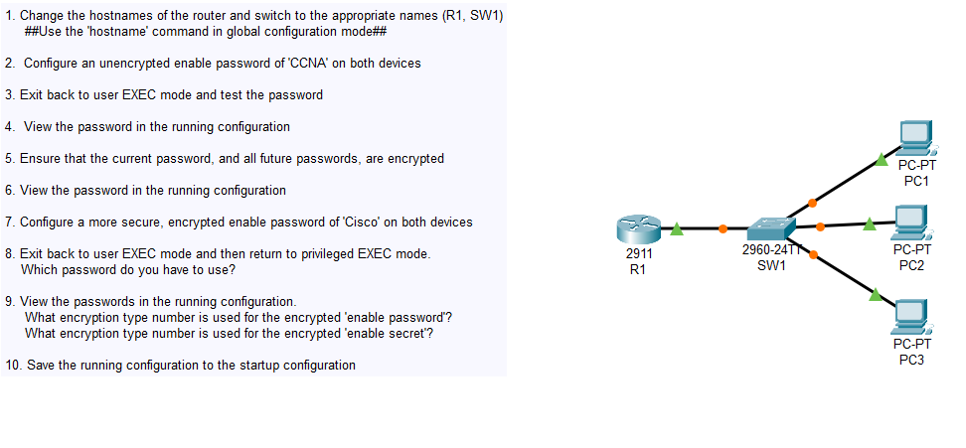

Router>

Router>en

Router#conf t

Enter configuration commands, one per line. End with CNTL/Z.

Router(config)#hostname R1

R1(config)#exit

R1#

%SYS-5-CONFIG_I: Configured from console by console

R1#enable password CCNA

^

% Invalid input detected at '^' marker.

R1#conf t

Enter configuration commands, one per line. End with CNTL/Z.

R1(config)#enable password CCNA

R1(config)#exit

R1#

%SYS-5-CONFIG_I: Configured from console by console

R1#show running-config

Building configuration...

Current configuration : 713 bytes

!

version 15.1

no service timestamps log datetime msec

no service timestamps debug datetime msec

no service password-encryption

!

hostname R1

!

!

!

enable password CCNA

!

!

!

!

!

!

ip cef

no ipv6 cef

R1#

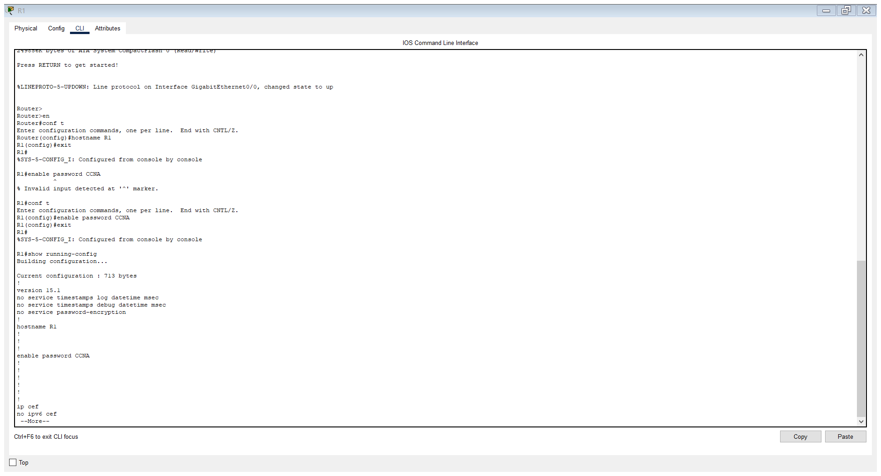

R1#conf t

Enter configuration commands, one per line. End with CNTL/Z.

R1(config)#service passwo

R1(config)#service password-encryption

R1(config)#do show rh conf

show rh conf

^

% Invalid input detected at '^' marker.

R1(config)#do show running-conf

Building configuration...

Current configuration : 718 bytes

!

version 15.1

no service timestamps log datetime msec

no service timestamps debug datetime msec

service password-encryption

!

hostname R1

!

!

!

enable password 7 08026F6028

!

!

!

!

!

!

ip cef

no ipv6 cef

R1(config)#enable secret Cisco

R1(config)#do show running-config

Building configuration...

Current configuration : 765 bytes

!

version 15.1

no service timestamps log datetime msec

no service timestamps debug datetime msec

service password-encryption

!

hostname R1

!

!

!

enable secret 5 $1$mERr$YlCkLMcTYWwkF1Ccndtll.

enable password 7 08026F6028

!

!

!

!

!

!

ip cef

R1(config)#exit

R1#

%SYS-5-CONFIG_I: Configured from console by console

exit

R1 con0 is now available

Press RETURN to get started.

R1>en

Password:

R1#conf t

Enter configuration commands, one per line. End with CNTL/Z.

R1(config)#

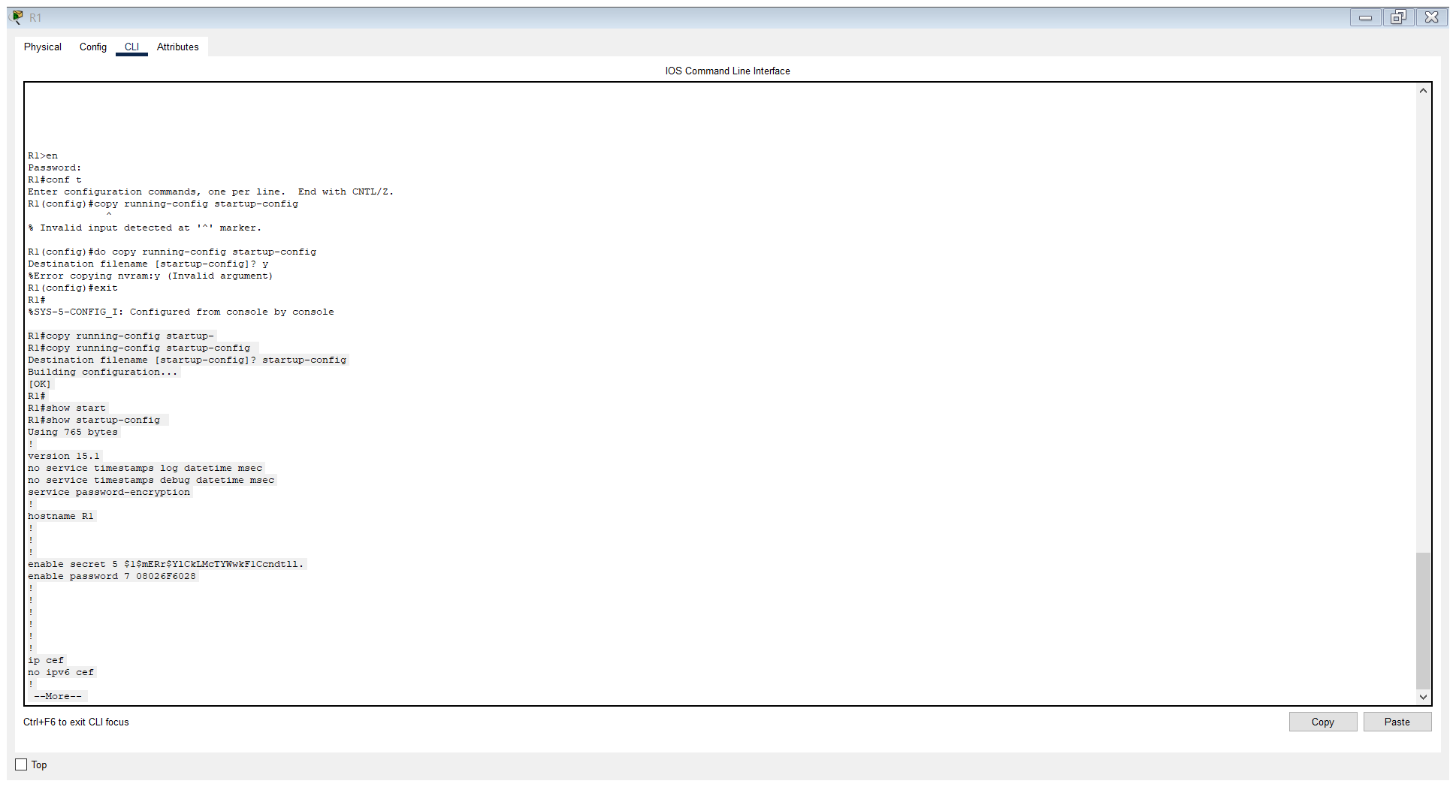

R1#copy running-config startup-

R1#copy running-config startup-config

Destination filename [startup-config]? startup-config

Building configuration...

[OK]

R1#

R1#show start

R1#show startup-config

Using 765 bytes

!

version 15.1

no service timestamps log datetime msec

no service timestamps debug datetime msec

service password-encryption

!

hostname R1

!

!

!

enable secret 5 $1$mERr$YlCkLMcTYWwkF1Ccndtll.

enable password 7 08026F6028

!

!

!

!

!

!

ip cef

no ipv6 cef

!

Encryption type number used in enable password is 7 and for enable secret, it is 5.

Password Cisco is required to be typed when re-entering Privileged EXEC mode from user EXEC mode.

Running-config saved to startup-config.

R1#copy running-config startup-

R1#copy running-config startup-config

Destination filename [startup-config]? startup-config

Building configuration...

[OK]

frame check sequence. The only field of the Ethernet trailer is the FCS, which as I mentioned stands for frame

11:54

check sequence. It is 4 bytes, or 32-bits in length.

12:00

It’s purpose is to detect corrupted data by running a ‘CRC’ algorithm over the

12:06

received data. CRC means cyclic redundancy check.

12:13

Cyclic refers to something called ‘cyclic codes', ‘redundancy’ refers to the fact that these 4 bytes at the end of the message enlarge the message without adding any new

12:23

information, so they are redundant, and check refers to the fact that is CHECKS, or verifies,

12:29

the data for errors. Don’t worry about the details of CRC too much, just be aware of the term,

12:37

and remember that the Ethernet frame’s Frame Check Sequence is a Cyclic Redundancy Check.

12:43

If you remember that, you should be good for the CCNA.

By the way, this kind of frame is called a ‘unicast frame’, a frame destined for

21:18

a single target, PC2 in this case. There are other kinds of frames, like broadcast frames, which we’ll learn as we go along.

21:27

But for now, remember this term, unicast. PC1 sends the frame through it’s network interface card, which is connected to SW1,

21:37

and SW1 receives the frame. After SW1 receives the frame, it looks at the source MAC address field of the frame

21:45

and then uses that information to LEARN where PC1 is. As you can see here, it adds the MAC address AAAA.AA00.0001 to it’s MAC Address table,

22:00

and it associates that MAC address with its F0/1 interface. This is known as a ‘dynamically learned’ MAC address, or just ‘dynamic MAC address’,

22:11

because it wasn’t manually configured on the switch, the switch learned it itself.

22:17

Every switch will keep a MAC address table like this, and they fill the MAC address table dynamically by looking at the source MAC address of frames it receives.

22:27

Since SW1 received a frame from source MAC Address AAAA.AA00.0001 on it’s F0/1 interface,

22:37

it knows that I can reach that MAC address on that interface, and adds it to the MAC address table.

22:44

This is a very important concept, so I’ll probably repeat it multiple times.

22:50

This is how switches dynamically learn where each device on the network is, by looking at the source MAC address of the frame.

22:57

Now, there is one problem. The destination of the frame is AAAA.AA00.0002, but SW1 doesn’t know where that is.

23:11

This, by the way, is called an ‘unknown unicast’ frame, a frame for which the switch

23:17

doesn’t have an entry in its MAC Address table. Because the switch doesn’t know how to reach the destination, it has only one option.

23:27

That is to FLOOD the frame. Flood means to forward the frame out of ALL of its interfaces, except the one it received

23:35

the packet on. So, that would look like this. SW1 copies the frame and sends it out its F0/2 and F0/3 interfaces.

23:46

It doesn’t send it out of its F0/1 interface, because that’s the interface it received the frame on.

23:52

So, what happens next? Well, PC3 ignores the packet, because the destination MAC address doesn’t match its

24:00

own MAC address, it simply drops the packet. PC2, however, receives the packet, and then processes it normally, up the OSI stack.

24:11

However, unless PC2 sends a reply of some sort, it stops there. SW1 never receives a packet from PC2, so it can’t learn PC2’s MAC address and use

24:22

it to populate the MAC address table. So, let’s say PC1 sends another frame to PC2.

24:30

Once again, it is received by SW1, and it already knows PC1’s MAC address, so it doesn’t have to add it to the MAC address

24:37

table again. However, it still doesn’t know where PC2 is, so it once again floods the frame.

24:45

PC3 drops the frame, and PC2 receives it and processes it normally.

24:52

Now, let’s say PC2 then wants to send some data to PC1, maybe a reply to what PC1 sent

24:59

to PC2. Notice the destination and source addresses of the frame are reversed.

25:06

PC2 sends the frame out of its network interface, and SW1 receives it.

25:12

SW1 looks at the source MAC address of the frame, and then adds it to its MAC address

25:18

table, associating it with the F0/2 interface.

25:23

This time, however, it doesn’t flood the frame. This is known as a KNOWN UNICAST frame, because the destination is already in its MAC address

25:32

table. Whereas UNKNOWN unicast frames are flooded, known unicast frames are simply forwarded

25:41

to the destination, like this. And PC1 then processes the frame up the OSI stack, through the de-encapsulation process

25:50

which we learned about in day 3’s video. One more point about these dynamic MAC addresses.

25:58

On Cisco switches, these MAC addresses are removed from the MAC address table after 5

26:03

minutes of inactivity. So, if PC1 didn’t send any traffic for over 5 minutes, SW1 would remove the MAC address

26:13

to clean out the MAC address table. Of course, if PC1 sent traffic again, SW1 would dynamically learn its MAC address again.

26:22

Let’s look at another example, this time with two switches.

26:28

Notice the MAC address table of each switch. Currently they are empty, so once again we will see the process of MAC address learning

26:35

and flooding. So, PC1 wants to send some information to PC3.

26:42

The source MAC address of the packet is aaaa.aa00.0001, and the destination is aaaa.aa00.0003.

26:57

So, PC1 sends the frame out of its network interface and it arrives at SW1.

27:03

SW1 learns PC1’s MAC address from the source address field of the frame, and associates

27:09

it with the interface on which it was received, F0/1. I’ll just say once more, I’m only writing a short version of the MAC address due to

27:18

the lack of space here, really the frame and the MAC address table would include the whole MAC address, of course.

27:26

Once again, a MAC address learned in this way is called a ‘dynamically learned MAC address, or more often, a ‘dynamic’ mac address.

27:34

Now, SW1 has learned that PC1 can be reached via it’s F0/1 interface, but it still doesn’t

27:41

know where PC3 is. Do you remember the name for this kind of frame?

27:46

It’s called an ‘unknown unicast frame’. And what does a switch do with an unknown unicast frame?

27:54

It floods it out all of its ports, except the one it was received on.

27:59

In this case it will flood the frame out of F0/2 and F0/3, but not F0/1, because it received

28:06

the frame on F0/1. PC2 drops the frame because the destination MAC Address doesn’t match its own MAC address.

28:15

Now, what will SW2 do? Well, the exact same rules apply.

28:22

Just like SW1 did, it uses the source MAC address field of the frame to dynamically

28:27

learn PC1’s MAC address and the interface it can use to reach PC1.

28:33

Note that, unlike on SW1, PC1 isn’t actually directly connected to the interface SW2 enters in its

28:40

own MAC address table. However, this is the interface which SW2 will use to reach PC1.

28:48

That’s the meaning of the interface in the MAC address table, it doesn’t mean the device is directly connected to this interface.

28:55

Now, SW2 received a unicast frame, that is a frame destined for a single device, but

29:02

it doesn’t know how to reach that device, because its not in its MAC address table.

29:08

One last time, what is this kind of frame called? It’s an unknown unicast frame.

29:14

And what does the switch do with it? It floods it out all interfaces, except the one it was received on.

29:21

So, which interfaces will it send the frame out of? Well, it received the frame on F0/3, so it won’t be flooded out of that interface,

29:32

but it will be sent out of all other interfaces, F0/1 and F0/2 in this case.

29:38

PC4 drops the frame because the destination MAC address doesn’t match its own.

29:45

PC3, however, receives the frame, as the destination MAC address matches its own MAC address.

29:51

Let’s say that PC3 is going to send a reply back to PC1.

29:58

Notice the destination and source MAC address fields of the frame are reversed. PC3 sends the frame out of its network interface, and it is received by SW2.

30:09

SW2 learns PC3’s MAC address, and enters the MAC address and the corresponding interface

30:16

in its MAC address table. Just so we’re clear, the switch uses the SOURCE MAC ADDRESS field to fill its MAC address

30:24

table because, if it receives a frame from that source on the interface, it knows that

30:29

it can reach that MAC address via that interface. So, lets continue.

30:35

SW2 already has an entry for the destination MAC Address, aaaa.aa00.0001, in its MAC address

30:45

table, so there is no need to flood the frame. Instead, it is forwarded normally out of the corresponding interface in the MAC address

30:53

table, which is F0/3. The frame is received by SW1, which adds an entry for PC3’s MAC address in its MAC address

31:02

table, with the interface F0/3, since that’s where it received the frame.

31:07

Finally, since SW1 already has an entry for the destination MAC address in its own MAC address

31:13

table, SW1 forwards the frame out of the corresponding interface, and it reaches its destination,

31:20

PC1.

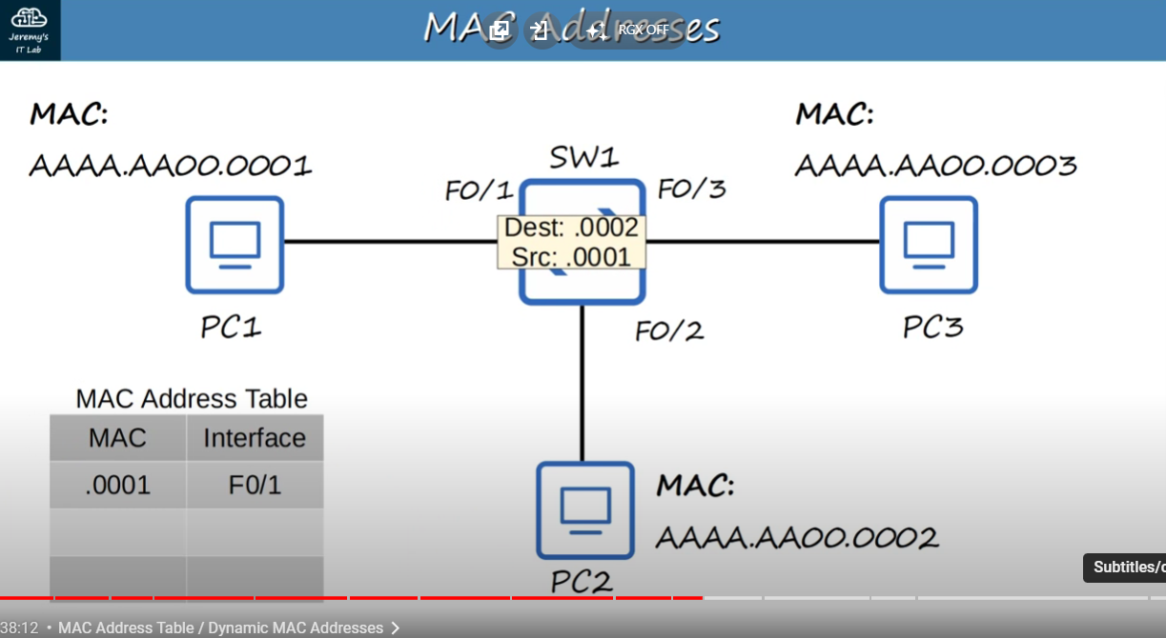

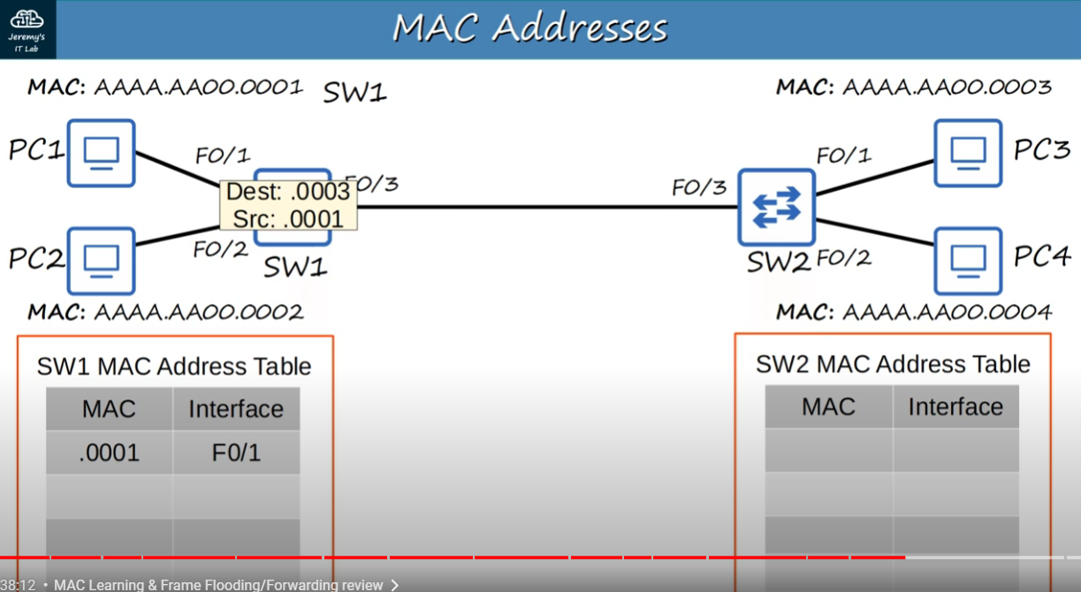

LAB 6:

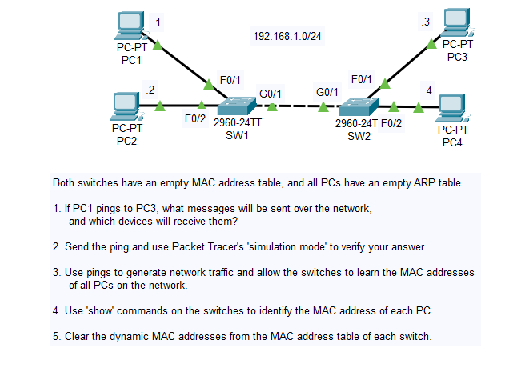

PC1s ARP table is empty so it will first broadcast an ARP request which will be received by PC2, PC3 and PC4.

PC4 and PC2 would ignore it as the ARP packets IP address would not match their own but PC3 would see that its IP addres matches the one in the ARP request packet so it sends a unicast ARP reply to PC1 with its MAC address.

Now that PC1 knows PC3s MAC address, it can now send an ICMP Echo Request through the network which will be received by PC3 (unicast) and it will reply with a unicast ICMP Echo Reply which will be sent back to PC1.

The switches at this point would be aware of PC1 and PC3s interfaces because of Source MAC Address.

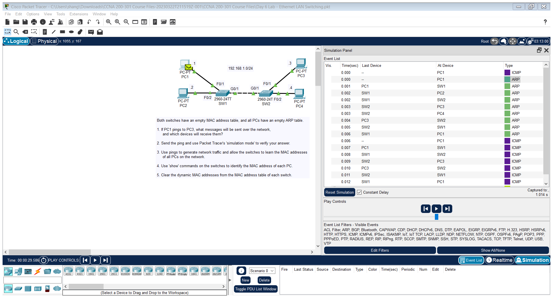

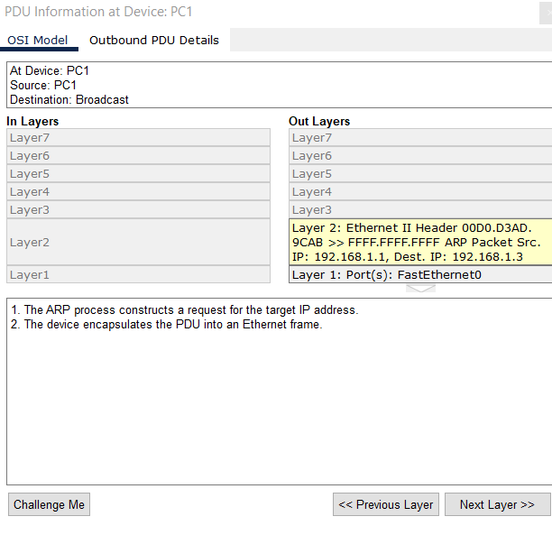

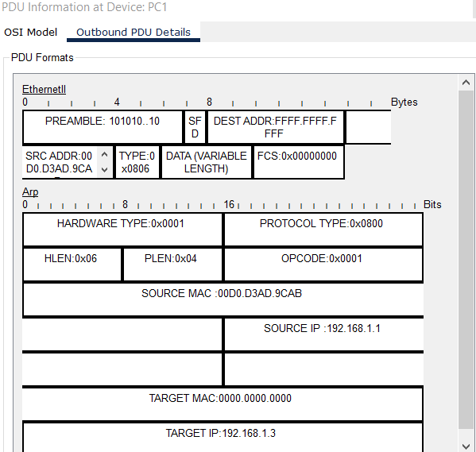

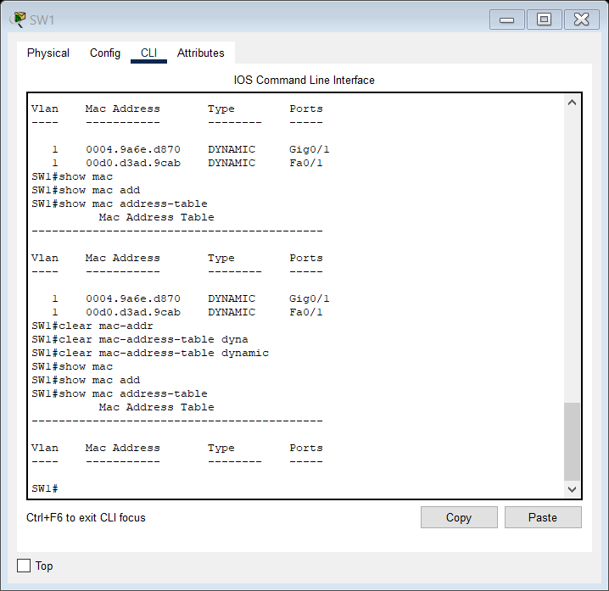

Now, this part here displays the number of possible networks in each class. As I said,

29:09

class A has fewer potential networks, but more hosts in each network, class C is the

29:15

opposite, and class B is in between. Class A has 128 possible networks, Class B has about

29:24

16,000 networks, and Class C has about 2 million networks. Class A allows about 16.7 million

29:32

hosts in each network, Class B allows about 65,000 hosts in each network, and class C

29:39

allows 256 hosts in each network. However, because the first address in each network

29:46

is the network address, it cant be assigned to hosts. Also the last address of the network

29:52

is the broadcast address, the Layer 3 address used when you want to send traffic to all hosts, and it also can’t be assigned to hosts, so really the host count is two less, for example

30:04

254 in class C.

LAB 8 FOR DAY 8:

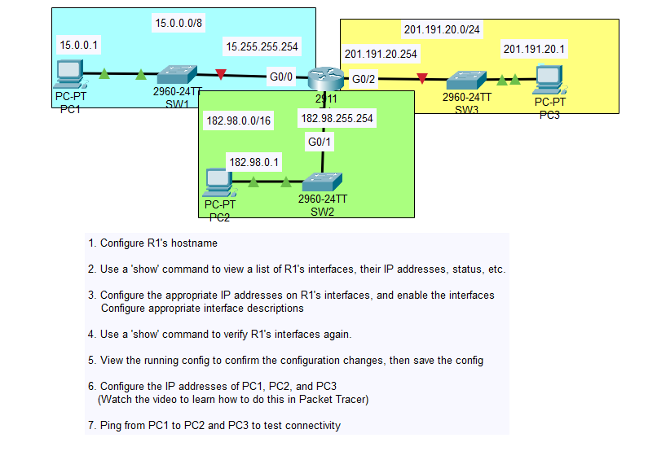

R1(config)#do show ip interface brief

Interface IP-Address OK? Method Status Protocol

GigabitEthernet0/0 unassigned YES unset administratively down down

GigabitEthernet0/1 unassigned YES unset administratively down down

GigabitEthernet0/2 unassigned YES unset administratively down down

Vlan1 unassigned YES unset administratively down down

R1(config)#int Gig0/0

R1(config-if)#ip address 15.255.255.254 255.0.0.0

R1(config-if)#no shut

R1(config-if)#

%LINK-5-CHANGED: Interface GigabitEthernet0/0, changed state to up

%LINEPROTO-5-UPDOWN: Line protocol on Interface GigabitEthernet0/0, changed state to up

R1(config-if)#int Gig0/1

R1(config-if)#ip address 182.98.255.254 255.255.0.0

R1(config-if)#no shut

R1(config-if)#

%LINK-5-CHANGED: Interface GigabitEthernet0/1, changed state to up

%LINEPROTO-5-UPDOWN: Line protocol on Interface GigabitEthernet0/1, changed state to up

R1(config-if)#int Gig0/2

R1(config-if)#ip address 201.191.20.254 255.255.255.0

R1(config-if)#no shut

R1(config-if)#

%LINK-5-CHANGED: Interface GigabitEthernet0/2, changed state to up

%LINEPROTO-5-UPDOWN: Line protocol on Interface GigabitEthernet0/2, changed state to up

R1(config-if)#exit

R1(config)#

R1(config)#do show ip interface brief

Interface IP-Address OK? Method Status Protocol

GigabitEthernet0/0 15.255.255.254 YES manual up up

GigabitEthernet0/1 182.98.255.254 YES manual up up

GigabitEthernet0/2 201.191.20.254 YES manual up up

Vlan1 unassigned YES unset administratively down down

R1(config)#

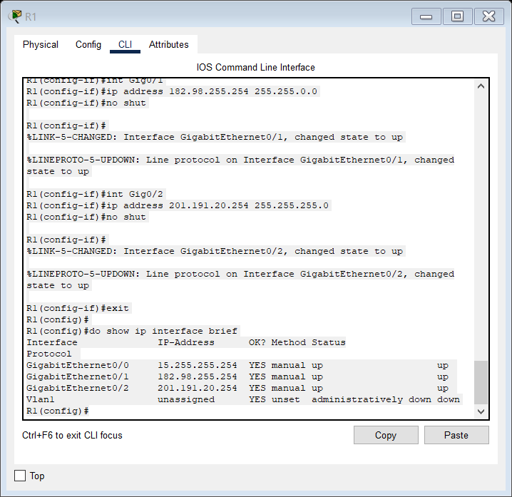

R1(config)#do show running-config

Building configuration...

Current configuration : 755 bytes

!

version 15.1

no service timestamps log datetime msec

no service timestamps debug datetime msec

no service password-encryption

!

hostname R1

!

!

!

!

!

!

!

!

ip cef

no ipv6 cef

!

!

!

!

license udi pid CISCO2911/K9 sn FTX1524NMDP-

!

!

!

!

!

!

!

!

!

!

!

spanning-tree mode pvst

!

!

!

!

!

!

interface GigabitEthernet0/0

ip address 15.255.255.254 255.0.0.0

duplex auto

speed auto

!

interface GigabitEthernet0/1

ip address 182.98.255.254 255.255.0.0

duplex auto

speed auto

!

interface GigabitEthernet0/2

ip address 201.191.20.254 255.255.255.0

duplex auto

speed auto

!

interface Vlan1

no ip address

shutdown

!

router rip

!

ip classless

!

ip flow-export version 9

!

!

!

no cdp run

!

!

!

R1(config)#do copy running-config startup-config

Destination filename [startup-config]?

Building configuration...

[OK]

R1(config)#enable secret Hello

R1(config)#show running-config

^

% Invalid input detected at '^' marker.

R1(config)#do show runn

R1(config)#do show running-config

Building configuration...

Current configuration : 804 bytes

!

version 15.1

no service timestamps log datetime msec

no service timestamps debug datetime msec

no service password-encryption

!

hostname R1

!

!

!

enable secret 5 $1$mERr$JC.BDE8.hB35B5XYR3ITE.

!

!

!

!

!

!

ip cef

no ipv6 cef

R1(config)#do write memory

Building configuration...

[OK]

R1(config)#

R1(config)#exit

R1#

%SYS-5-CONFIG_I: Configured from console by console

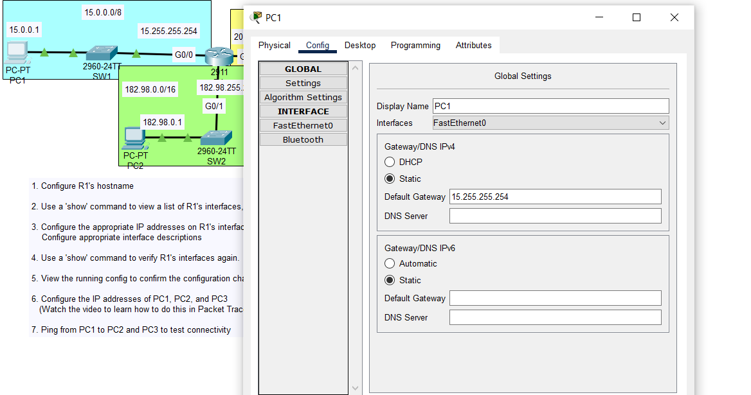

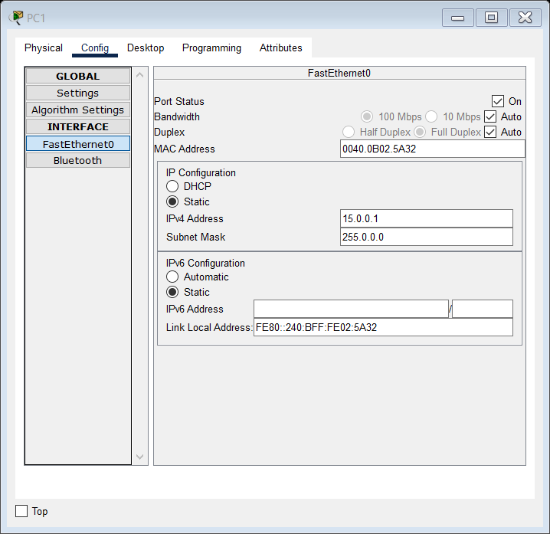

Static IP address manual configuration of PCs is done like this.

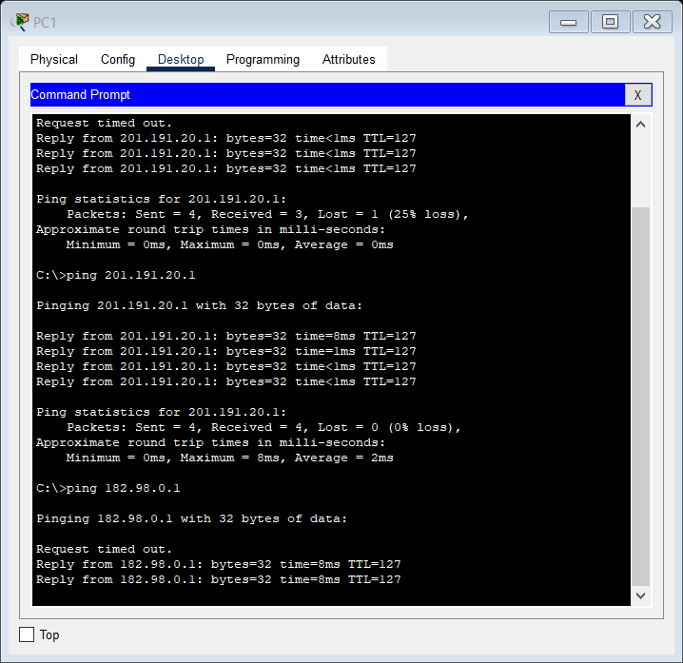

LAB 9 FOR DAY 9:

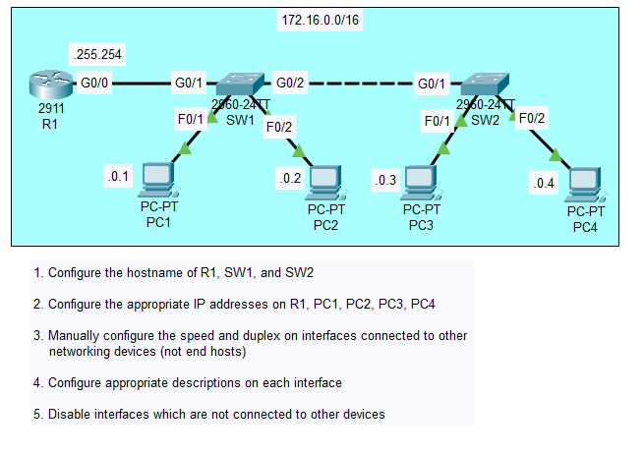

Router#conf t

Enter configuration commands, one per line. End with CNTL/Z.

Router(config)#hostname R1

R1(config)#int g0/0

R1(config-if)#ip addr 172.16.255.254 255.255.0.0

R1(config-if)#no shut

R1(config-if)#

%LINK-5-CHANGED: Interface GigabitEthernet0/0, changed state to up

%LINEPROTO-5-UPDOWN: Line protocol on Interface GigabitEthernet0/0, changed state to up

R1(config-if)#do show ip int brief

Interface IP-Address OK? Method Status Protocol

GigabitEthernet0/0 172.16.255.254 YES manual up up

GigabitEthernet0/1 unassigned YES unset administratively down down

GigabitEthernet0/2 unassigned YES unset administratively down down

Vlan1 unassigned YES unset administratively down down

R1(config-if)#exit

R1(config)#speed 1000

^

% Invalid input detected at '^' marker.

R1(config)#exit

R1#

%SYS-5-CONFIG_I: Configured from console by console

R1#speed?

% Unrecognized command

R1#conf t

Enter configuration commands, one per line. End with CNTL/Z.

R1(config)#int g0/0

R1(config-if)#speed 1000

R1(config-if)#duplex full

R1(config-if)#

%LINEPROTO-5-UPDOWN: Line protocol on Interface GigabitEthernet0/0, changed state to down

R1(config-if)#show ip interface status

^

% Invalid input detected at '^' marker.

R1(config-if)#int range g0/1-2

R1(config-if-range)#desc ## not in use ##

R1(config-if-range)#end

R1#

%SYS-5-CONFIG_I: Configured from console by console

R1#copy running-config start

R1#copy running-config startup-config

Destination filename [startup-config]?

Building configuration...

[OK]

R1#show star

R1#show startup-config

Now for SW1:

SW1(config)#

SW1(config)#int g0/2

SW1(config-if)#speed 1000

SW1(config-if)#duplex full

SW1(config-if)#

%LINK-3-UPDOWN: Interface GigabitEthernet0/2, changed state to down

%LINEPROTO-5-UPDOWN: Line protocol on Interface GigabitEthernet0/2, changed state to down

SW1(config-if)#int range Fa0/1-24

SW1(config-if-range)#shutdown

%LINK-5-CHANGED: Interface FastEthernet0/3, changed state to administratively down

%LINK-5-CHANGED: Interface FastEthernet0/4, changed state to administratively down

%LINK-5-CHANGED: Interface FastEthernet0/5, changed state to administratively down

%LINK-5-CHANGED: Interface FastEthernet0/6, changed state to administratively down

%LINK-5-CHANGED: Interface FastEthernet0/7, changed state to administratively down

%LINK-5-CHANGED: Interface FastEthernet0/8, changed state to administratively down

%LINK-5-CHANGED: Interface FastEthernet0/9, changed state to administratively down

%LINK-5-CHANGED: Interface FastEthernet0/10, changed state to administratively down

%LINK-5-CHANGED: Interface FastEthernet0/11, changed state to administratively down

%LINK-5-CHANGED: Interface FastEthernet0/12, changed state to administratively down

%LINK-5-CHANGED: Interface FastEthernet0/13, changed state to administratively down

%LINK-5-CHANGED: Interface FastEthernet0/14, changed state to administratively down

%LINK-5-CHANGED: Interface FastEthernet0/15, changed state to administratively down

%LINK-5-CHANGED: Interface FastEthernet0/16, changed state to administratively down

%LINK-5-CHANGED: Interface FastEthernet0/17, changed state to administratively down

%LINK-5-CHANGED: Interface FastEthernet0/18, changed state to administratively down

%LINK-5-CHANGED: Interface FastEthernet0/19, changed state to administratively down

%LINK-5-CHANGED: Interface FastEthernet0/20, changed state to administratively down

%LINK-5-CHANGED: Interface FastEthernet0/21, changed state to administratively down

%LINK-5-CHANGED: Interface FastEthernet0/22, changed state to administratively down

%LINK-5-CHANGED: Interface FastEthernet0/23, changed state to administratively down

%LINK-5-CHANGED: Interface FastEthernet0/24, changed state to administratively down

SW1(config-if-range)#

%LINK-5-CHANGED: Interface FastEthernet0/1, changed state to administratively down

%LINEPROTO-5-UPDOWN: Line protocol on Interface FastEthernet0/1, changed state to down

%LINK-5-CHANGED: Interface FastEthernet0/2, changed state to administratively down

%LINEPROTO-5-UPDOWN: Line protocol on Interface FastEthernet0/2, changed state to down

SW1(config-if-range)#desc ## not in use. was shut down##

SW1(config-if-range)#exit

SW1(config)#

SW1(config)#show int status

^

% Invalid input detected at '^' marker.

SW1(config)#do show int status

Port Name Status Vlan Duplex Speed Type

Fa0/1 ## not in use. was disabled 1 auto auto 10/100BaseTX

Fa0/2 ## not in use. was disabled 1 auto auto 10/100BaseTX

Fa0/3 ## not in use. was disabled 1 auto auto 10/100BaseTX

Fa0/4 ## not in use. was disabled 1 auto auto 10/100BaseTX

Fa0/5 ## not in use. was disabled 1 auto auto 10/100BaseTX

Fa0/6 ## not in use. was disabled 1 auto auto 10/100BaseTX

Fa0/7 ## not in use. was disabled 1 auto auto 10/100BaseTX

Fa0/8 ## not in use. was disabled 1 auto auto 10/100BaseTX

Fa0/9 ## not in use. was disabled 1 auto auto 10/100BaseTX

Fa0/10 ## not in use. was disabled 1 auto auto 10/100BaseTX

Fa0/11 ## not in use. was disabled 1 auto auto 10/100BaseTX

Fa0/12 ## not in use. was disabled 1 auto auto 10/100BaseTX

Fa0/13 ## not in use. was disabled 1 auto auto 10/100BaseTX

Fa0/14 ## not in use. was disabled 1 auto auto 10/100BaseTX

Fa0/15 ## not in use. was disabled 1 auto auto 10/100BaseTX

Fa0/16 ## not in use. was disabled 1 auto auto 10/100BaseTX

Fa0/17 ## not in use. was disabled 1 auto auto 10/100BaseTX

Fa0/18 ## not in use. was disabled 1 auto auto 10/100BaseTX

Fa0/19 ## not in use. was disabled 1 auto auto 10/100BaseTX

Fa0/20 ## not in use. was disabled 1 auto auto 10/100BaseTX

Fa0/21 ## not in use. was disabled 1 auto auto 10/100BaseTX

Fa0/22 ## not in use. was disabled 1 auto auto 10/100BaseTX

Fa0/23 ## not in use. was disabled 1 auto auto 10/100BaseTX

Fa0/24 ## not in use. was disabled 1 auto auto 10/100BaseTX

Gig0/1 ## connected to R1 connected 1 a-full a-100010/100BaseTX

Gig0/2 notconnect 1 a-full a-100010/100BaseTX

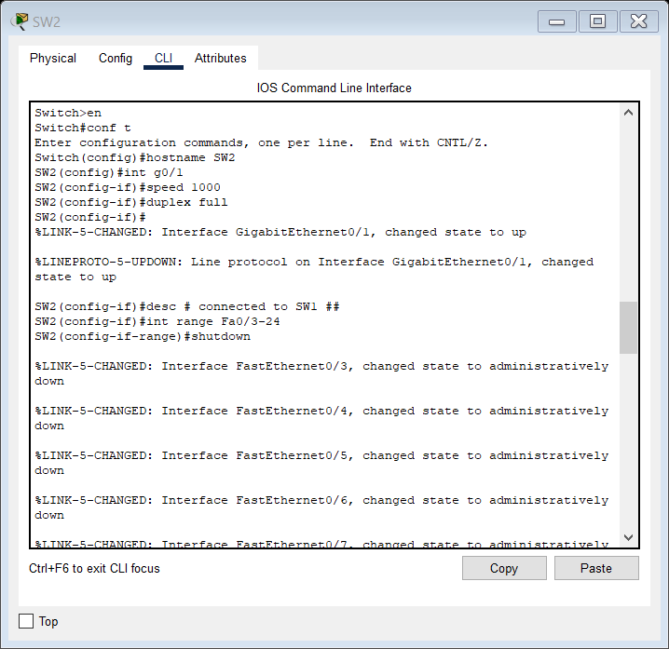

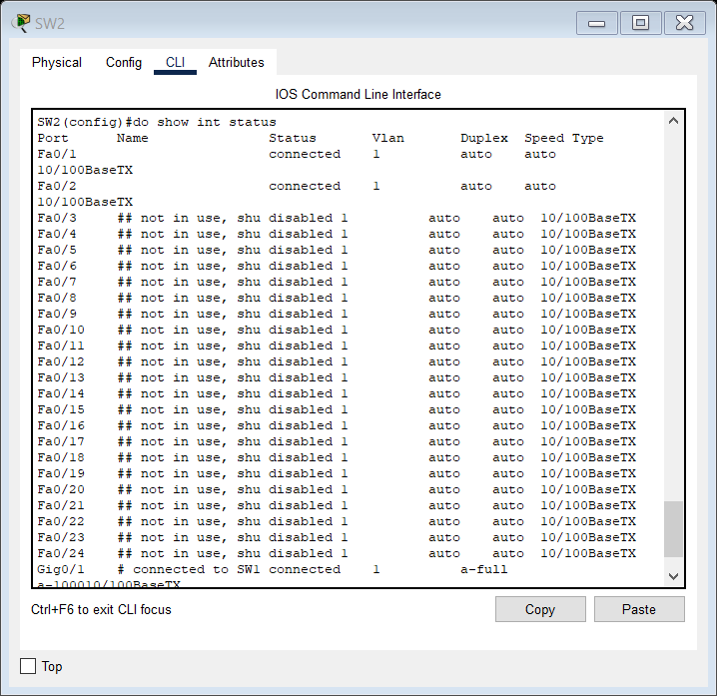

DAY 11 LAB:

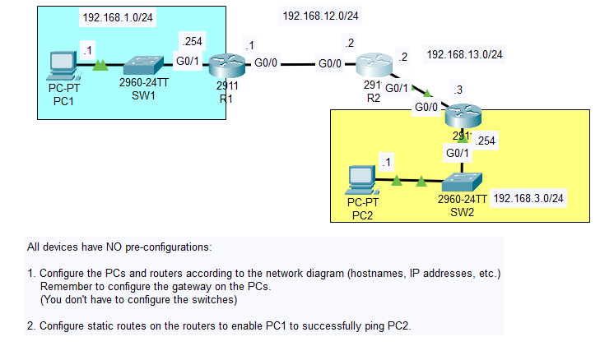

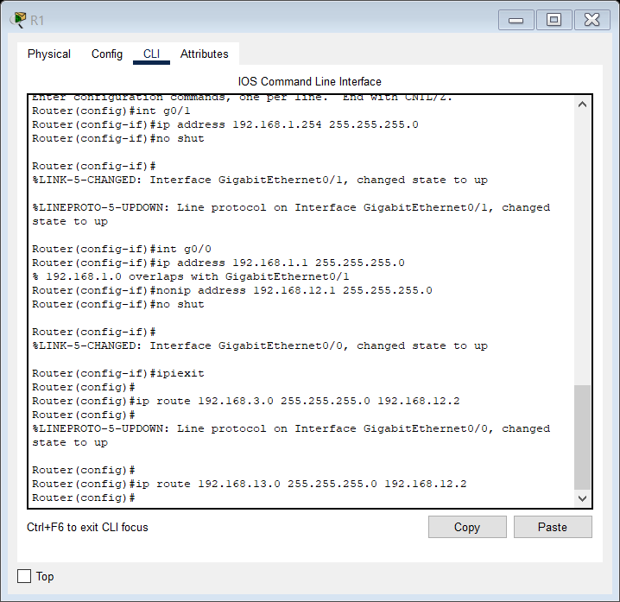

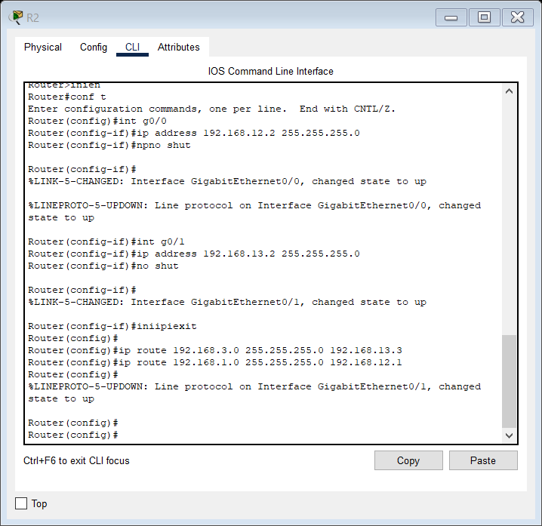

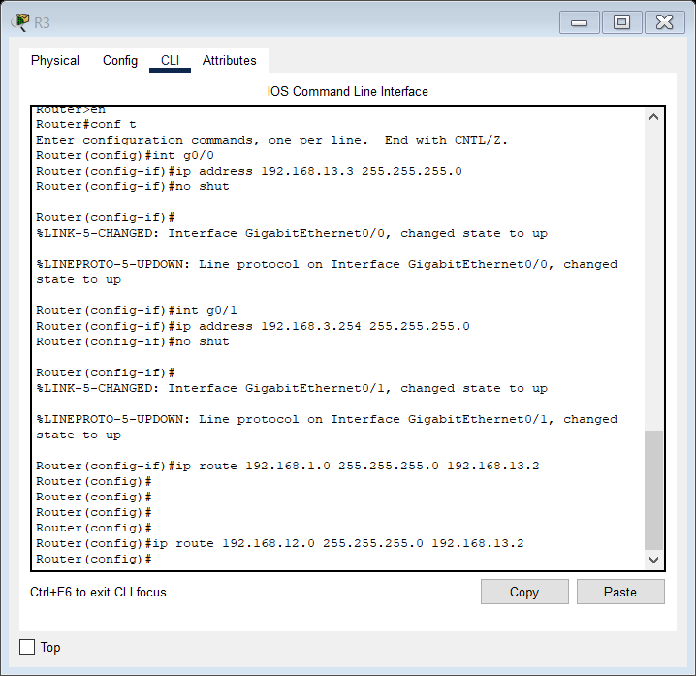

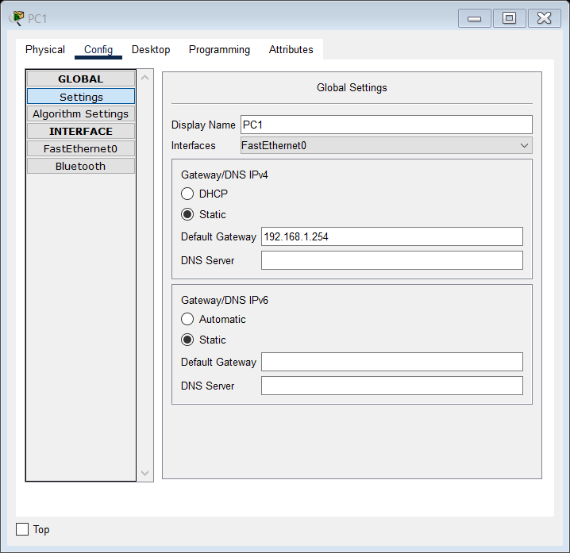

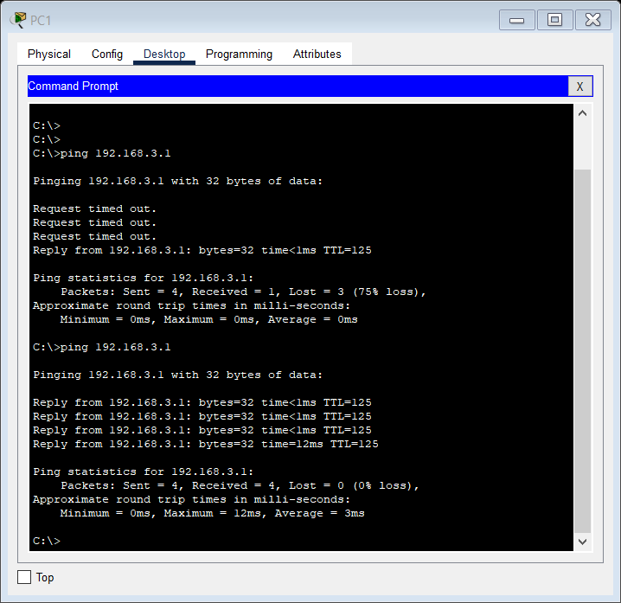

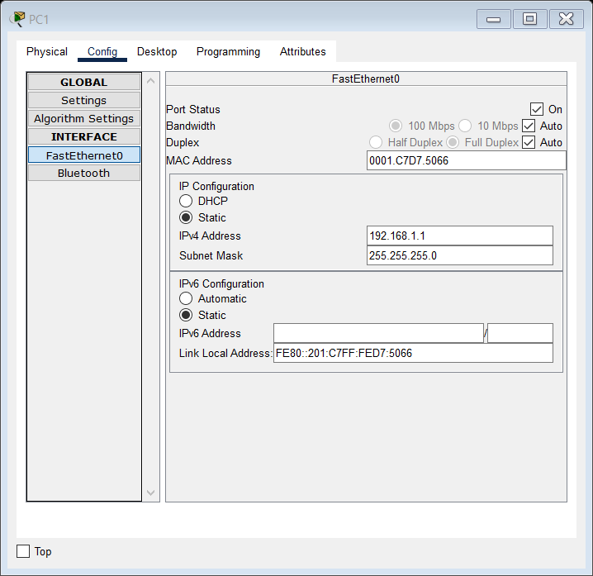

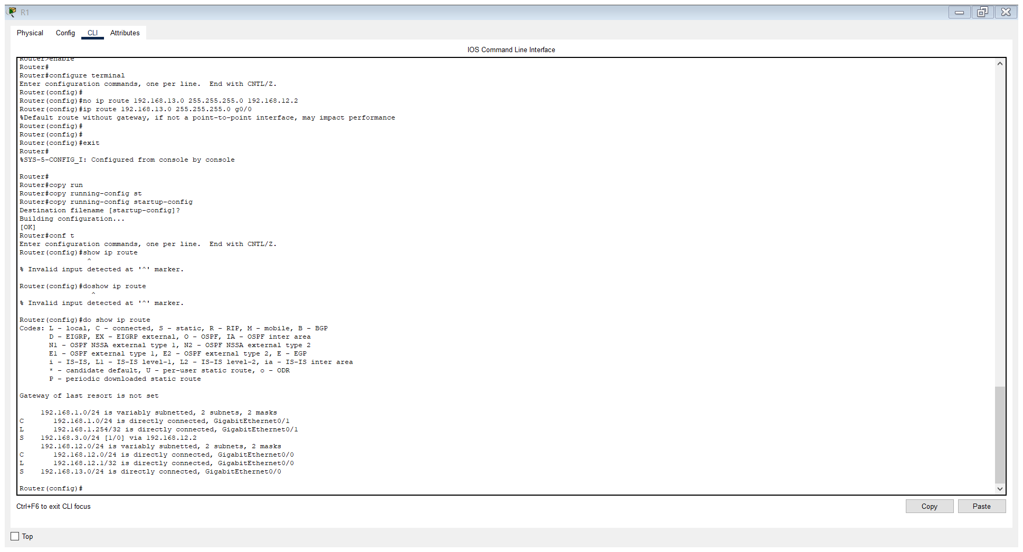

DAY 11 LAB TROUBLESHOOTING STATIC ROUTES:

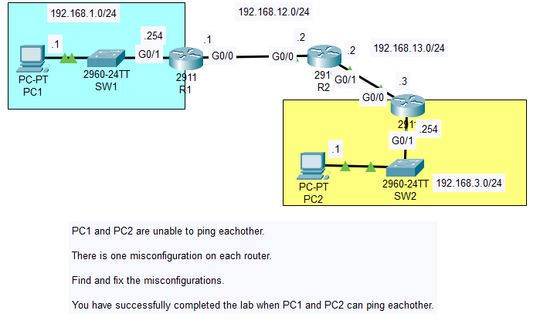

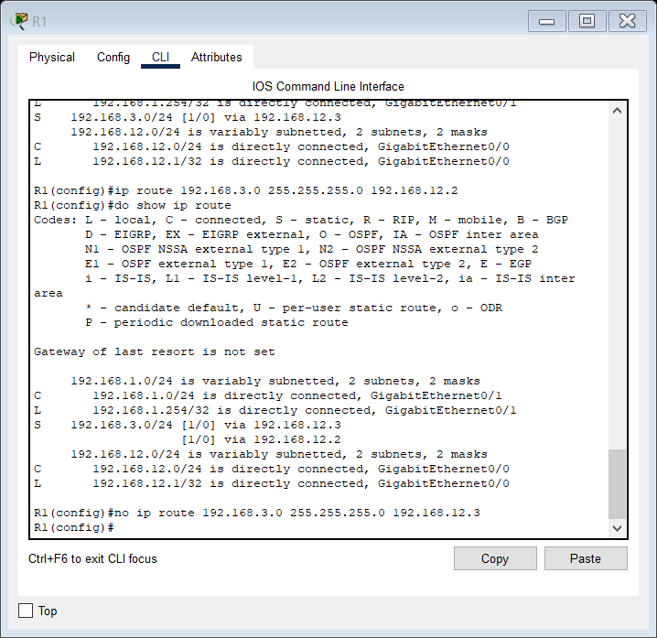

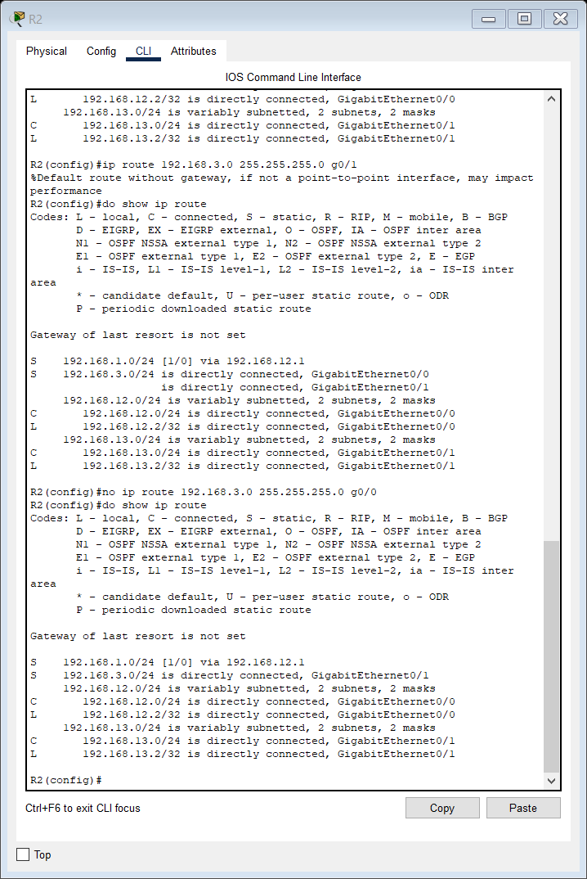

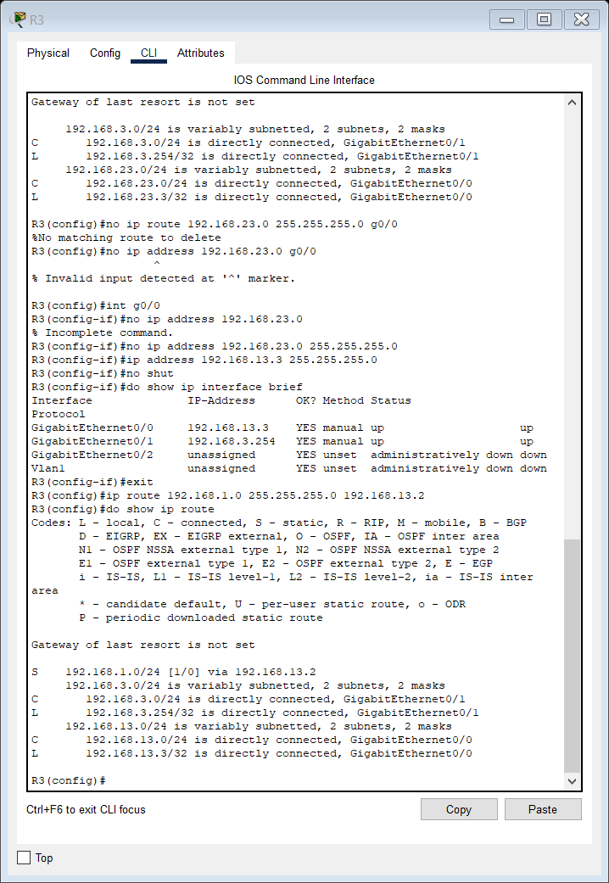

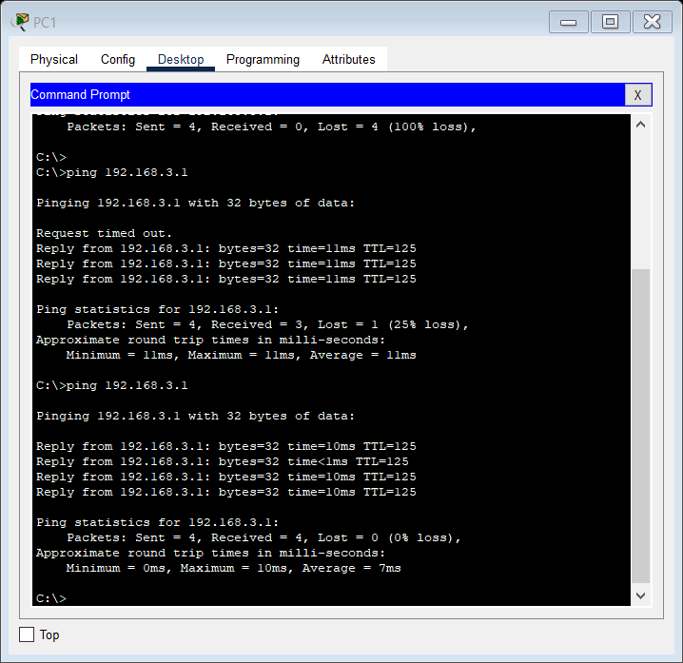

We were successfully able to troubleshoot the network.

Cool command:

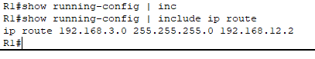

DAY 12 LAB

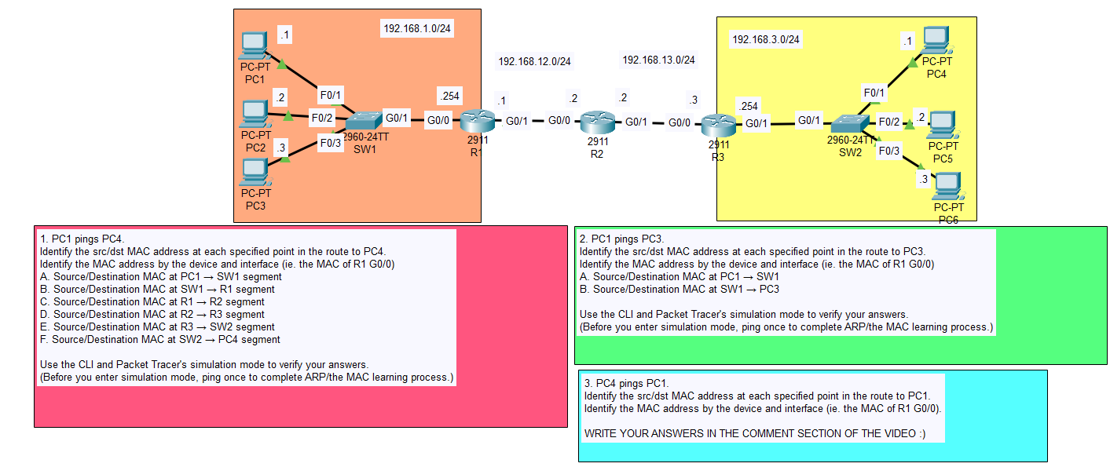

1.

When PC1 tries to ping PC4, it must forward the frame to its default gateway that is R1s G0/0 interface so that R1 can route it out to a different network.

To do this PC1 will send an ARP request first to learn R1s G0/0 interface’s MAC address. The ARP packet would look like this:

ARP REQUEST

Source IP address : 192.168.1.1

Destination IP address: 192.168.1.254

Destination MAC address: FFFF.FFFF.FFFF

Source MAC address: 00D0.BA11.1111

It is important to note that since this frame is a broadcast frame, the switch SW1 will forward it out of every one of its interfaces except the one it received the frame on.

R1 will receive the request and notice that the packet was destined for its own IP address so it will receive it and send an ARP reply directly to PC1 which is a unicast reply.

Source IP address : 192.168.1.254

Destination IP address: 192.168.1.1

Destination MAC address: 00D0.BA11.1111

Source MAC address: 00d0.ff77.0101

The Switch SW1 would have learned the MAC of PC1 and router by now as a result of receiving the packet with the source MACs of them in it.

PC1 will receive the reply and encapsulate R1s G0/0 interface’s MAC in a Layer 2 header and send the packet.

The packet would look like this:

Src IP address: 192.168.1.1

Destination IP address: 192.168.3.1

Destination MAC : 00d0.ff77.0101

Source MAC: 00D0.BA11.1111

R1 receives the packet and it de encapsulates the Layer 2 header and checks the dest. IP address and checks its Routing table and upon checking, it knows it needs to send it out of the G0/1 interface however it has to learn the MAC of the other device first.

ARP REQUEST

Source IP address : 192.168.12.1

Destination IP address: 192.168.12.2

Destination MAC address: FFFF.FFFF.FFFF

Source MAC address: R1s G0/1 interface MAC

R2 would receive it and send a unicast ARP reply back to R1.

ARP REPLY

Source IP address : 192.168.12.2

Destination IP address: 192.168.12.1

Destination MAC address: R1’s G0/1 interface Mac

Source MAC address: R2’s G0/0 interface MAC

R1 receives the packet and then encapsulates R2’s G0/0 interface’s MAC in its Layer 2 header and sends it over to R2.

Packet:

Src IP address: 192.168.1.1

Destination IP address: 192.168.3.1

Destination MAC : R2’s G0/0 interface MAC

Source MAC: R1’s G0/1 interface MAC

R2 deencapsulates the packet and checks for the Destination IP address and then subsequently its routing table and knows it has to forward the packet out of its G0/1 interface.

Now R2 will send an ARP request to R3 to learn its MAC address.

ARP REQUEST

Source IP address : 192.168.13.2

Destination IP address: 192.168.13.3

Destination MAC address: FFFF.FFFF.FFFF

Source MAC address: R2s G0/1 interface MAC

ARP REPLY

Source IP address : 192.168.13.3

Destination IP address: 192.168.13.2

Destination MAC address: R2s G0/1 interface MAC

Source MAC address: R3s G0/0 interface MAC

Then R2 would encapsulate the packet with a Layer 2 header that includes R3s G0/0 interface and send it over to R3.

Layer 3 packet with Layer 2 header:

Src IP address: 192.168.1.1

Destination IP address: 192.168.3.1

Destination MAC : R3’s G0/0 interface MAC

Source MAC: R2’s G0/1 interface MAC

Now R3 has received the packet and since it has a connected route to 192.168.3.0/24, it will forward the packet to 192.168.3.1.

But first R3 has to learn PC4s MAC address so it will send an ARP request to PC4.

ARP REQUEST

Source IP address : 192.168.3.254

Destination IP address: 192.168.3.1

Destination MAC address: FFFF.FFFF.FFFF

Source MAC address: R3s G0/1 interface MAC

ARP REPLY

Source IP address : 192.168.3.1

Destination IP address: 192.168.3.254

Destination MAC address: R3s G0/1 interface MAC

Source MAC address: PC4s MAC address

The switch SW2 will learn PC4s and R3s MAC addresses and its interfaces dynamically.

When R3 will receive the ARP request, it will encapsulate the packet with a Layer 2 Ethernet header containing the MAC address of PC4 and send it over to PC4 as a unicast Layer 3 packet.

The packet looks like this in the end:

Src IP address: 192.168.3.254

Destination IP address: 192.168.3.1

Destination MAC : PC4s MAC address

Source MAC: R3’s G0/1 interface MAC

2.

Source MAC at PC1 -> SW1 would be PC1s MAC address.

Destination MAC at PC1 -> SW1 would be PC3s MAC address.

Same at SW1 -> PC3.

3.

Follow same methodology as 1.

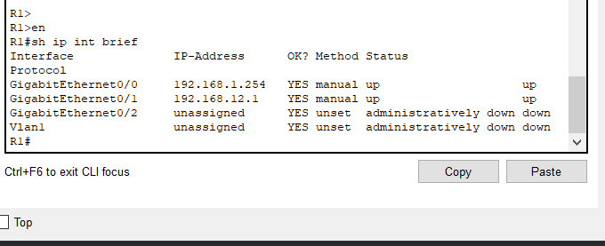

Status is the layer 1 status of the interface

whether the physical interface is working as intended

while Protocol is Layer 2

if layer 2 is down, it means that Ethernet is not working as intended on that interface, that there is some sort of problem

ip route 192.168.1.0 255.255.255.0 g0/0

%Default route without gateway, if not a point-to-point interface, may impact

performance

point-to-point interface means it is connected only to one other device.

This is different than, for example. many routers connected to a single switch,

which we could call a shared segment.

DAY 13 SUBNETTING NOTES

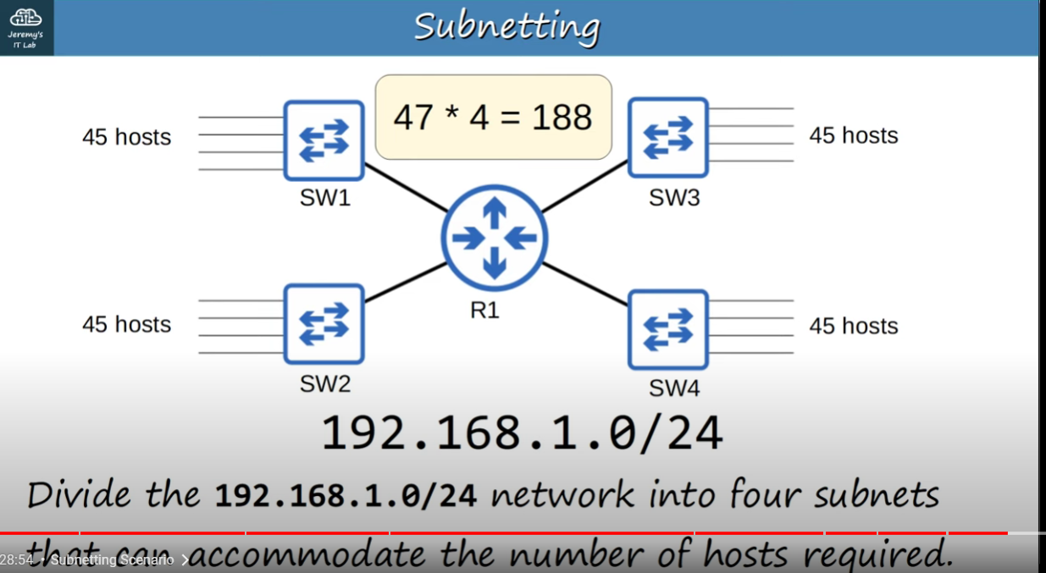

So for this ,we can use a CIDR notation of /26

11000000 . 1010100 . 00000001 . 00000000

192. 168 . 1 . 0

For /26, we have

11000000 . 1010100 . 00000001 . 00 000000 (the space is denoting difference between network and host bits)

26 network bits, 6 host bits

This gives us 2^6 – 2 = 62 usable addresses which is enough for our 45 host requirement for the first subnet.

So we have to go with 192.168.1.0/26 for FIRST subnet.

NOW SECOND SUBNET,

We need to first calculate broadcast address for Subnet 1 that is 192.168.1.0/26

To find broadcast address, we set all the bits in the host portion to 1.

So we have

192.168.1.0

11000000 . 1010100 . 00000001 . 00 000000 as our network address.

For broadcast address:

11000000 . 1010100 . 00000001 . 00 111111

So we have 192.168.1.63

So the address range of SUBNET 1 is therefore, 192.168.1.0 – 192.168.1.63

THIS MEANS THAT SUBNET 2 will be 192.168.1.64/26.

So we have

11000000 . 1010100 . 00000001 . 01 000000

192. 168 . 1 . 64

For broadcast address, we need all host bits as 1.

11000000 . 1010100. 00000001 . 01 111111

192.168.1.127

So Subnet 2s address range is 192.168.1.64 – 192.168.1.127

Now for Subnet 3, we have 192.168.1.128/26

We have,

11000000 . 1010100. 00000001 . 10 000000

192. 168.1.128

For broadcast address, all host bits are gonna be

111000000 . 1010100. 00000001 . 10 111111

192. 168 . 1 .191

So address range for Subnet 3 is 192.168.1.128 – 192.168.1.191

So for SUBNET 4 , we have 192.168.1.192/26

111000000 . 1010100. 00000001 . 11 000000

192.168.1.192

Notice that we have now borrowed all the 1s so no more borrowing of 1s is possible so this is the fourth and the last subnet for /26 as 2 network bits so 2^2 subnets = 4 subnets ( 00, 01, 10 , 11)

To find broadcast address, we again need our host bits to be 1

111000000 . 1010100. 00000001 . 11 111111

192.168.1.255

So our subnet 4 is ranging from

192.168.1.192(network address) – 192.168.1.255 (broadcast address)

The above notes are pretty inane, do not refer to them lol.

**ANYWAY ON TO VLSM SUBNETTING I GUESS.**

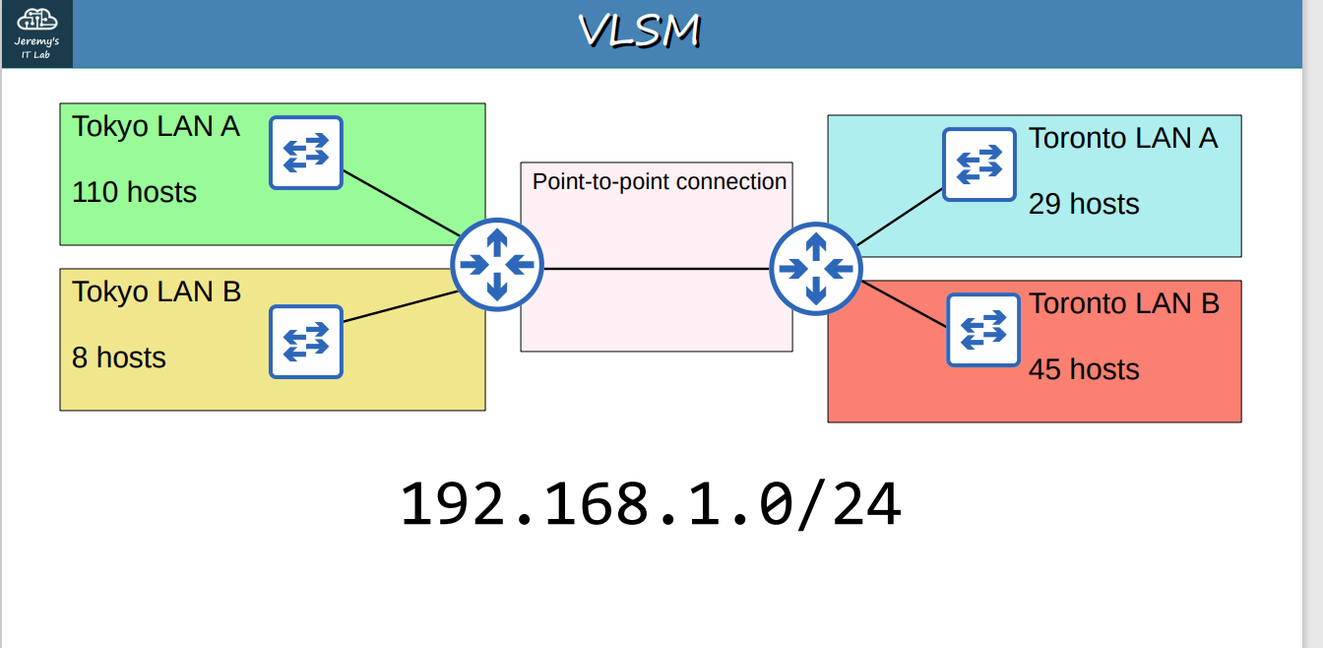

VLSM Subnetting

192.168.1.0/24

into 4 segments, Tokyo LAN A requiring 110 hosts, Tokyo LAN B requiring 8 hosts,

Toronto LAN A requiring 29 hosts and Toronto LAN B requiring 45 hosts.

The point to point connection requiring only 2 IP addresses.

So for Tokyo LAN A, we will assign to it first as it is the largest segment.

128 64 32 16 8 4 2 1

/25 /26 /27 /28 /29 /30 /31 /32

/24 means we can assign 256 IP addresses.

/25 means we can assign 128 IP addresses, 126 host addresses.

we will choose /25 and assign 192.168.1.0/25 to our Tokyo LAN A.

Tokyo LAN A:

Network address: 192.168.1.0/25

Broadcast address: 192.168.1.127

First usable: 192.168.1.1

last usable: 192.168.1.126

Total usable host addresses: 2^(32-25) - 2 = 2^7 - 2 = 126 host addresses

Next up which is the largest is Toronto LAN B, which needs 45 hosts.

We will choose /26 to assign to Toronto LAN B.

so 192.168.1.128/26

/26 has increments of 64.

Toronto LAN B:

Network address: 192.168.1.128/26

Broadcast address: 192.168.1.191

First usable: 192.168.1.129

last usable: 192.168.1.190

Total usable host addresses: 2^(32-26) - 2 = 2^6 - 2 = 62 host addresses

Next up is Toronto LAN A which needs 29 hosts.

We shall assign /27, increment of 32.

so 192.168.1.192/27

Toronto LAN A:

Network address: 192.168.1.192/27

Broadcast address: 192.168.1.223

First usable: 192.168.1.193

last usable: 192.168.1.222

Total usable host addresses: 2^(32-27) - 2 = 2^5 - 2 = 30 host addresses

Lastly we have Tokyo LAN B which requires 8 hosts.

So we shall assign /28 to it as 14 host addresses are needed.

incrememnt of 16.

Tokyo LAN B:

Network address: 192.168.1.224/28

Broadcast address: 192.168.1.239

First usable: 192.168.1.225

last usable: 192.168.1.238

Total usable host addresses: 2^(32-28) - 2 = 2^4 - 2 = 14 host addresses

Point to point connection

It requires 2 hosts, so we can use /30 prefix length.

(Although we can use /31 prefix for point to point connections,

for the CCNA, it is recommended to use /30 for point to point

networks)

So our next network is 192.168.1.240/30

Network address: 192.168.1.240/30

Broadcast address: 192.168.1.243

First usable: 192.168.1.241

last usable: 192.168.1.242

Total usable host addresses: 2^(32-30) - 2 = 2^2 - 2 = 2 host addresses

Therefore, we have successfully Subnetted this network using VLSM.

SUBNETTING QUESTIONS:

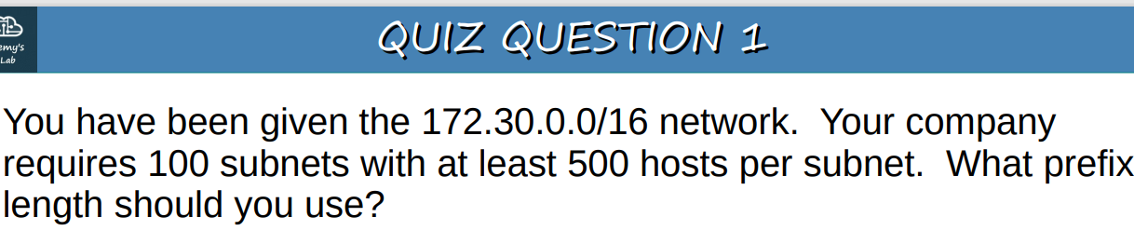

128 64 32 16 8 4 2 1

/17 /18 /19 /20 /21 /22 /23 /24

For 100 subnets , we need 2^7 = 128

So we have,

7 borrowed bits, 16 + 7 = /23

Hosts per subnet = 2^(32-23) = 2^9 – 2 = 510 usable addresses

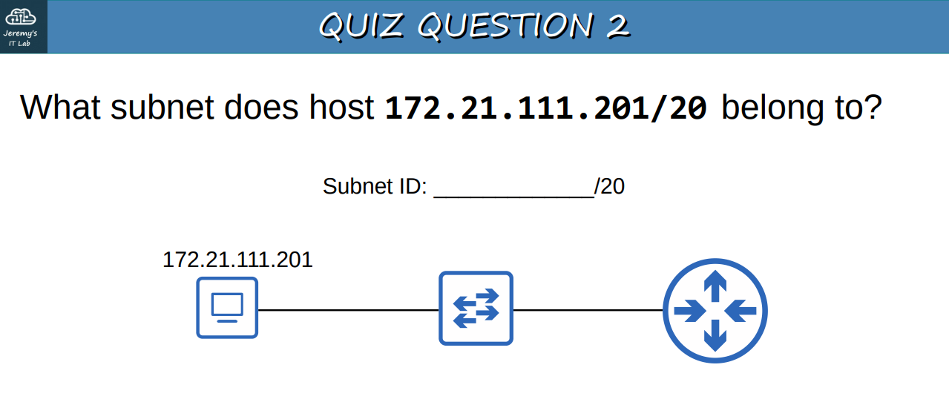

128 64 32 16 8 4 2 1

128 192 224 240 248

/17 /18 /19 /20 /21 /22 /23 /24

/20 is increment of 16. We are in the 3rd octet.

.80 (16 x 5) , so .80 - .96 is the 5th subnet and then .96 to .112 is the 6th subnet.

.96

.112

Host belongs in the 6th subnet.

Host belongs in 172.21.96.0/20 subnet

Q. What is the broadcast address of the network that 192.168.91.78/26 belongs to?

128 64 32 16 8 4 2 1

/25 /26 /32

192.168.91.128

192.168.91.127 -> broadcast address

Q. 172.16.0.0/16 network into 4 subnets of equal size.

network and braodcast address?

128 64 32 16 8 4 2 1

Borrowing 2 bits so /18

so we have 2^2 = 4 subnets and they are as follows:

First subnet - 172.16.0.0

second subnet - 172.16.64.0

third subnet - 172.16.128.0

fourth subnet - 172.16.192.0

network addr of second subnet - 172.16.64.0/18

broadcast address - 172.16.127.255

Q. You divide the 172.30.0.0/16 network into subnets of 1000 hosts each.

How many subnets are you able to make?

128 64 32 16 8 4 2 1

/22 /23 /24

hosts = 2(32-22) = 2^10 = 1024 - 2 = 1022

no of borrowed bits = 22 - 16 = 6

no of subnets = 2^6 = 64

64 subnets can be made.

**Subnetting CLass A networks**.

Q. You have been given 10.0.0.0/8 network. Create 2000 subnets.

What prefix length do you use?

How many host addresses in each subnet?

10.0.0.0/8

128 64 32 16 8 4 2 1

/9 /10 /11 /12 /13 /14 /15 /16

/17 /18 /19 /20 /21

19 - 8 = 11 borrowed bits

2^11 = 2048 subnets, prefix length = /19

no of hosts in each subnet = 26(32-19) - 2^13 hosts in each subnet

Q. PC1 has IP of 10.217.182.223/11.

1) Network address?

128 64 32 16 8 4 2 1

/9 /10 /11

128 192 224

10.217.182.223/11

.192

.224

network address - 10.192.0.0/11

2)Broadcast address?

10.224.0.0 - Next network

so broadcast = next - 1

broadcast address = 10.223.255.255

3) First usable

first usable address = 10.192.0.1

4) last usable

last usable address = 10.223.255.254

5) no. of hosts?

2^(32-11) - 2

2^21 - 2 usable hosts per subnet

no of subnets = 11 - 8 = 3

2^3 = 8 subnets

172.16.1.0/18

/21

32-26 = 64

/26

26-21 = 5

2^5 = 32 sub networks that contain 64 IP addresses in each subnet.

Q. What subnet does host 192.168.5.57/27 belong to?

Ans. 128 64 32 16 8 4 2 1

/25 /26 /27

2^3 = 8 subnets

.0

.32

.64

host 192.168.5.57 belongs to the 2nd subnet.

Q. How many subnets and hosts per subnet can you get from the network

172.28.0.0/22?

128 64 32 16 8 4 2 1

/22 /23 /24

22 - 16 = 6 borrowed bits

number of subnets = 2^6 = 64 subnets

hosts per subnet = 2^(32-22) - 2 = 2^10 - 2 = 1024 -2 = 1022 hosts per subnet

Please refer to more Subnetting questions and tricks in the notebook you took notes in!

DAY 15 LAB VLSM:

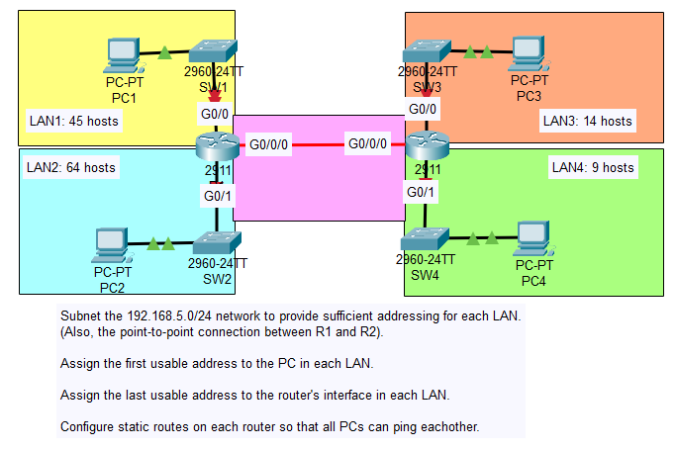

128 64 32 16 8 4 2 1 - GS

128 192 224 240 248 252 254 255 – Subnet Mask

/25 /26 /27 /28 /29 /30 /31 /32 - CIDR

Network – 192.168.5.0/24

Largest LAN – LAN 2 : 64 hosts

We will first assign /25 to LAN 2 with 126 usable hosts.

LAN 2:

Network address: 192.168.5.0/25

Broadcast address: 192.168.5.127

First usable: 192.168.5.1

Last usable: 192.168.5.126

Subnet mask: 255.255.255.128

LAN 1 is the second largest and requires 45 hosts.

We will assign /26 to LAN 1,so 192.168.5.128/26

LAN 1:

Network address: 192.168.5.128/26

Broadcast address: 192.168.5.191

First usable: 192.168.5.129

Last usable: 192.168.5.190

Subnet mask: 255.255.255.192

Next up, we have LAN 3 which requires 14 hosts.

We will assign /28 to LAN 3, so 192.168.5.192/28

LAN 3:

Network address: 192.168.5.192/28

Broadcast address: 192.168.5.207

First usable: 192.168.5.193

Last usable: 192.168.5.206

Subnet mask: 255.255.255.240

Next, we have LAN 4 which requires 9 hosts.

We will again assign /28 to LAN 4, so 192.168.5.208/28.

LAN 4:

Network address: 192.168.5.208/28

Broadcast address: 192.168.5.223

First usable: 192.168.5.209

Last usable: 192.168.5.222

Subnet mask: 255.255.255.240

For point to point network, we will assign /30.

Point to point network, 192.168.5.224/30

Point to Point network:

Network address: 192.168.5.224/30

Broadcast address: 192.168.5.227

First usable: 192.168.5.225

Last usable: 192.168.5.226

Subnet mask: 255.255.255.252

Now we can go and assign IPs to our nodes in the network in Cisco Packet Tracer.

**Configuring IP addresses:**

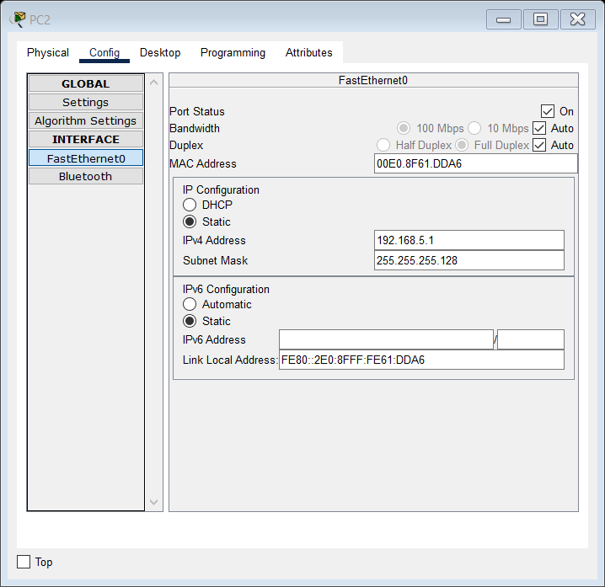

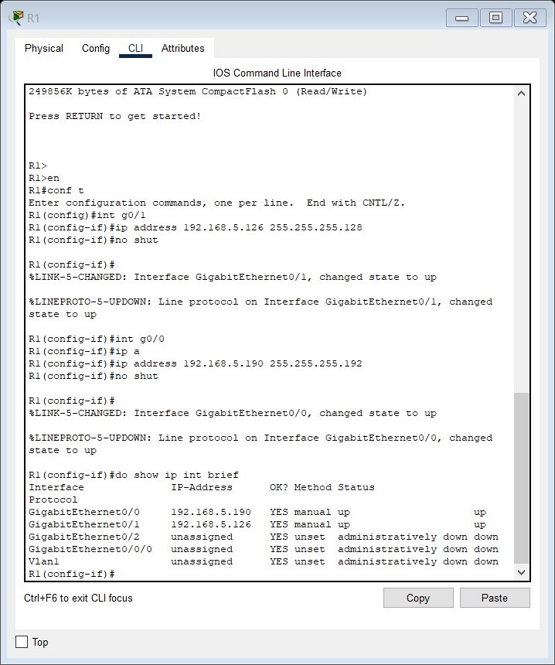

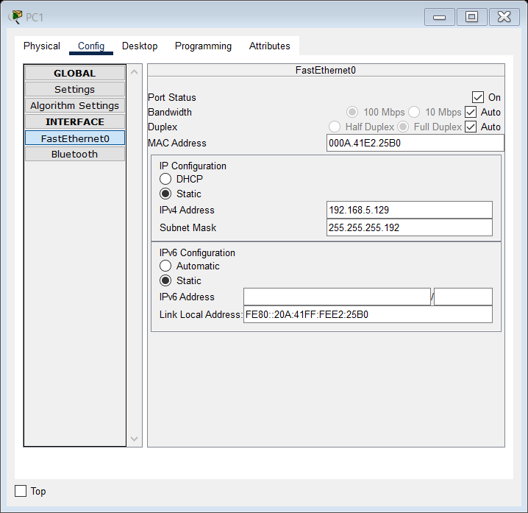

Now for for LANs 3 and 4:

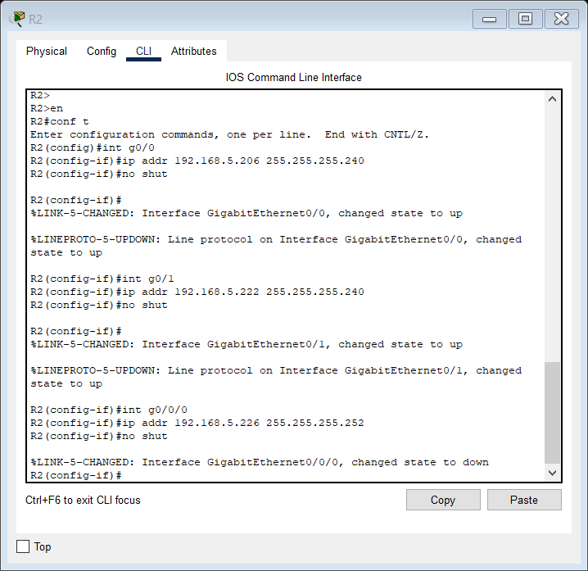

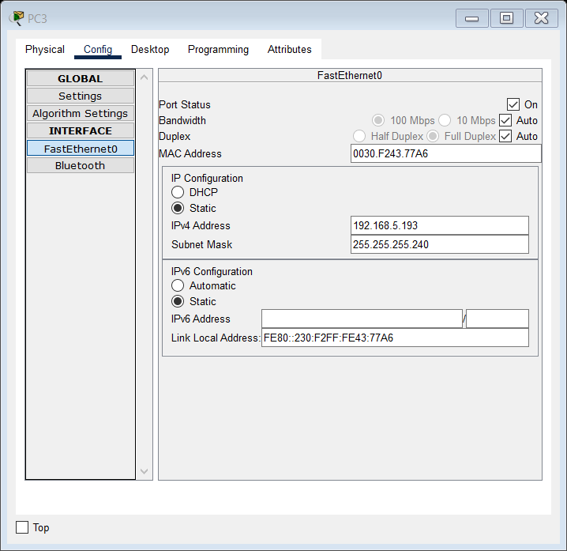

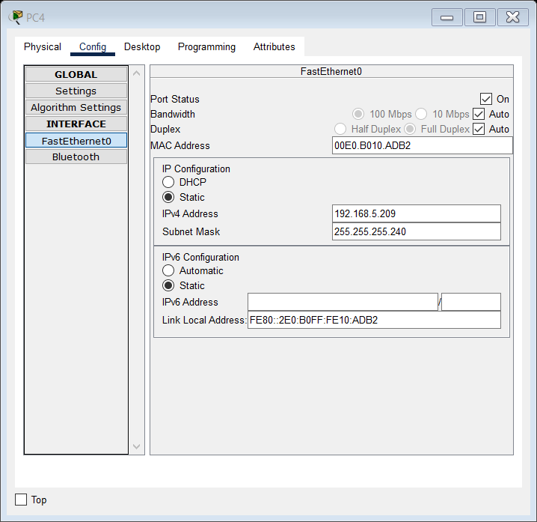

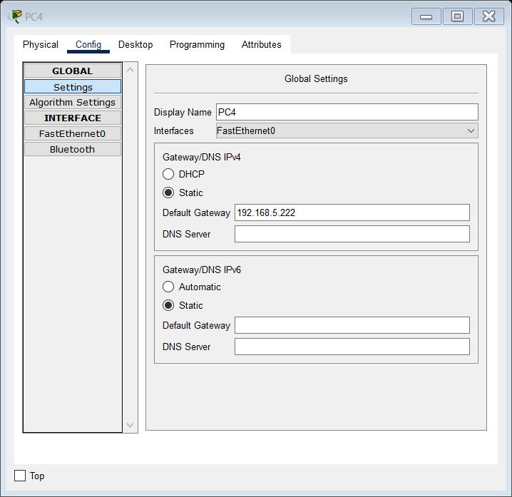

Let us configure static routes on R1 and R2 so that these PCs can ping each other.

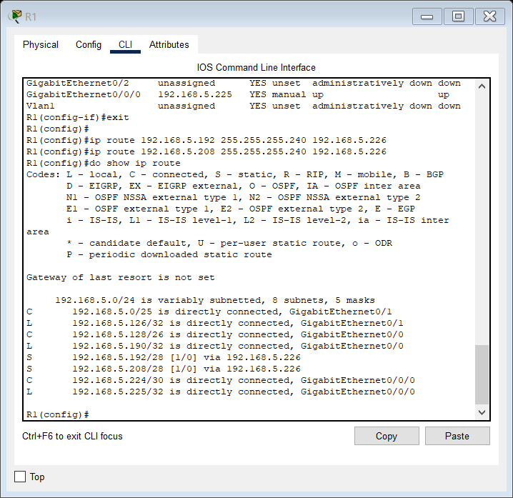

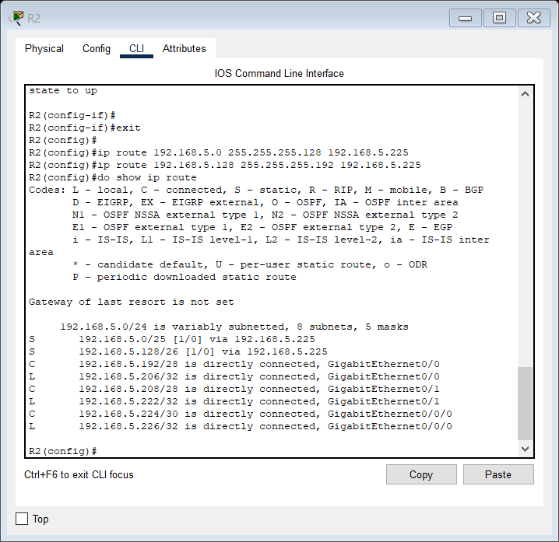

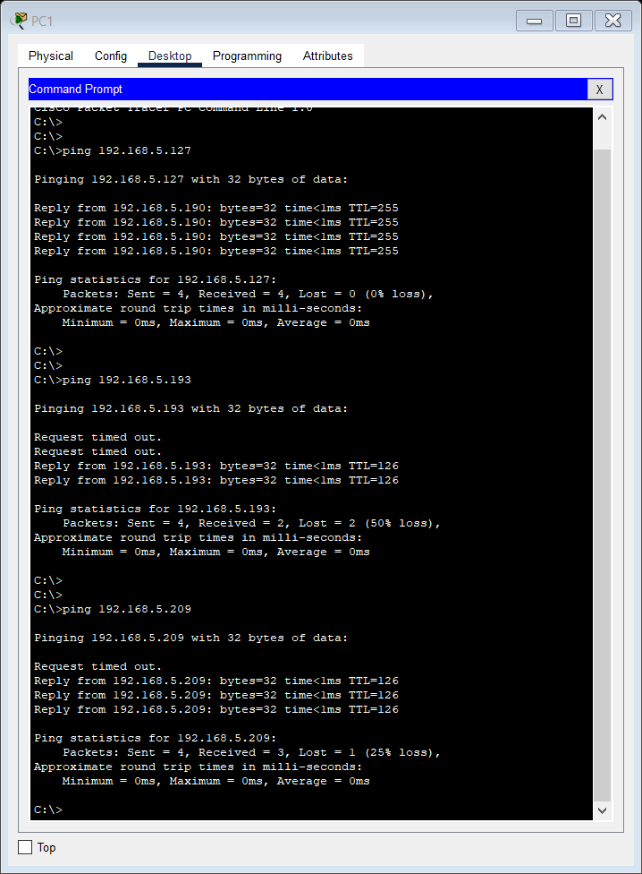

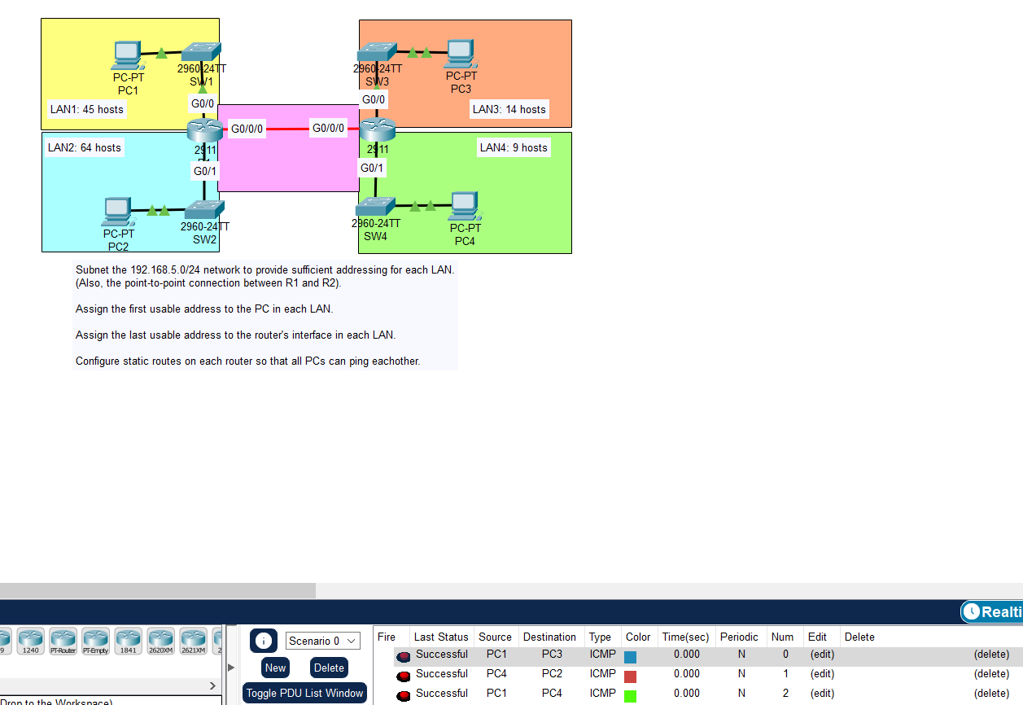

Lab successfully completed.

DAY 16 VLAN PART 1;

LAB

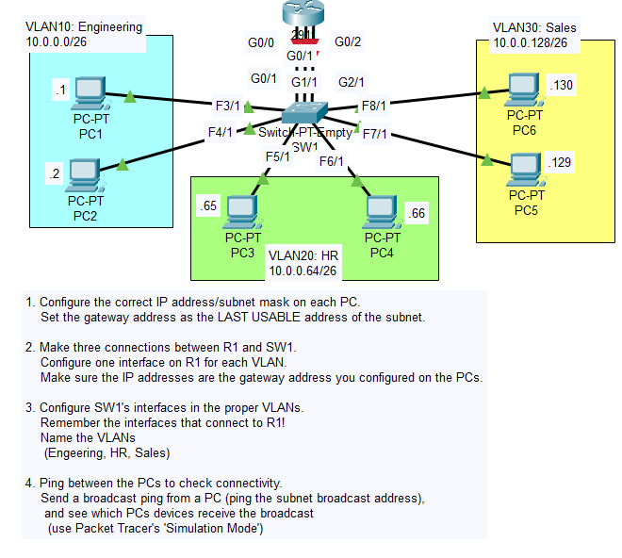

We will use a straight through cable to connect a Router and a switch.

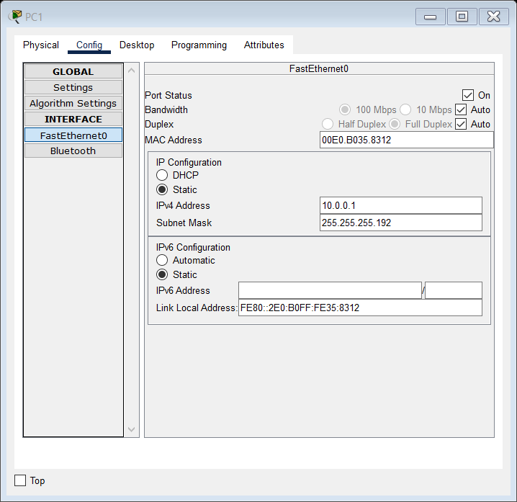

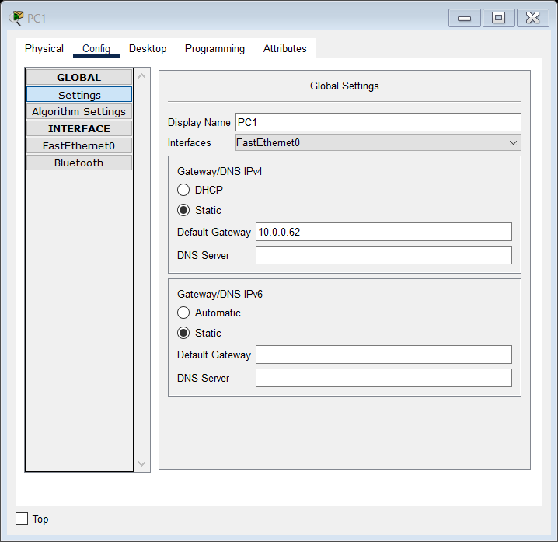

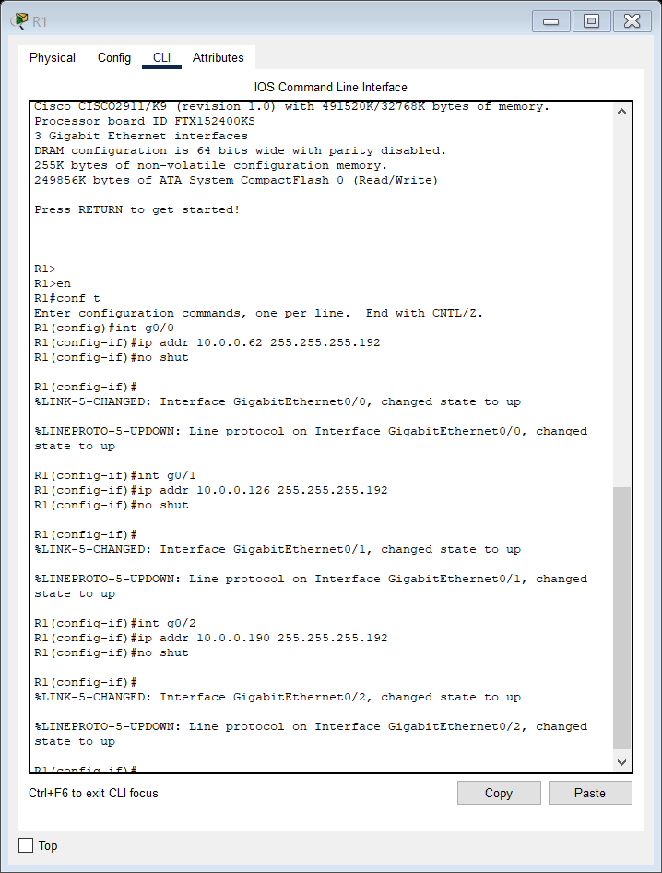

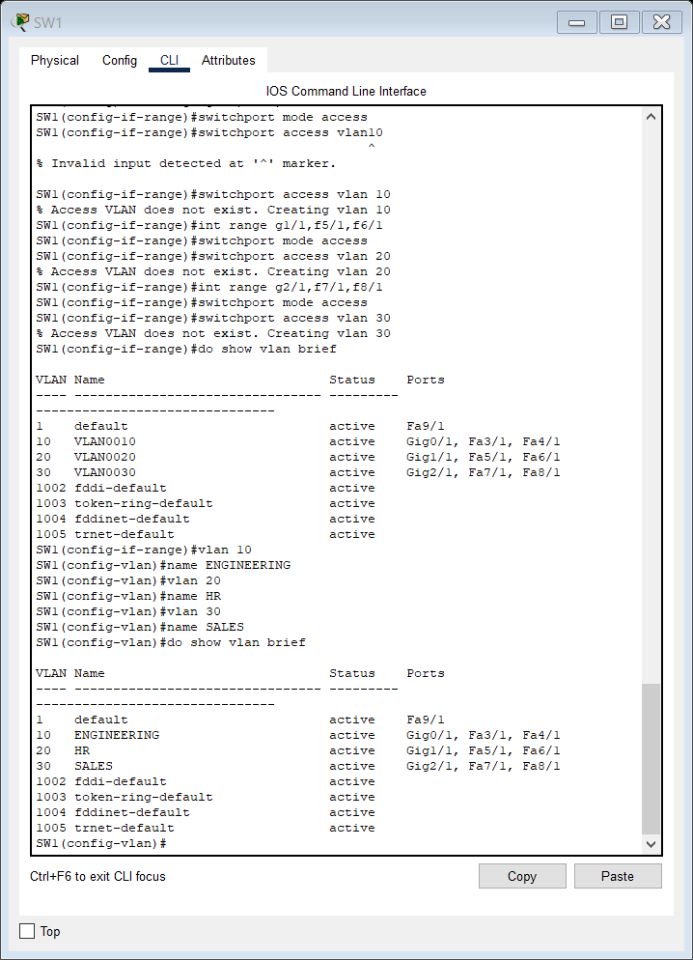

R1 will do the inter-VLAN routing for us as we will see in the simulation mode.

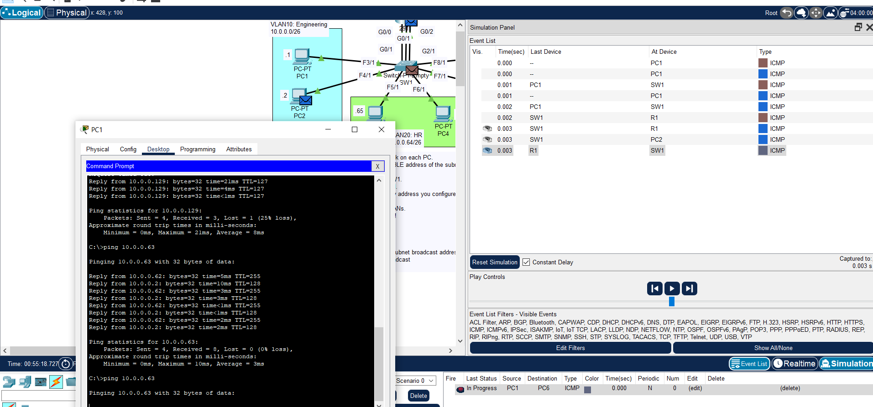

When we ping broadcast IP of 10.0.0.63, it only forwards it to R1s G0/0 and PC2 and we only get a reply from those as we should.

So we completed the Lab.

DAY 17 LAB VLAN PART 2 TRUNK PORTS

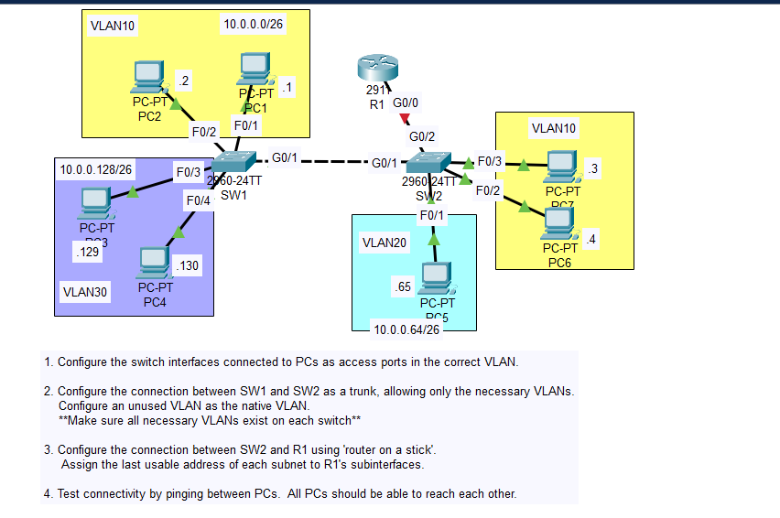

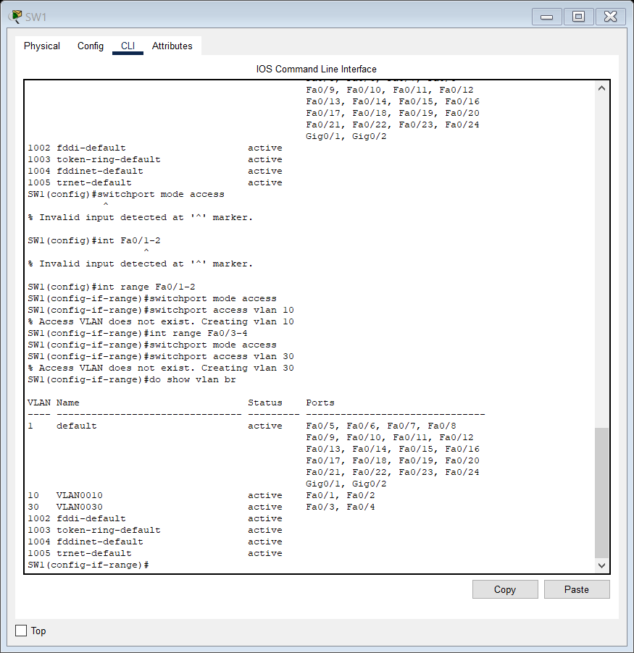

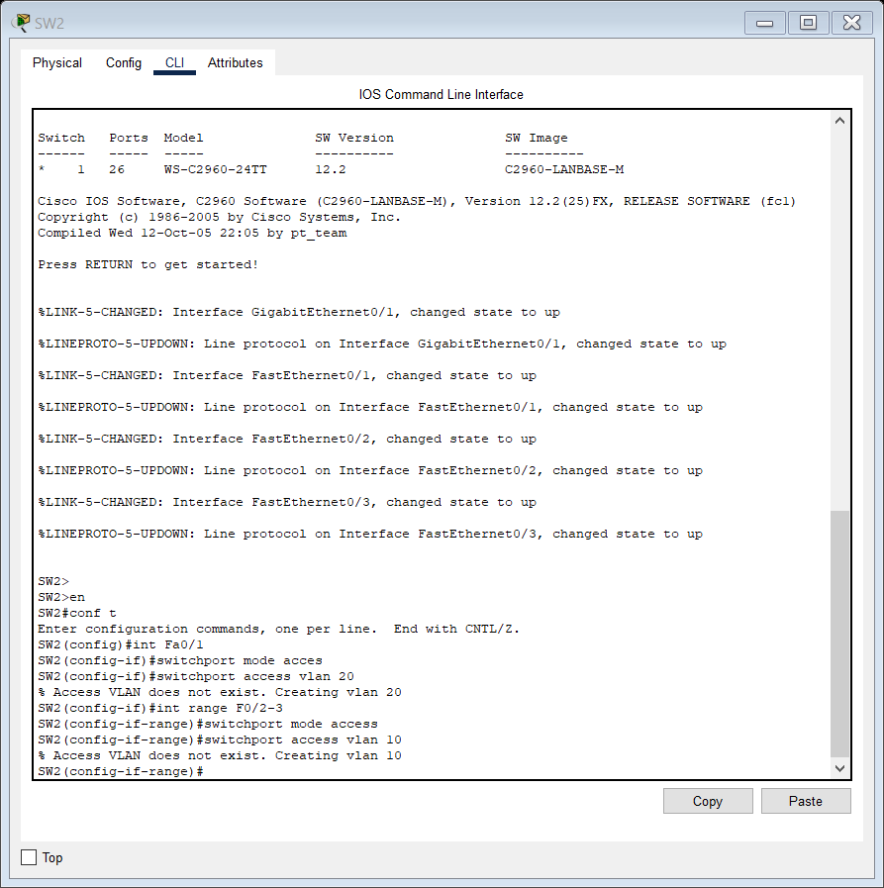

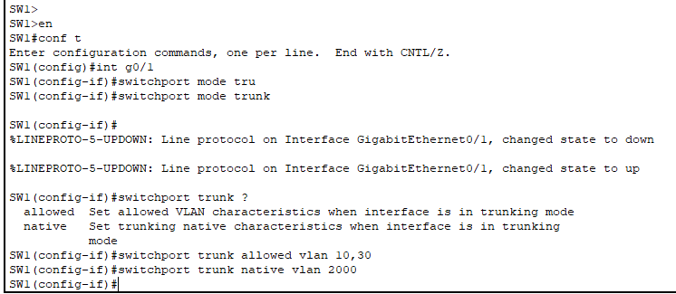

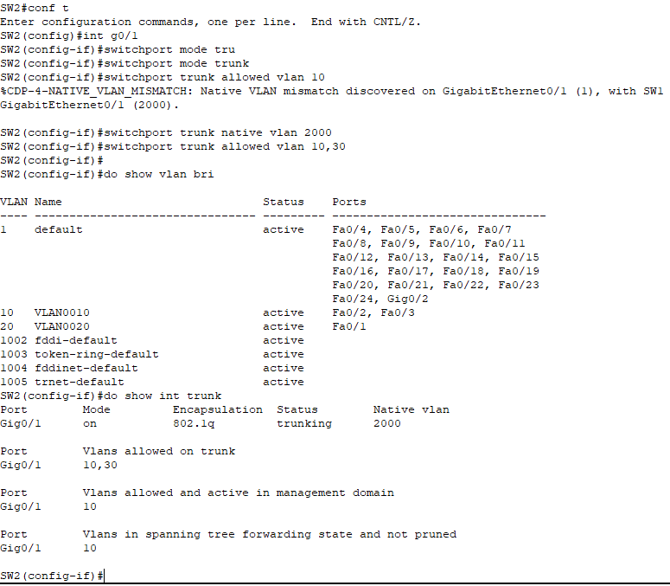

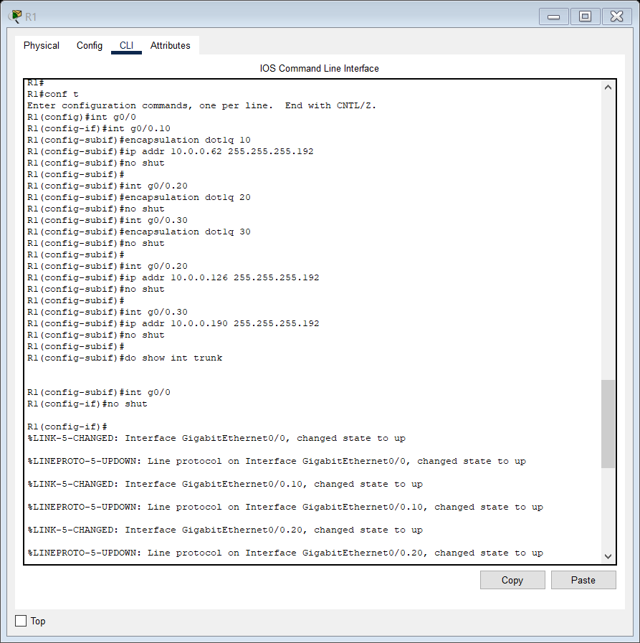

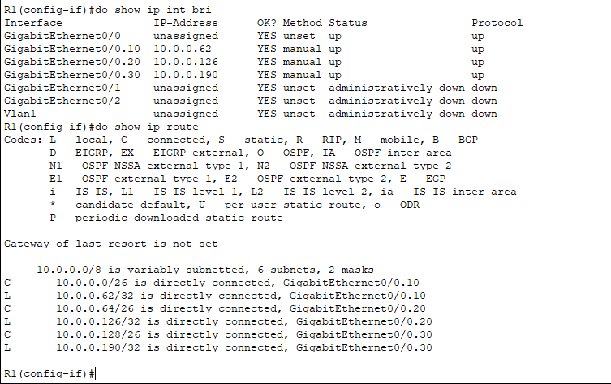

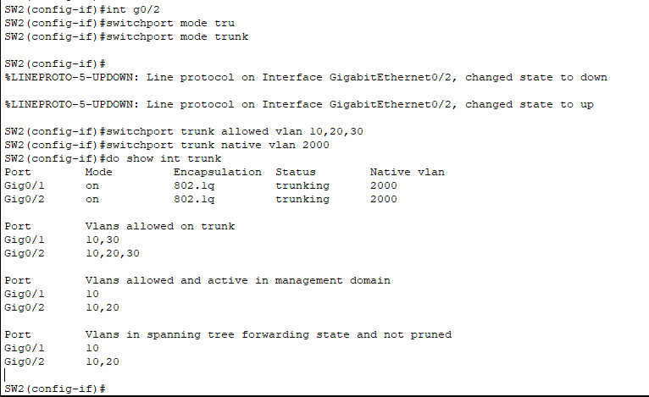

There was a problem with this that I fixed below.

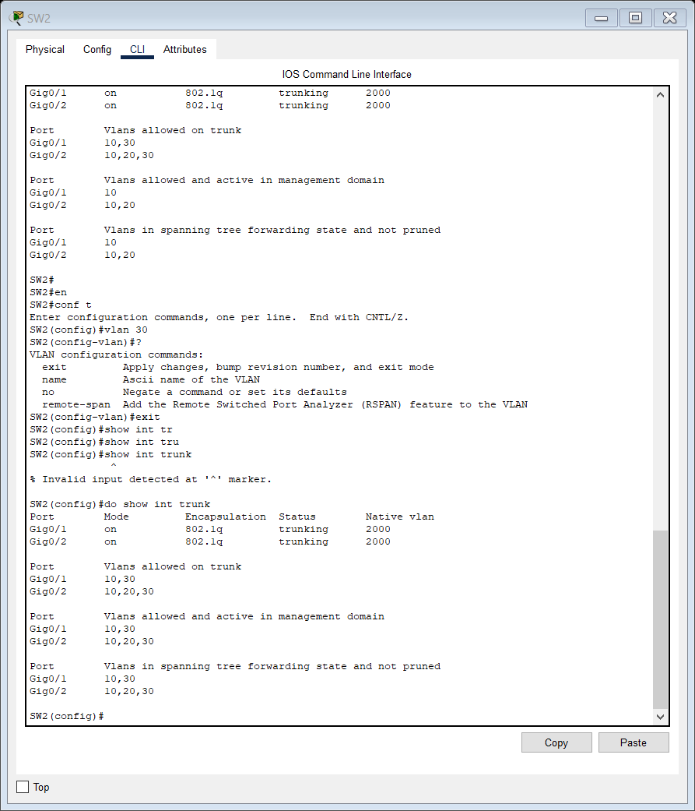

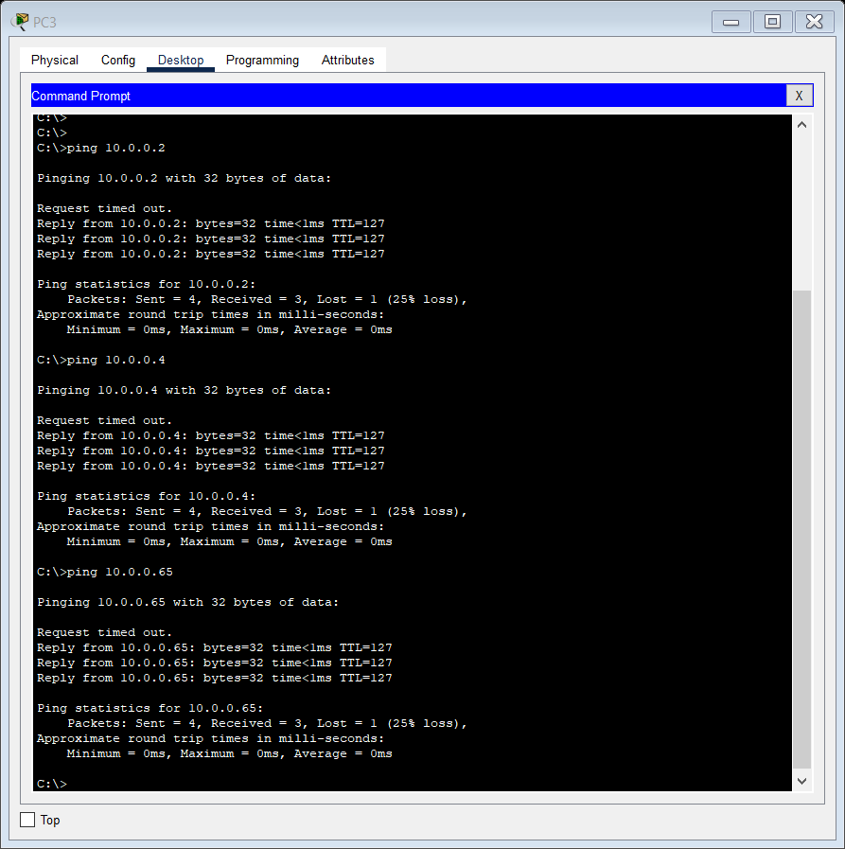

DAY 18 LAB MULTILAYER SWITCHING SVIs:

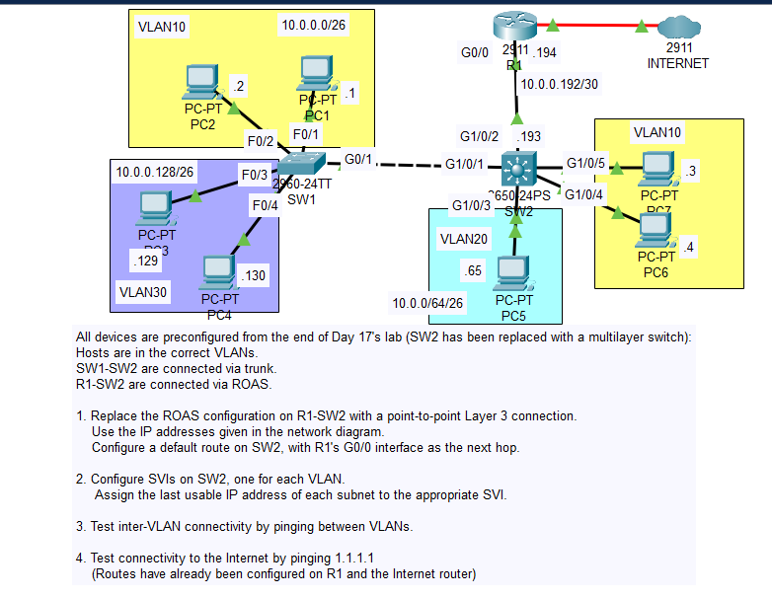

We will carry out all the 4 tasks now.

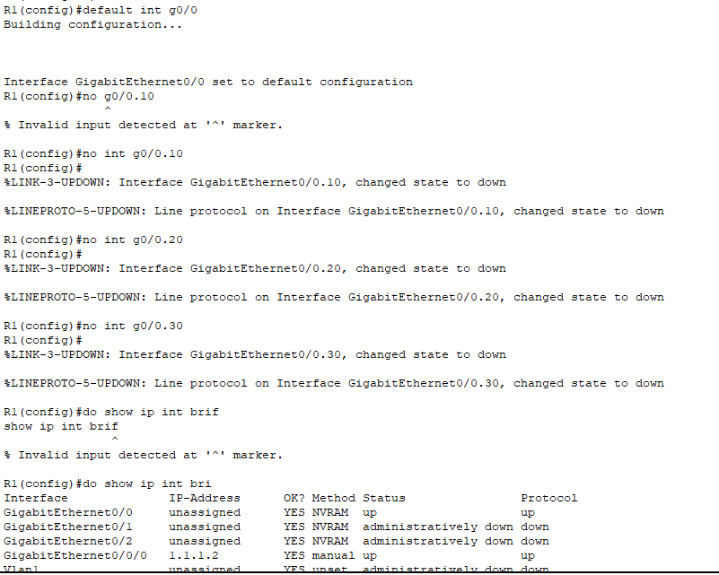

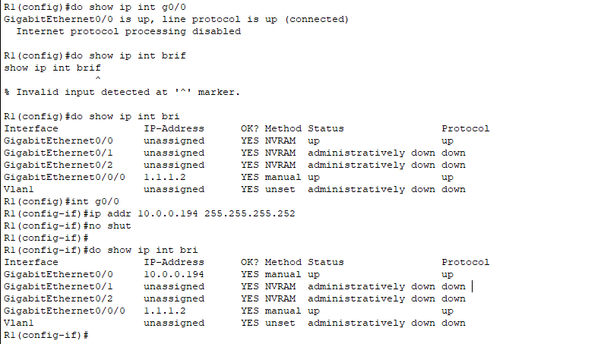

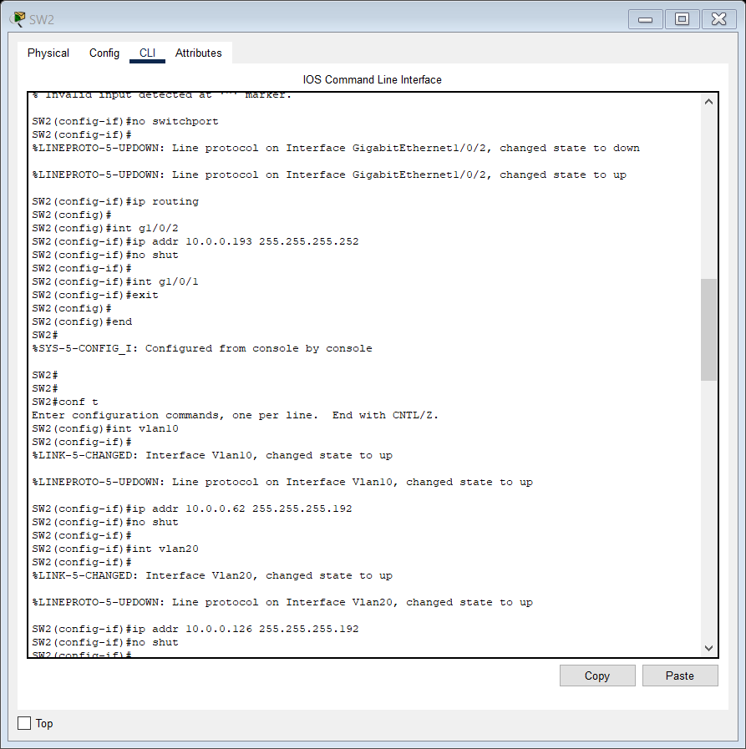

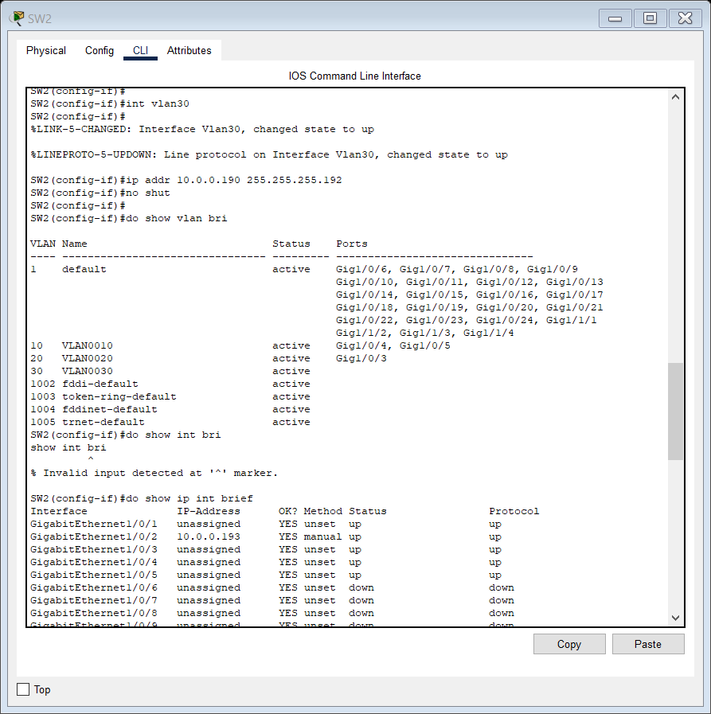

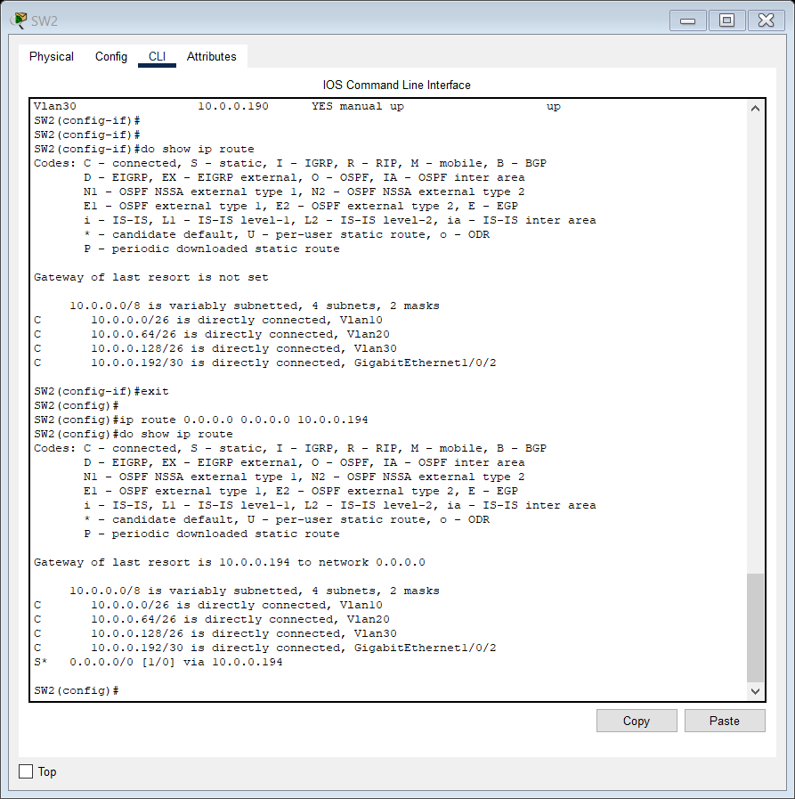

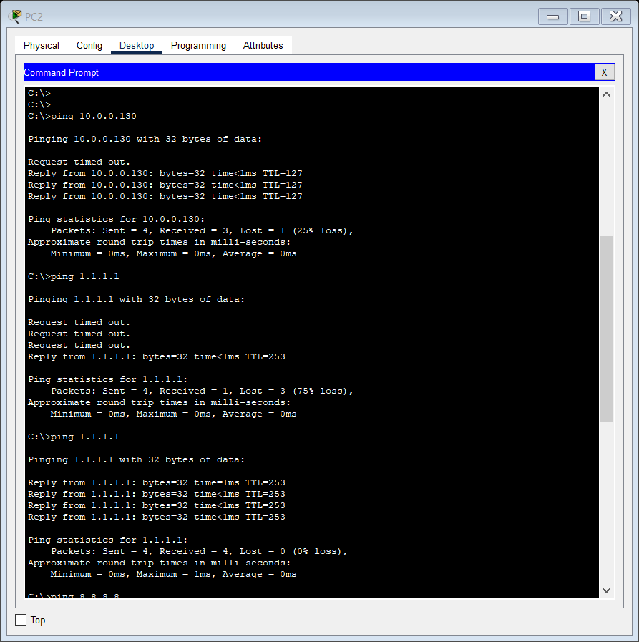

We looked at DTP first, which is a protocol that allows Cisco switches to form trunk connections

27:46

with other Cisco switches, without manual configuration. However, it’s recommended that you disable this protocol for security purposes.

27:56

Then we looked at VTP, another Cisco proprietary protocol that allows you to configure VLANs

28:01

on switches that operate as central VTP servers, which then advertise their VLAN database,

28:07

and VTP client switches sync their database to it.

28:12

Note that VTP only syncs the VLAN database, you still have to configure the interfaces on each switch separately, for example SWITCHPORT ACCESS VLAN 10, etc.

28:24

VTP does not automatically assign interfaces to VLANs. Both of these protocols are no longer on the exam topics list, but you should know about

28:33

them and their basic functions, you may get questions about them on the exam.

Access and dynamic auto, same thing. So, dynamic auto can form a trunk but it won't actively try to form a trunk unless the other

33:22

end is trying to form a trunk. So, that will be access. Access and dynamic desirable.

33:29

Although this end is trying to form a trunk, this end will not, so that is access.

DTP/VTP LAB 19 DAY 19:

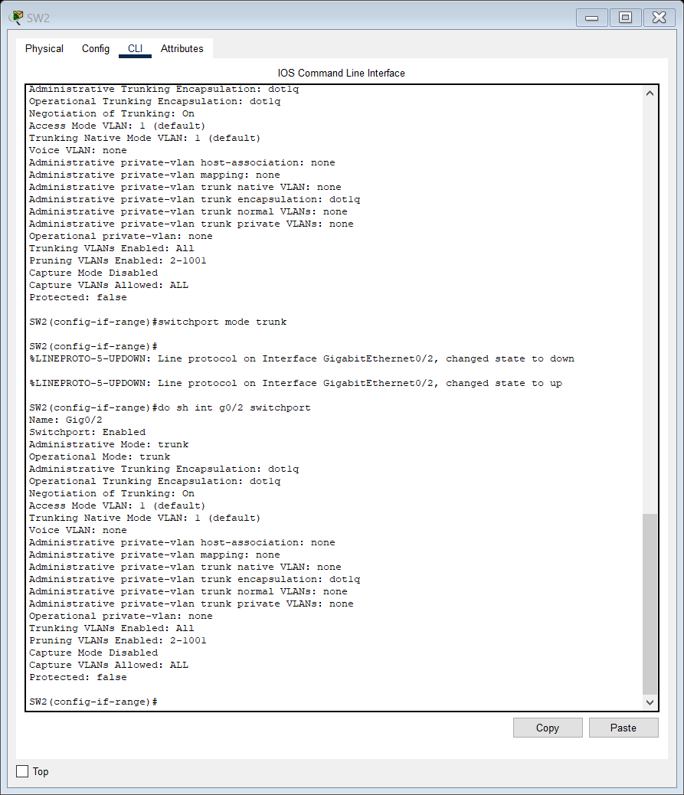

Also add switchport nonegotiate command to disable Negotiation of Trunking that is DTP on all the switches.

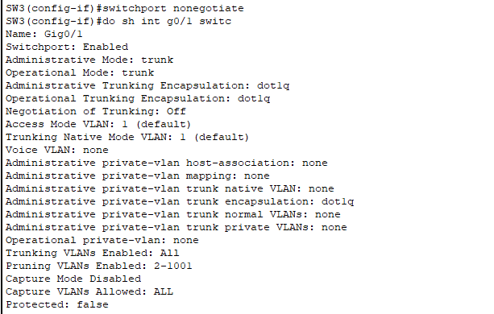

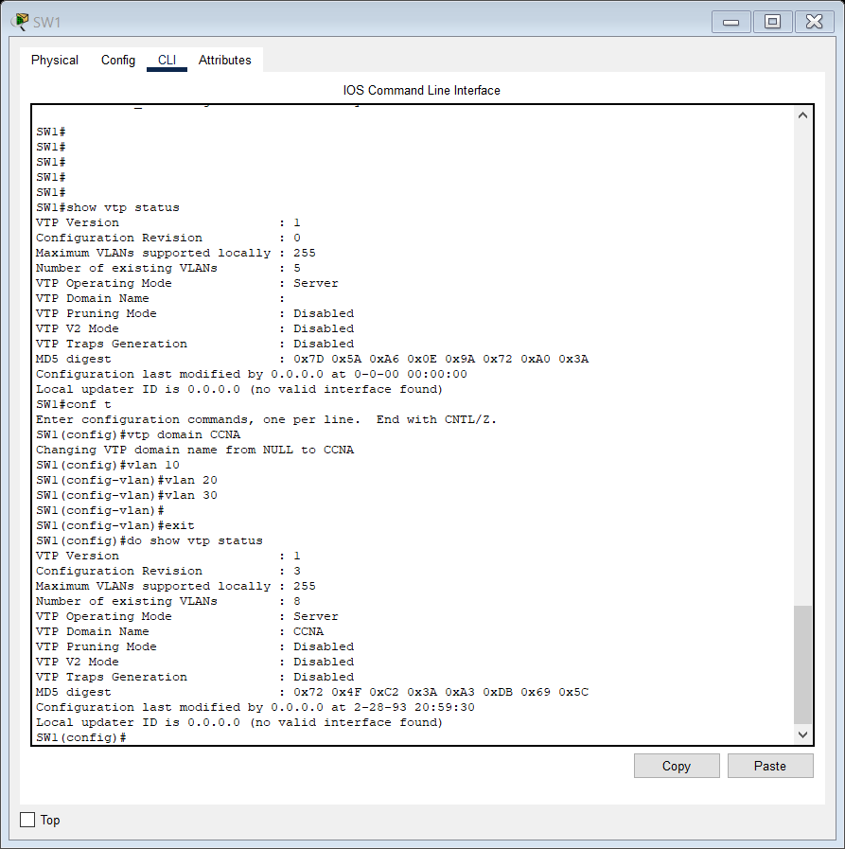

SW2 and SW3 have synched their VLAN databases to SW1 as soon as we configured SW1 as shown in the following screenshot.

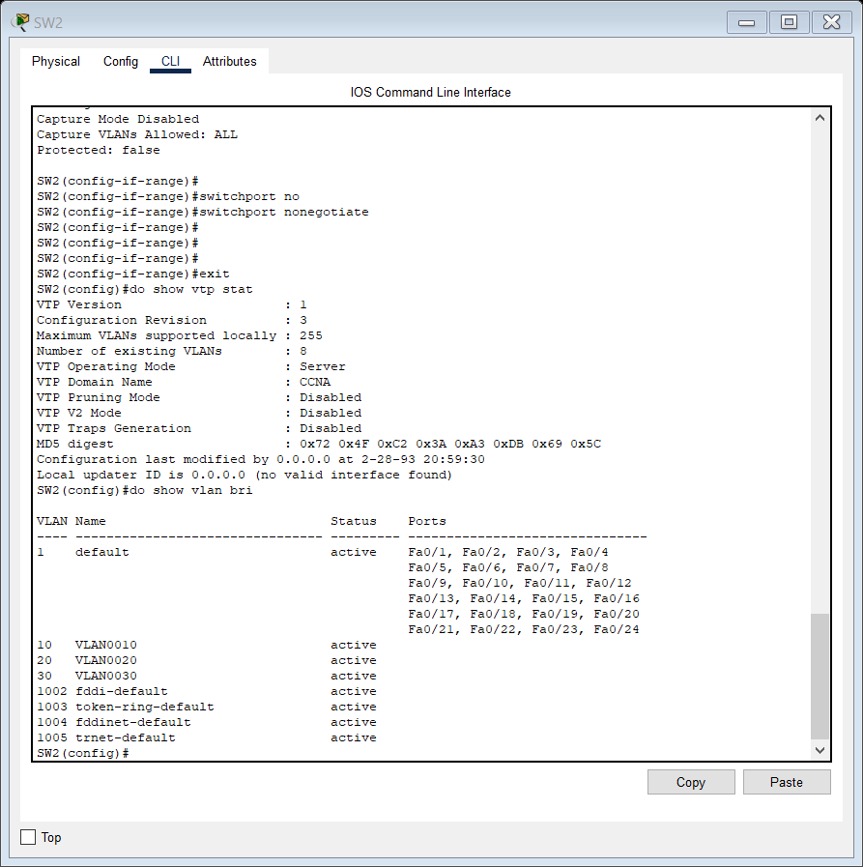

Changing SW2 to Transparent mode.

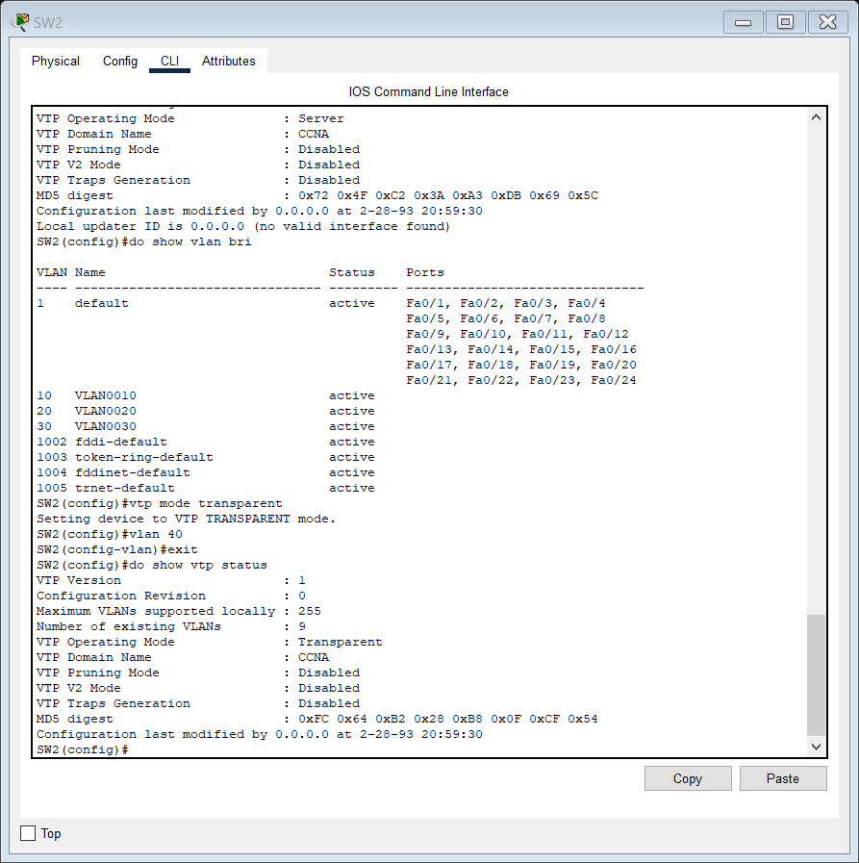

The other switches will not have added VLAN 40 as SW2 will not advertise its VLAN database to other servers or client switches but it will forward VTP advertisements between SW1 and SW3.

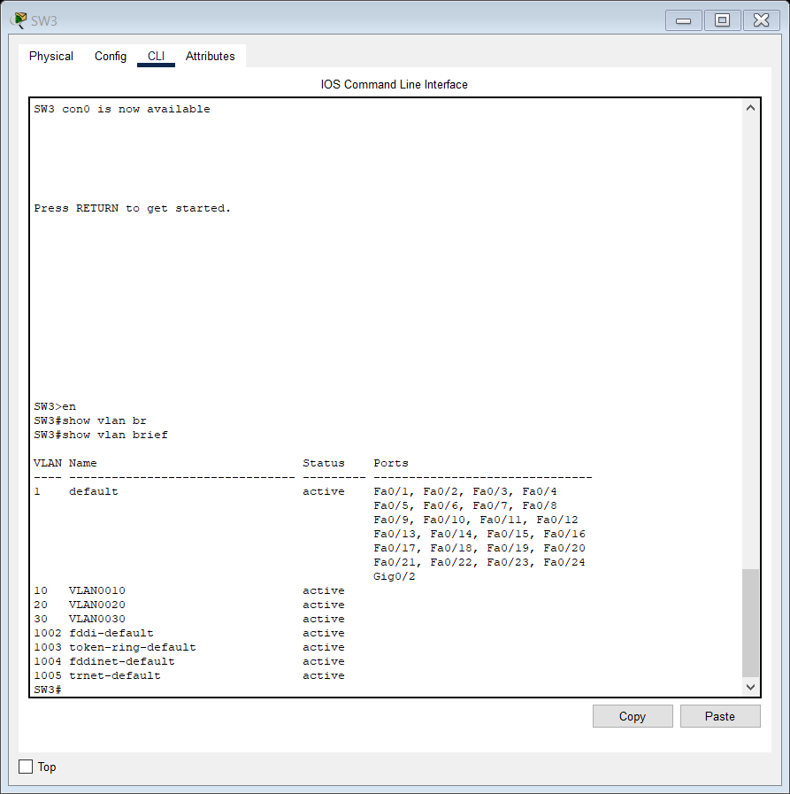

As we can see, SW3 has not added VLAN 40.

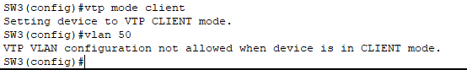

No VLAN 50 is not added to SW3.

So, if we want to add new VLANs on SW3, we have to configure them on SW1, which will advertise the changes to SW3, which will then sync its VLAN database.

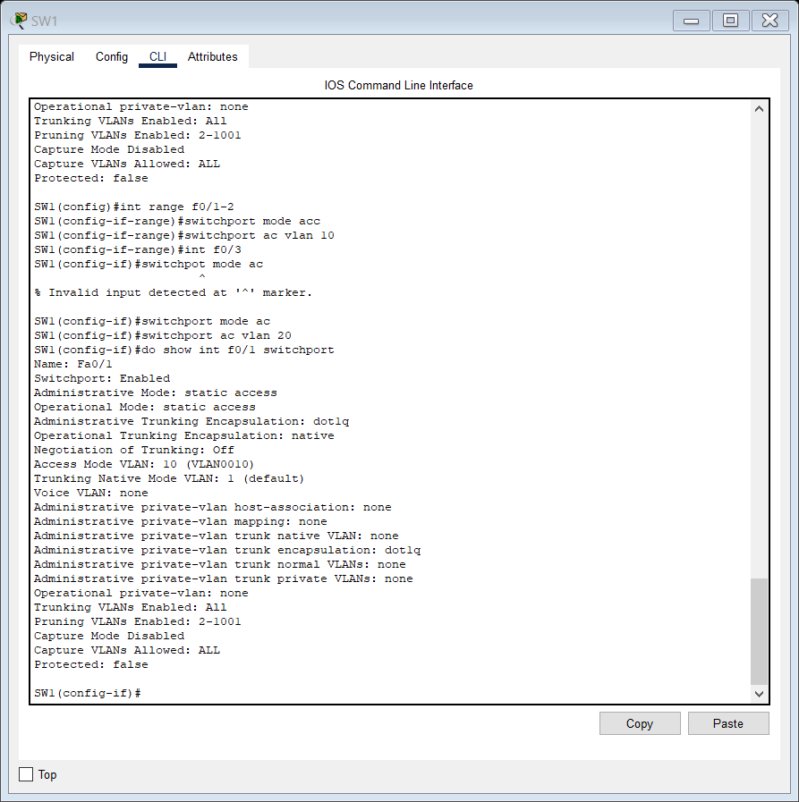

 I want to show you one more feature of VTP

that I didn’t mention in the lecture video, it’s the VTP password.

A switch will reject any VTP advertisement if the password doesn’t match.

So, let’s go back on SW1.

I’ll set the password with this command: VTP PASSWORD, and I’ll make it cisco.

Now let’s make another VLAN.

VLAN 50.

exit.

DO SHOW VTP STATUS.

So, the revision number is now 4, and the number of VLANs is 9.

Let’s go see if SW3 accepts this advertisement. DO SHOW VTP STATUS.

So, SW3 has a revision number of 3 and 8 VLANs, it has not accepted the advertisement.

What if I set an incorrect password?

VTP PASSWORD CCNA.

DO SHOW VTP STATUS.

It still doesn’t accept the advertisement.

Now let’s set the correct password.

VTP PASSWORD cisco.

DO SHOW VTP STATUS.

Okay, you can see SW3 has now accepted the advertisement and synced with SW1.

Just wanted to show you that extra feature of VTP.

That’s all for this lab.

NOW,

I WILL ADD A ROUTER TO THE ABOVE TOPOLOGY TO PRACTICE INTER-VLAN ROUTING USING ROAS.

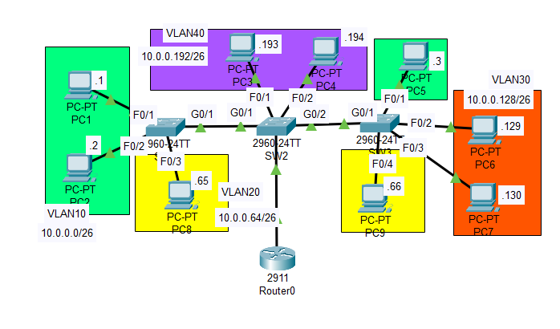

Now our aim is to perform inter-VLAN routing and test connectivity.

So we go on Router0 to configure it.

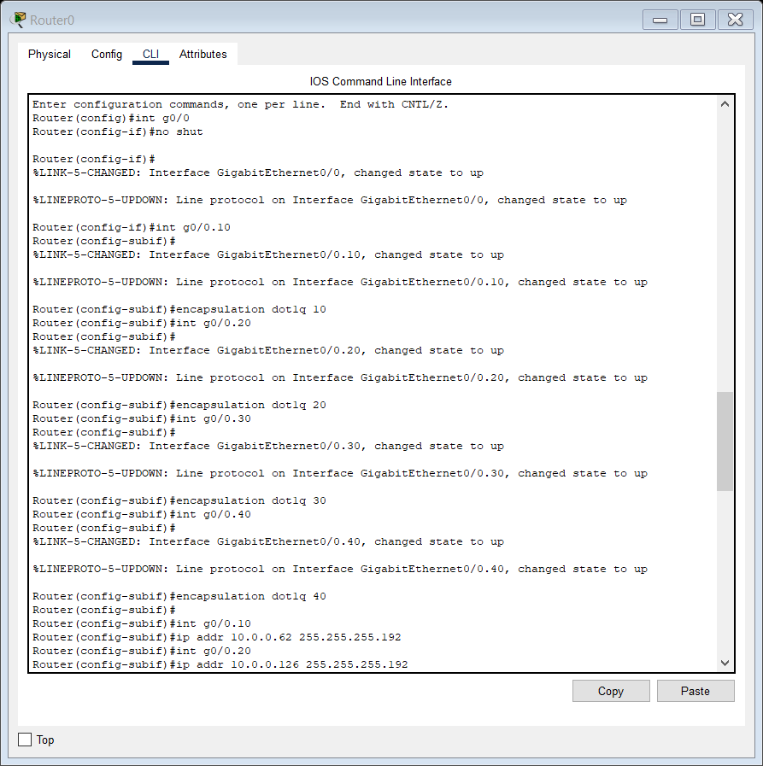

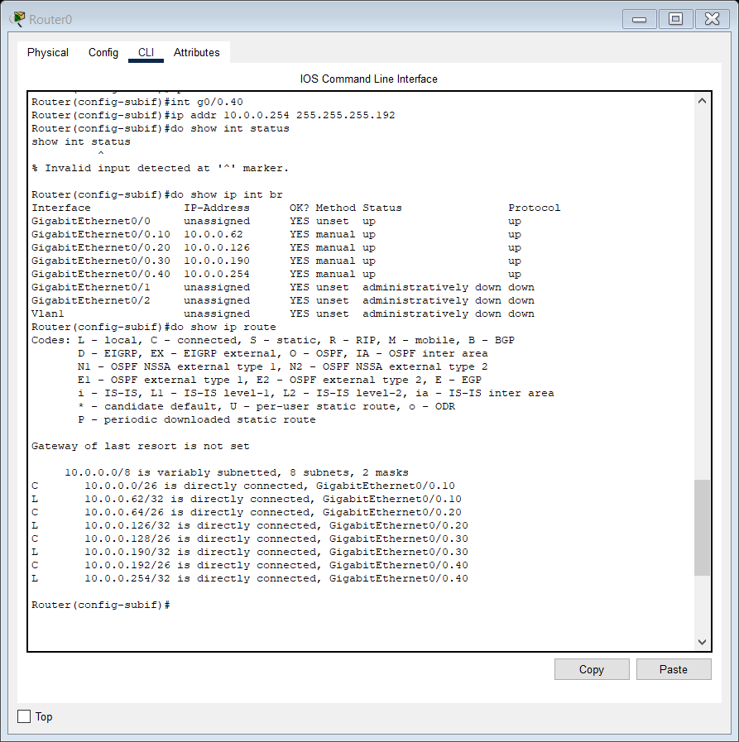

We have already configured the access ports on all switches for every VLAN. Now let us configure trunk ports on all switches.

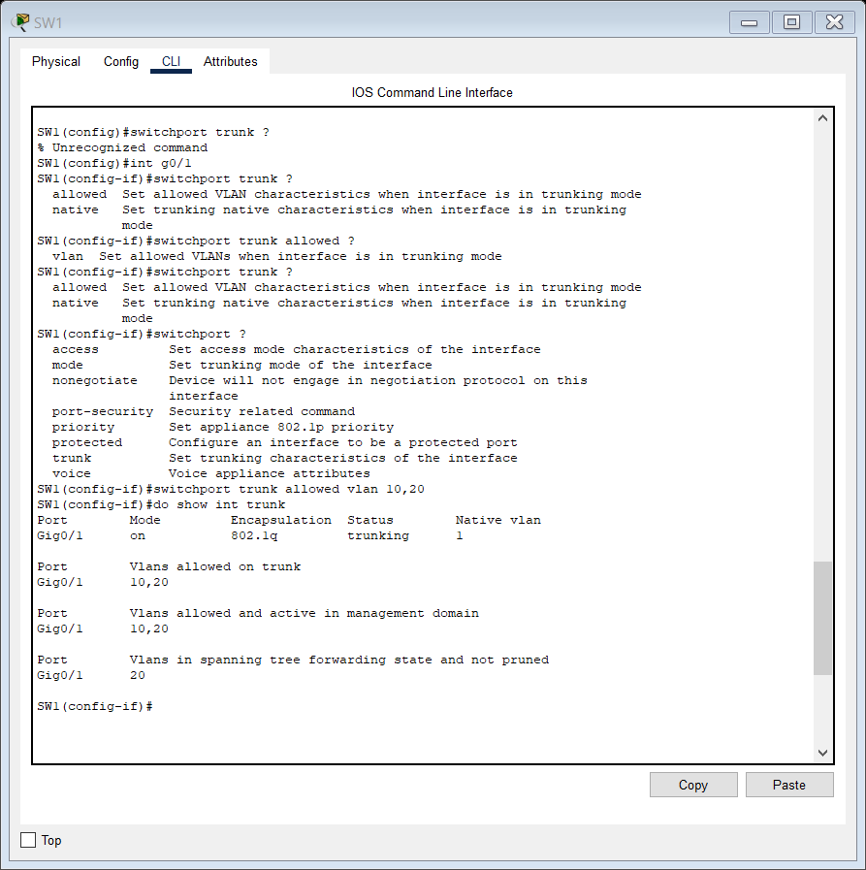

On SW2:

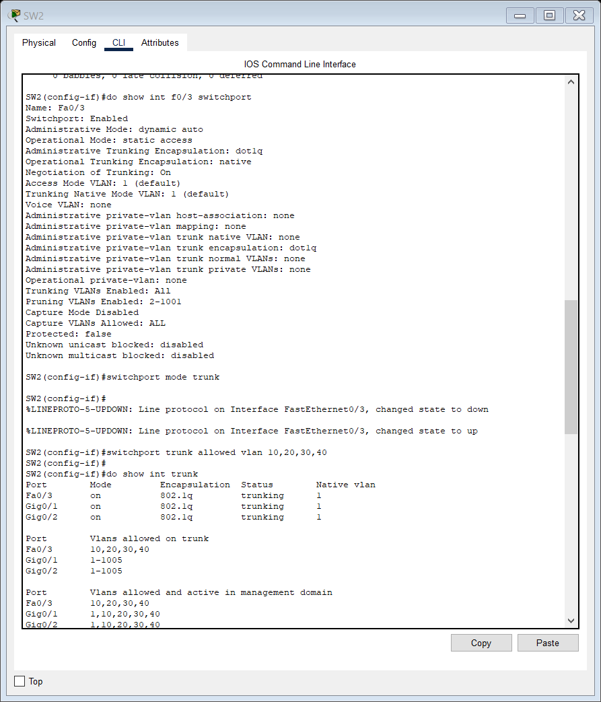

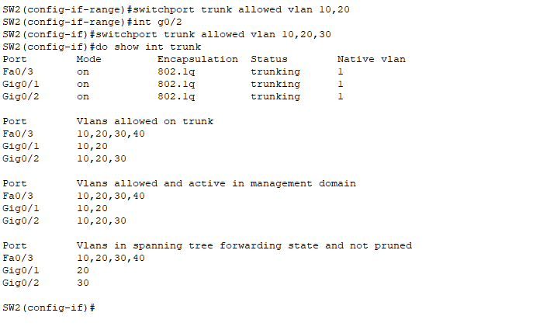

And on Switch 3:

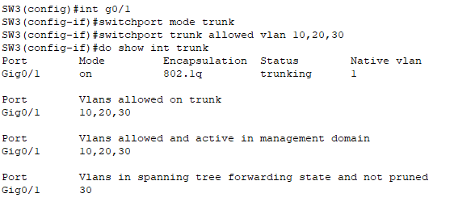

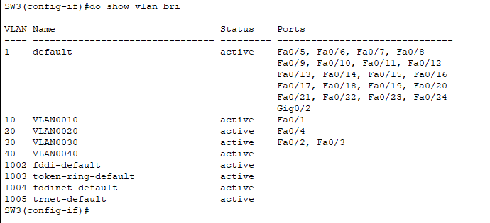

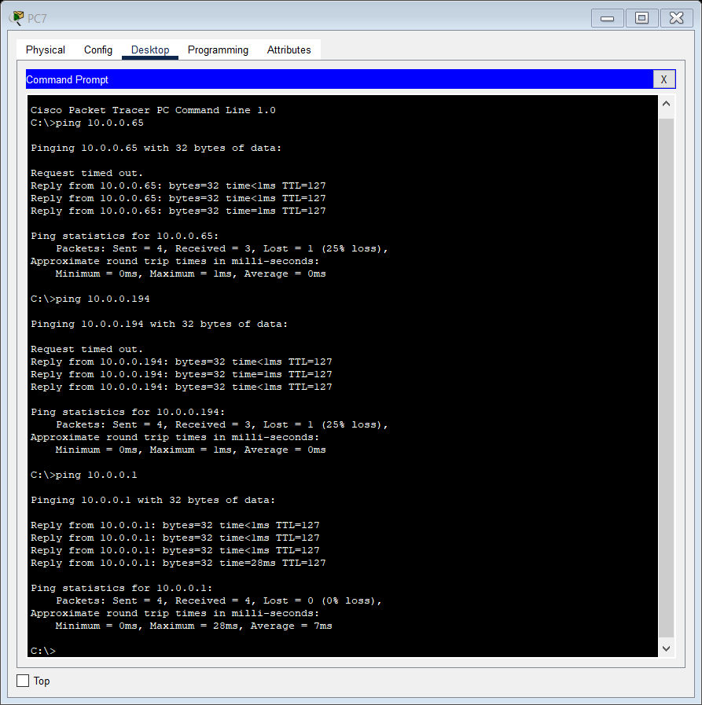

So we could perform inter-VLAN routing using ROAS on our own. Pretty POG if you ask me.

DAY 20 LAB ANALYZING STP:

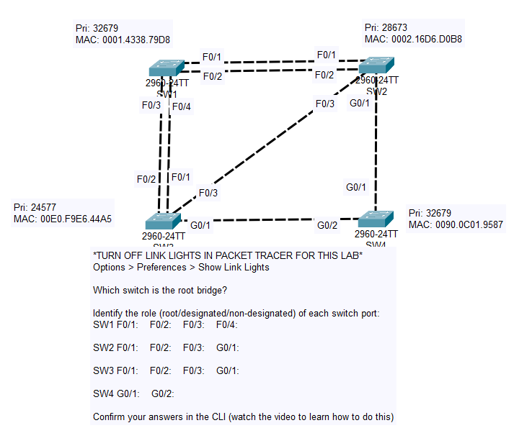

Root bridge: SW3 (cause lowest Bridge priority)

SW3 F0/1: Designated F0/2: Designated F0/3: Designated G0/1: Designated

SW1 F0/1: Non Designated (N) F0/2: Non Designated F0/3: Non designated (N) F0/4: Root port

SW2 F0/1: Designated F0/2: Designated F0/3: Non Designated(N) G0/1: Root port

SW4 G0/1: Designated (Connected to root port is always designated) G0/2: Root port

In this case the answer is fairly obvious, SW3 has the lowest priority, 24577, so it

will be the root bridge.

So, we now know port role of each interface on SW3, all of its interfaces must be designated ports because it is the root bridge.

Just to make things easier to remember, let me make labels.

Click on the note button up here, and let me make 4 Ds, for designated.

Okay, and after you have made them let’s move them into position.

Okay, so all four interfaces on SW3 are designated ports.

Next up, let’s find the root ports.

Each other switch in the topology must have a single root port.

The first criteria to determine the root port is the root cost, the interface with the lowest

root cost will become the root port.

How about SW1?

Via either F0/1 or F0/2 it would have a cost of 19, plus 4 for SW1’s G0/1, and plus 4 for

SW4’s G0/2, so 27.

Via f0/3 or f0/4 it has a cost of just 19.

So, it will be either F0/3 or F0/4, but we don’t know which so let’s look at the

tiebreaker, neighbor bridge ID.

Well, both are connected to the same switch, SW3, so that is a tie as well.

The final tie breaker is the neighbor switch’s port ID, the lowest one wins.

It’s important to remember that this isn’t the LOCAL switch’s port ID, it’s not SW1’s

port ID.

It’s the neighbor switch’s port ID, SW3’s port ID.

F0/1 is lower, so that means SW1’s F0/4 interface will be the root port, let me create

that label. And then I will move it over to SW1.

Okay next, which will be SW2’s root port?

F0/3 is directly connected to the root bridge, so it might look obvious that this will be the root port, however

via F0/3 it has a root cost of 19.

Via G0/1 it has a root cost of 4, plus 4 for SW4’s G0/2, so only 8.

Therefore, G0/1 will be the root port.

That also means we can label SW4’s G0/1 interface as designated, the interface connected

to a root port is always designated.

So, SW4’s root port is now obvious, since G0/1 is designated, it’s other port, G0/2,

5:18

must be the root port.

5:20

It also has a very low cost, only 4.

5:24

Okay, so we have found and labeled all of the root ports.

5:28

Next up, in each remaining collision domain we must determine which side will be designated

5:34

and which will be non-designated.

5:37

First up, two very obvious ones.

5:39

SW1’s F0/3 is connected to the root bridge, so it must be non-designated.

5:45

The same goes for SW2’s F0/3, it is connected directly to SW3, so it is non-designated. SW3's port is already designated.

5:54

All that remain are F0/1 and F0/2 on SW1 and SW2.

6:00

The first criteria is the root cost.

6:02

The interfaces on the switch with the lower root cost will be designated, the other side

6:07

will be non-designated.

6:09

SW1's root cost is 19, via F0/4.

6:14

However SW2’s root cost is 8 via G0/1.

6:17

So, SW2 has the lower root cost, therefore its F0/1 and F0/2 interfaces will both be

6:23

designated.

6:25

The other side, SW1’s F0/1 and F0/2, will both be non-designated, in a blocking state.

6:33

Now that we’ve figured out the answers, let’s actually check by using the CLI.

STP CLI COMMANDS:

show spanning-tree

for a specific VLAN:

show spanning-tree vlan 1 (since there is only one VLAN)

With more details:

show spanning-tree details

This lists each VLAN, and shows how many interfaces are in each STP state:

show spanning-tree summary

By the way, something I should have mentioned before, the COST displayed here(in show spanning-tree output) is just the cost of this interface, not the total root cost, so it only displays 4 here.

If you want to see the total root cost, use this command I showed you.

SHOW SPANNING-TREE DETAIL. (for total root cost)

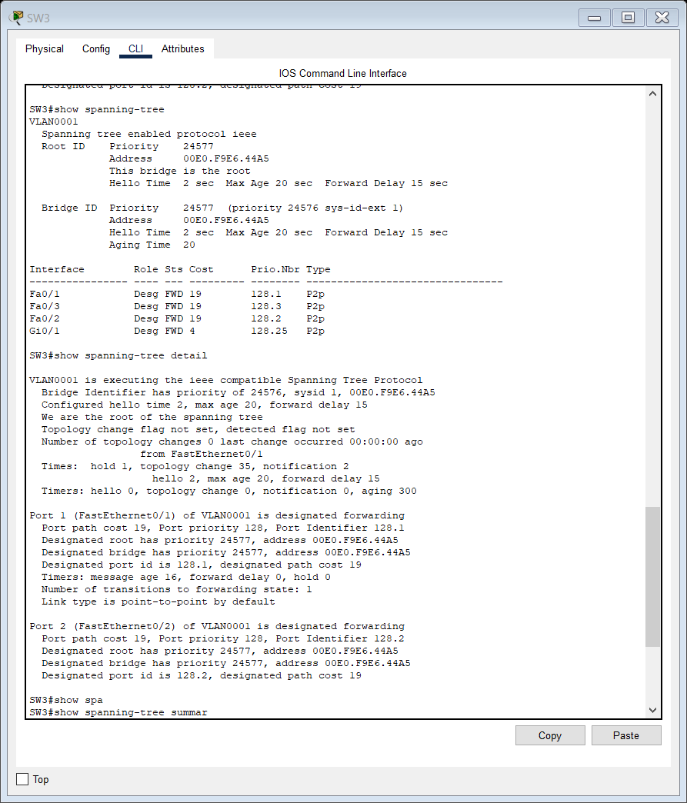

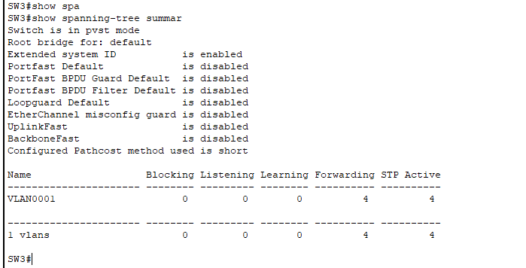

On SW1:

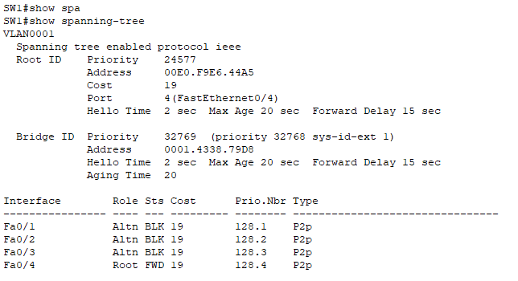

On SW2:

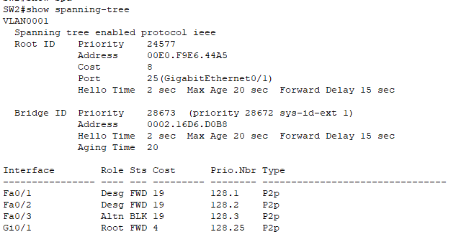

On SW4:

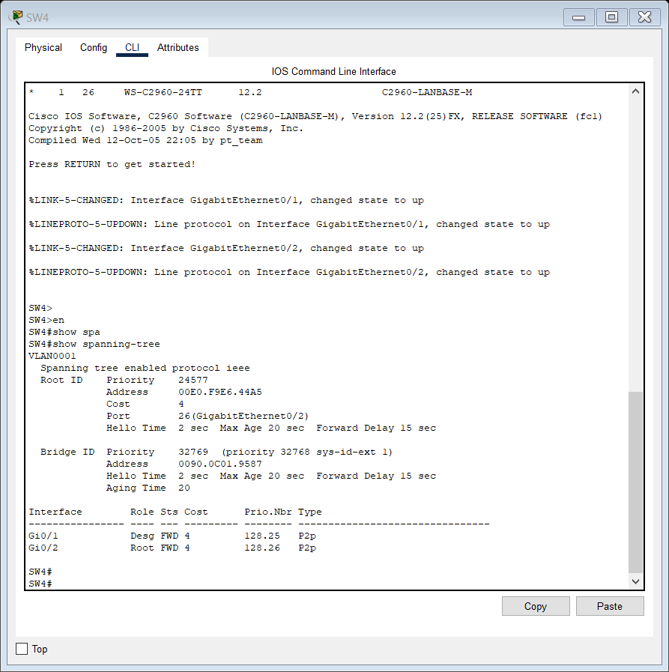

And we have confirmed our answers using CLI and explored STP commands.

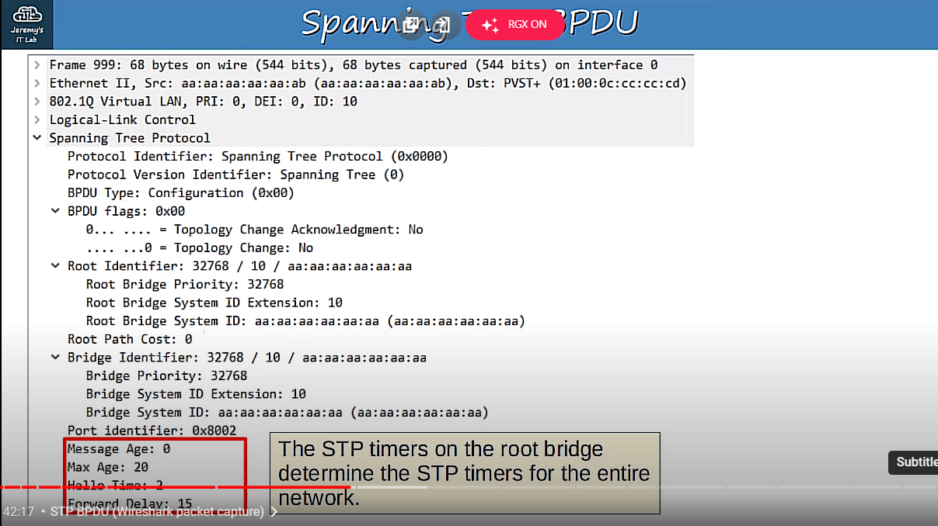

You can also know this is the root bridge by looking at this field. The information in the bridge identifier field is the same as in the root identifier field,

15:55

meaning this is the root bridge. After that is the port identifier, the interface which sent the BPDU.

16:03

It is hexadecimal 8 0 0 2. 8 0 in hexadecimal is equivalent to 128, which if you remember from day 20, is the default

16:14

port priority. 0 2 is the number of the port itself. Finally, the timers.

16:22

Message age is something I haven’t mentioned yet, but it starts at 0 at the root bridge

16:27

and is increased by 1 each time it is forwarded by another switch. It is subtracted from the max age when a switch receives the BPDU, so for example if the BPDU

16:38

is passed through 5 switches, when it reaches the 6th bridge it will immediately reduce

16:44

its max age timer to 15, meaning each time it receives a BPDU its max age will reset

16:50

to 15 instead of 20, even though the max age timer is 20. I don’t think that’s an important topic for the CCNA though, its a bit more advanced.

17:01

After that we have the three timers we talked about, max age, hello, and forward delay.

17:07

By the way, the spanning tree timers on the root bridge determine the spanning tree timers for the rest of the switches in the network, even if they are configured differently.

They are Root Guard and Loop Guard. If you enable root guard on an interface, even if it receives a superior BPDU (with a lower

24:25

bridge ID) on that interface, the switch will not accept the new switch as the root bridge.

24:30

The interface will be disabled. This helps maintain the spanning tree topology if someone plugs another switch into the network

24:38

either with bad intent, or perhaps without knowing the impact of their action.

24:44

If you enable loop guard on an interface, even if the interface stops receiving BPDUs,

24:50

it will not start forwarding. The interface will be disabled.

24:55

This prevents loops that can happen if an interface fails only in one direction, causing what is called a ‘unidirectional link’ that can’t receive data, but is still able

25:04

to forward it, or the opposite. So, those are two other optional spanning tree features.

25:10

However, as I said, You probably don’t have to know these spanning tree optional features (or others

25:16

such as UplinkFast, Backbone Fast, etc) for the CCNA.

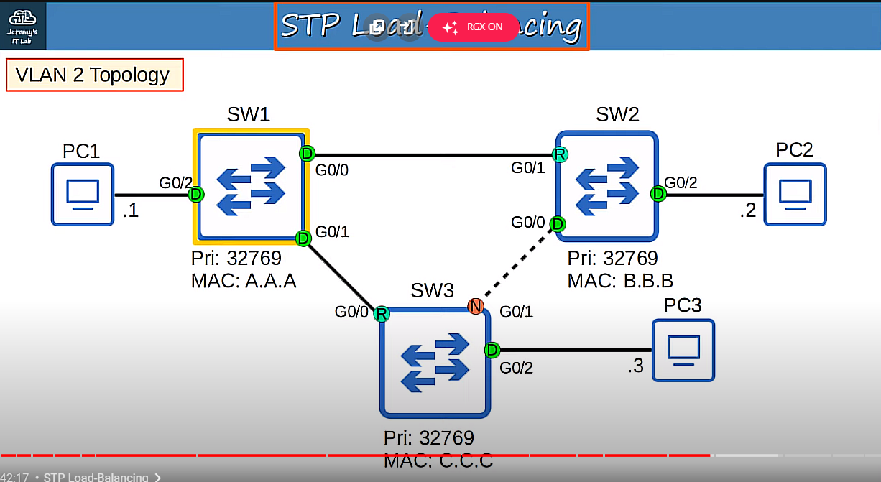

So, this is our topology now. The interface between SW1 and SW2 is disabled because SW1 is blocking its G0/0 interface.

28:58

This topology is running Cisco’s PVST+, so actually this is just the topology for

29:03

VLAN1. Perhaps there is another VLAN, VLAN 2, in this topology, what will the topology look

29:10

like for it? It will look like this, the default topology, because the root bridge settings we configured

29:17

only apply to VLAN 1. In VLAN 2, the connection between SW1 and SW2 WON’T be disabled, instead the connection

29:26

between SW2 and SW3 will be disabled. This allows for what’s called spanning tree load balancing.

29:34

If you have multiple VLANs in your network, blocking the same interface in each VLAN is

29:39

a waste of interface bandwidth. That connection will be doing nothing, just waiting for another connection to fail so

29:46

it can start forwarding. However, if you configure a different root bridge for different VLANs, different VLANs

29:53

will disable different interfaces.

**LAB 21 Configuring STP (PVST+)**

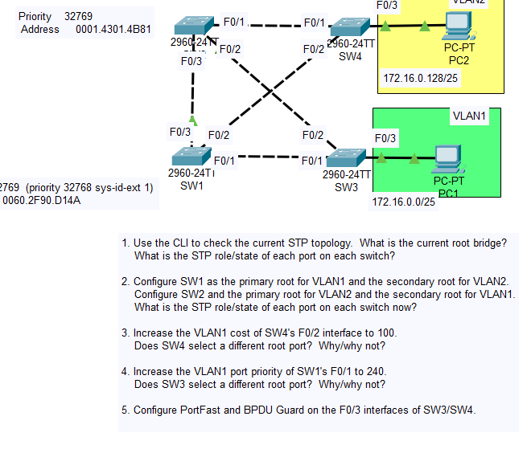

1.

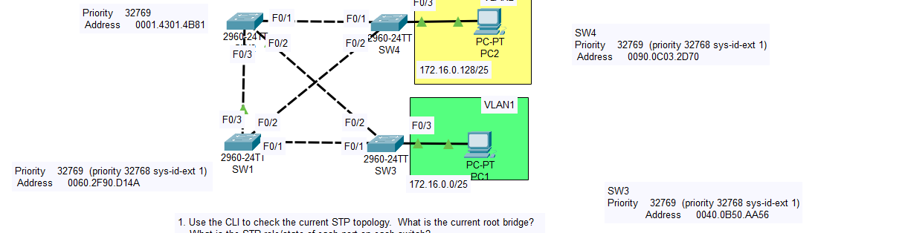

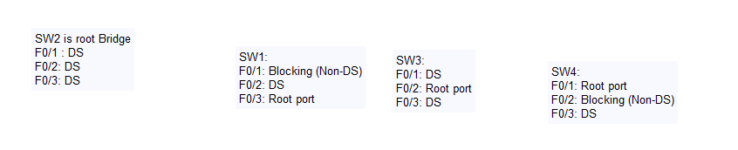

2.

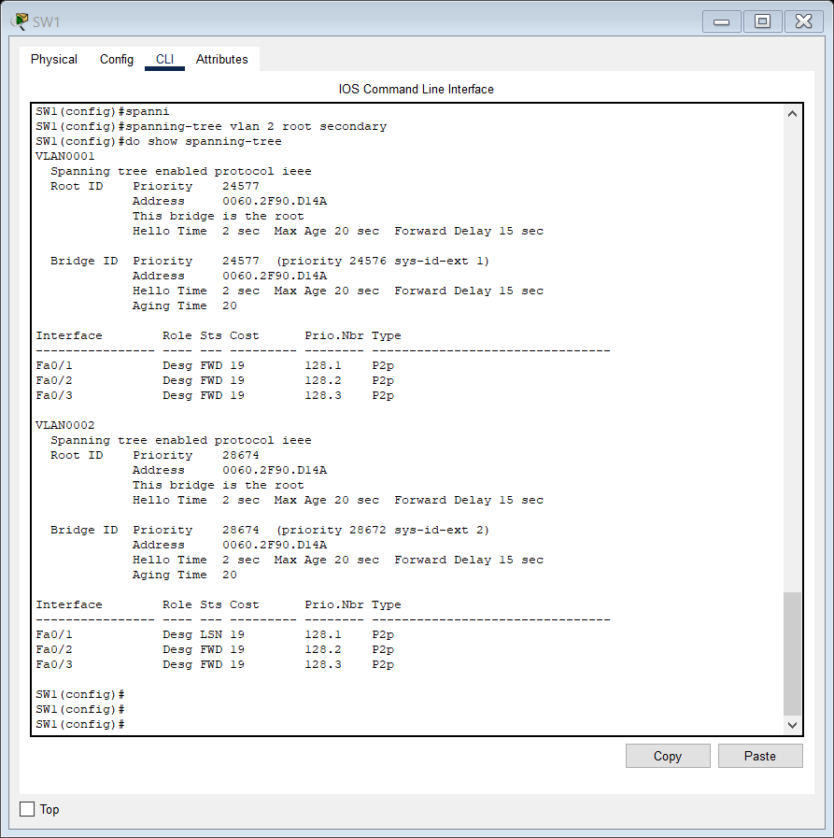

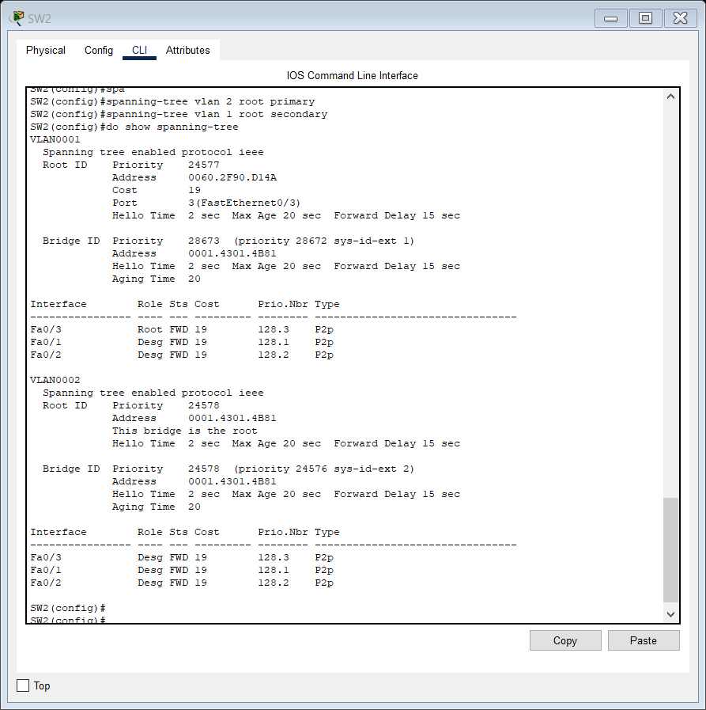

3.

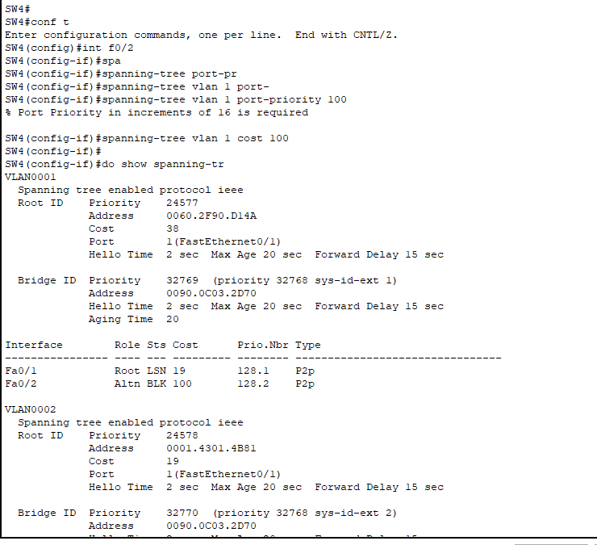

Yes SW4 chooses F0/1 as its root port now.

4.

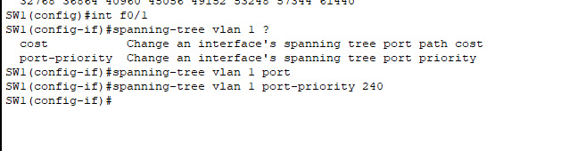’

Sender port ID is actually the last tiebreaker, after port cost and sender bridge ID.

So no SW3 does not select a different root port cause it doesn’t make a difference.

5.

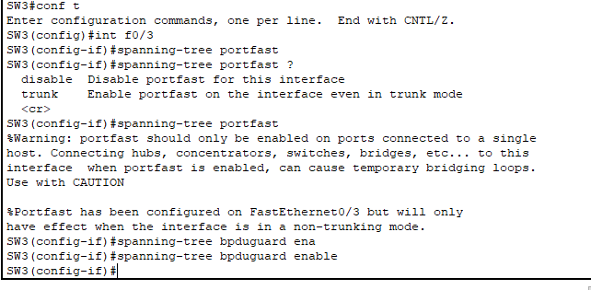

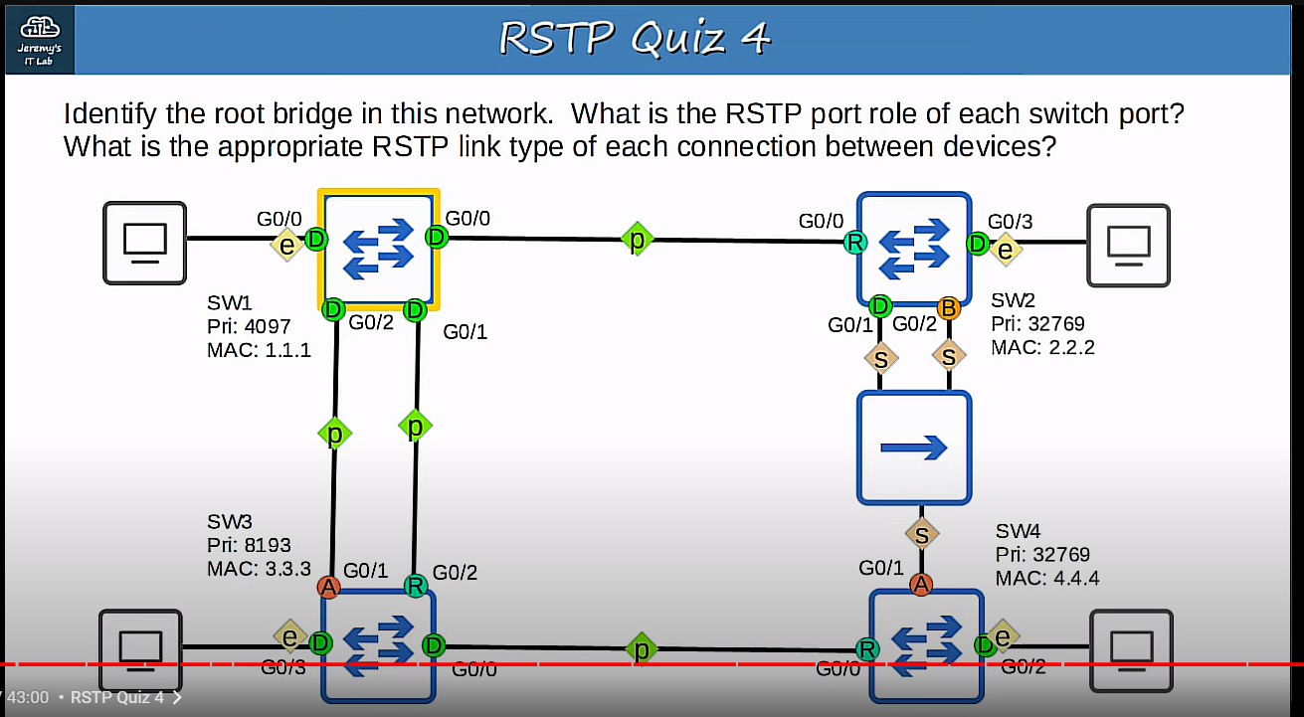

RSTP Quiz 4

SW1 is the root bridge,

G0/0: DS G0/1: DS G0/2: DS G0/3: DS

SW2:

g0/0: Root port G0/1: DS G0/2: Backup G0/3: DS

(Why was an interface on SW2 and not SW4 selected to be designated?

Because SW2 has the lower root cost.)

SW3:

G0/0: DS G0/1: Alternate G0/2: Root port (cause neighbor port ID G0/1 is lower) G0/3: DS

SW4:

G0/0; Root port G0/1: Alternate G0/2: DS

**DAY 22 LAB RAPID STP:**

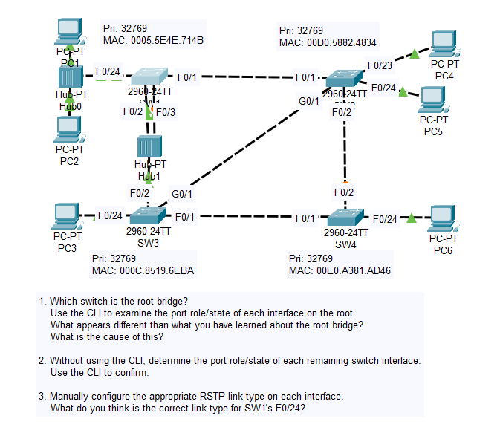

1. and 2.

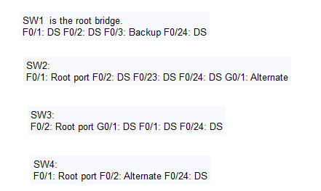

3.

SW1: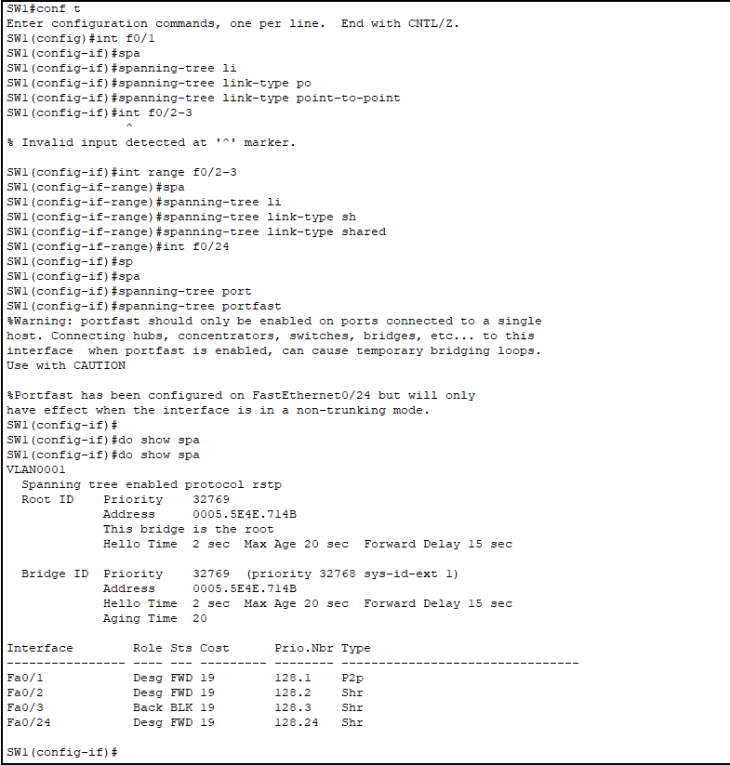

SW2

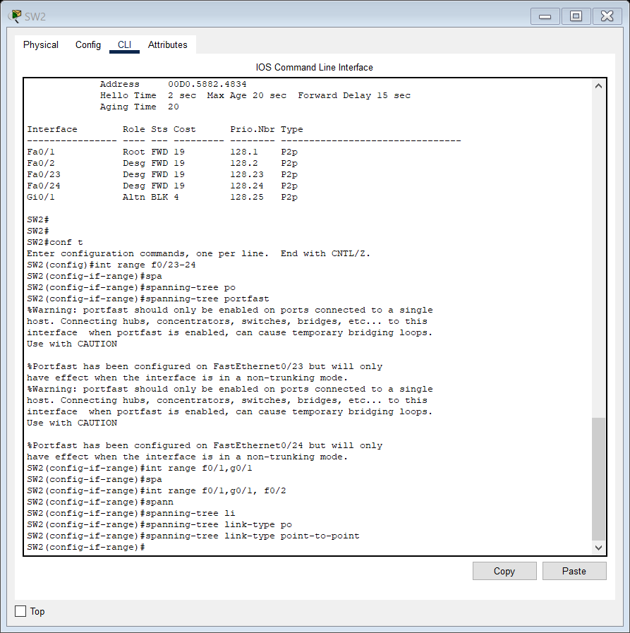

SW3

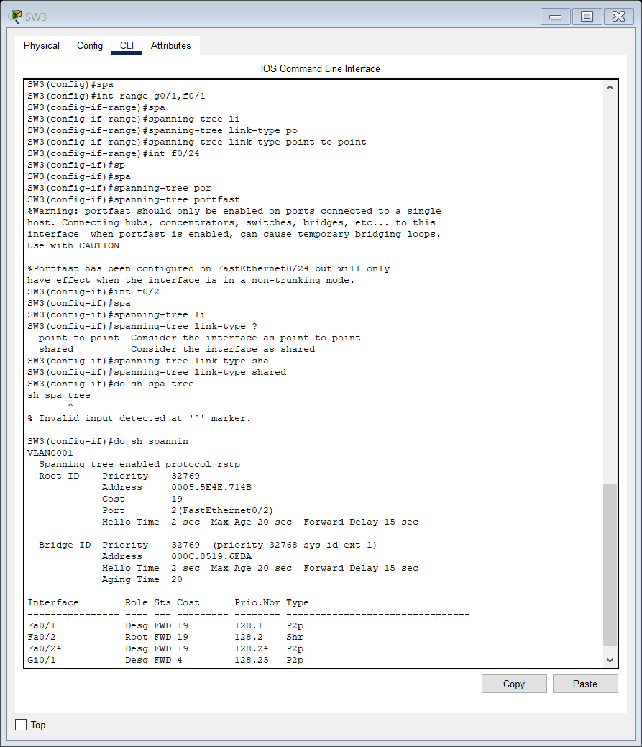

SW4:

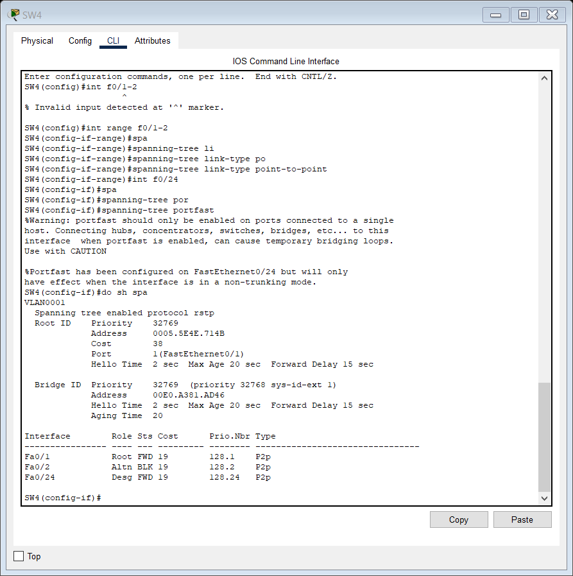

**DAY 23 LAB CONFIURING ETHERCHANNEL:**

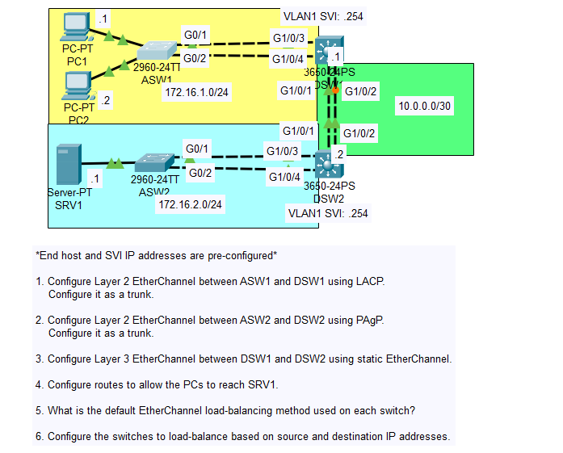

1.

So, they are configured to be part of an etherchannel, but because of some problem they are acting

as stand-alone, individual ports.

Why is that?

It’s because we haven’t configured DSW1 yet.

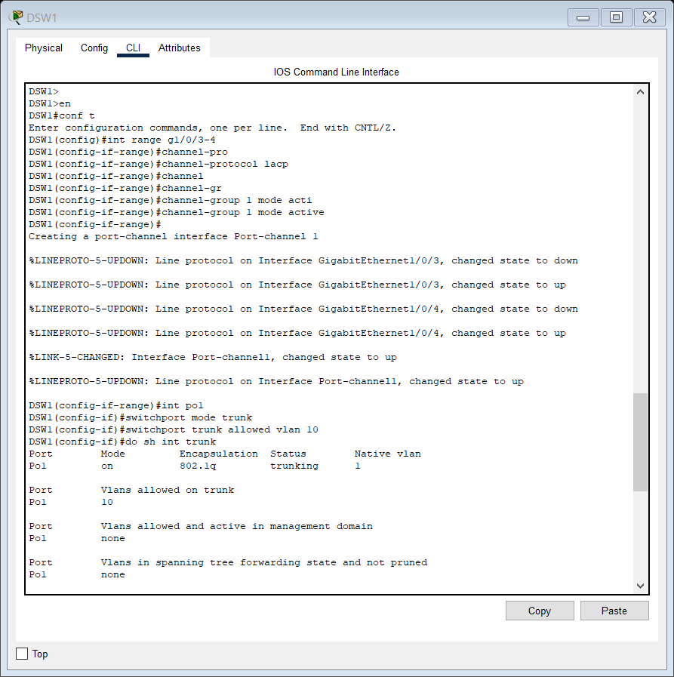

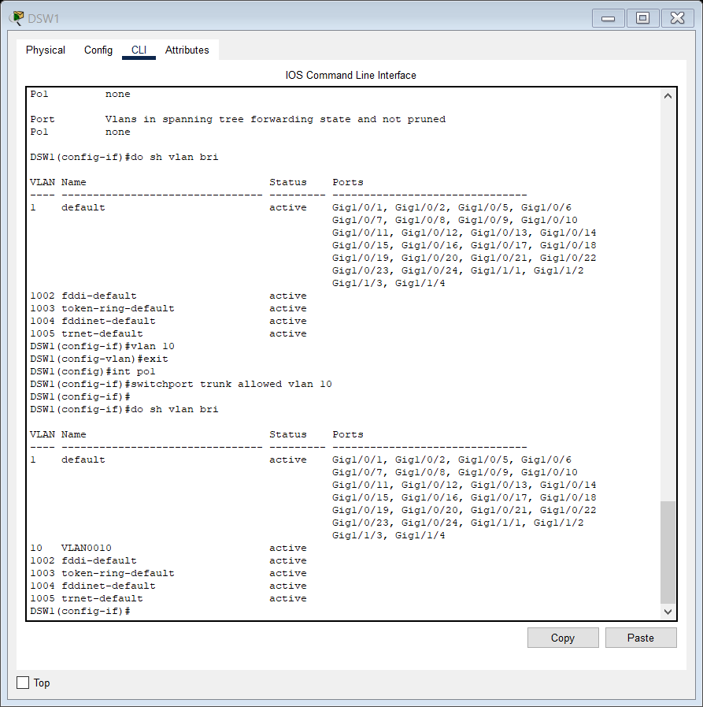

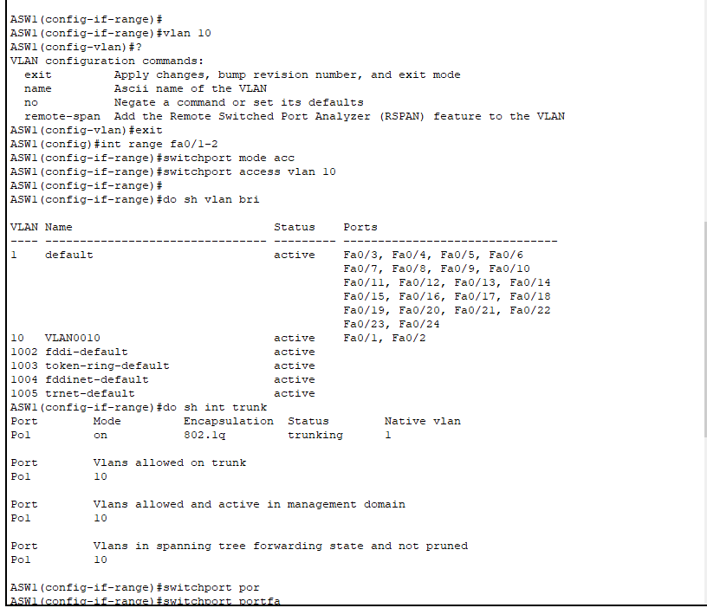

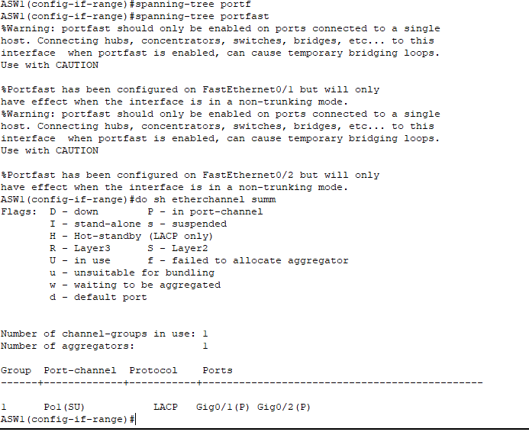

2.

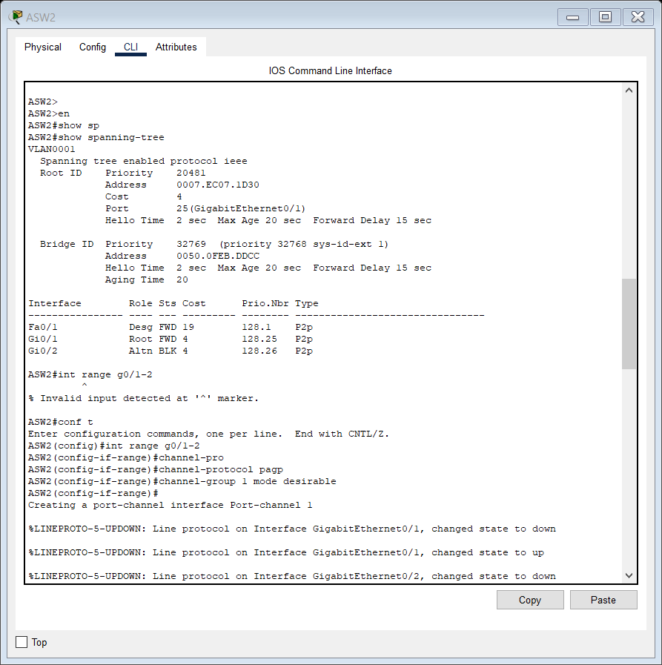

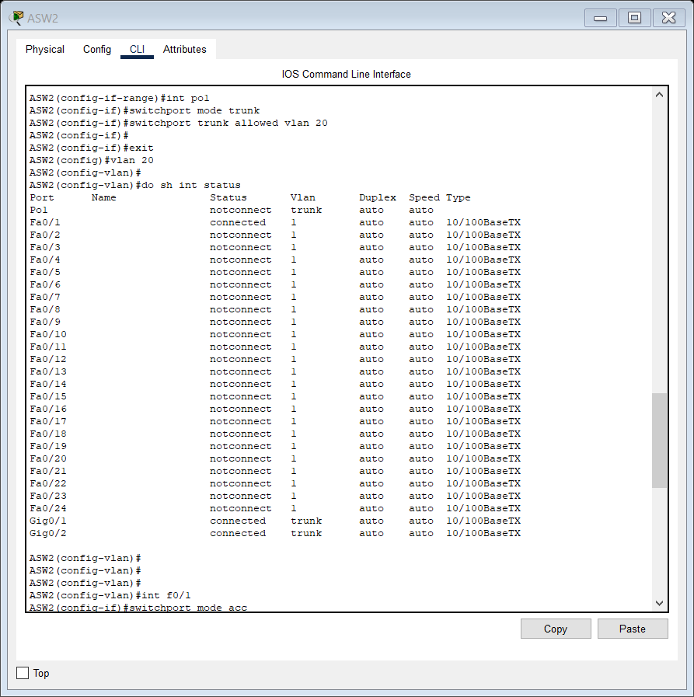

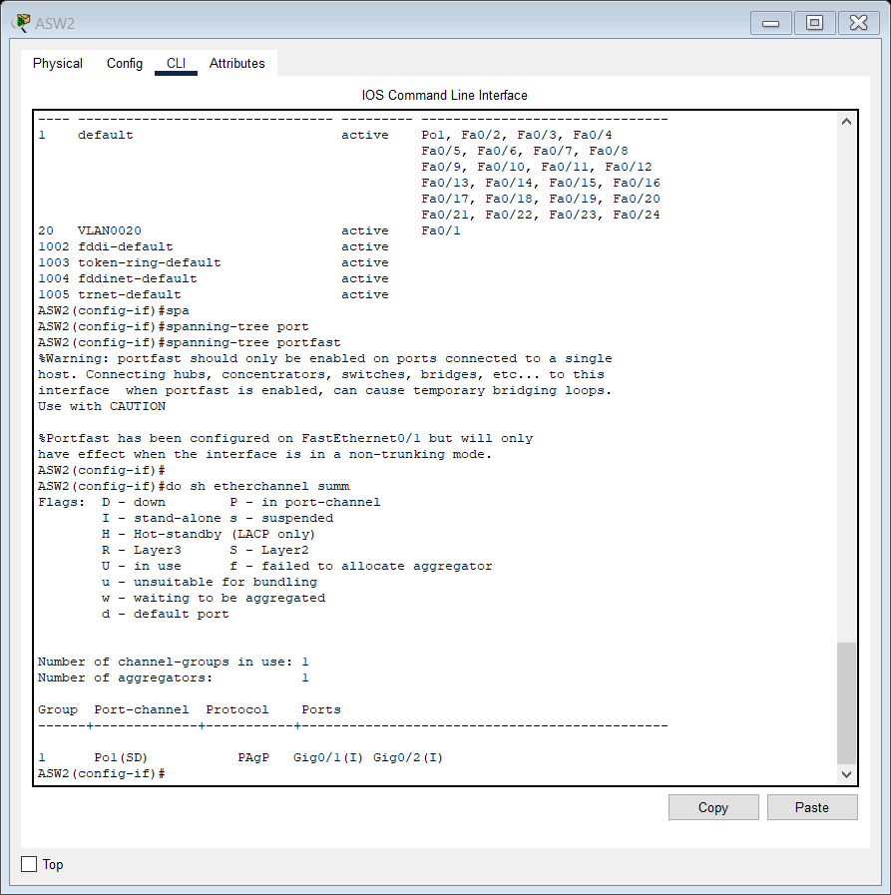

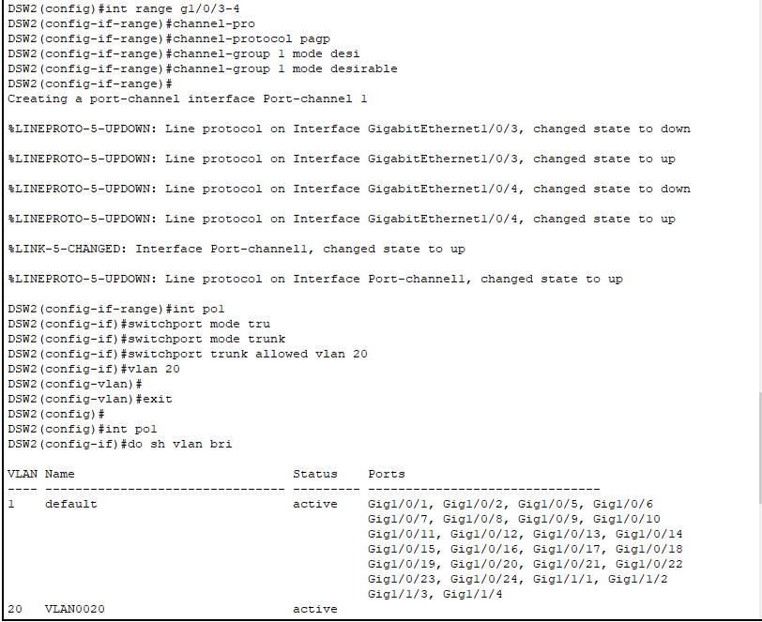

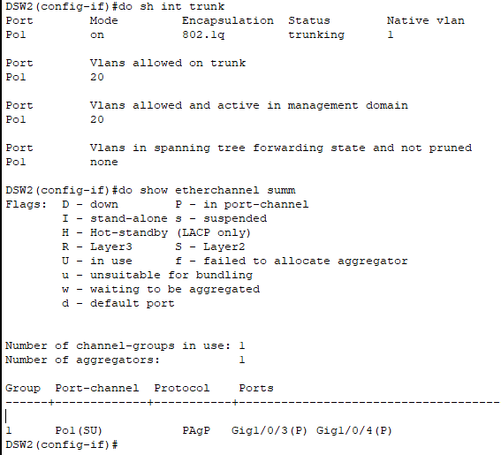

3, 4.

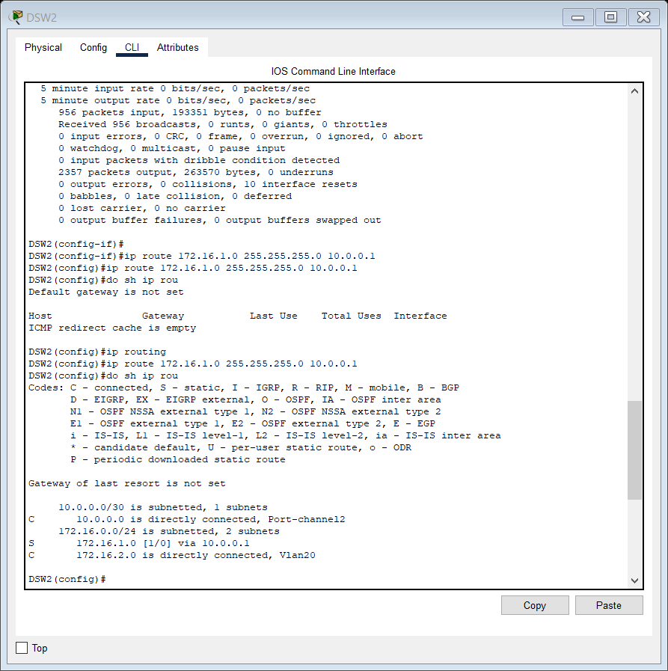

5., 6

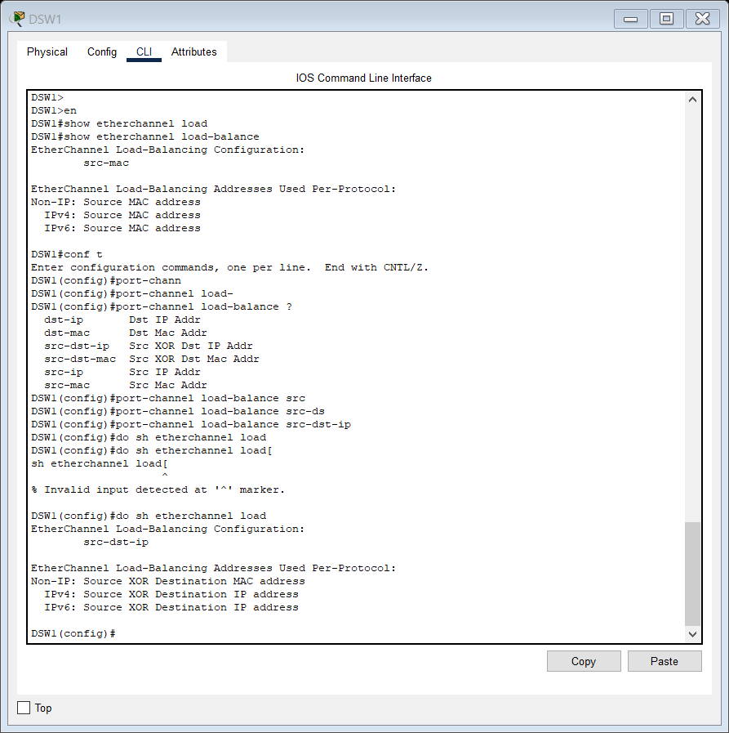

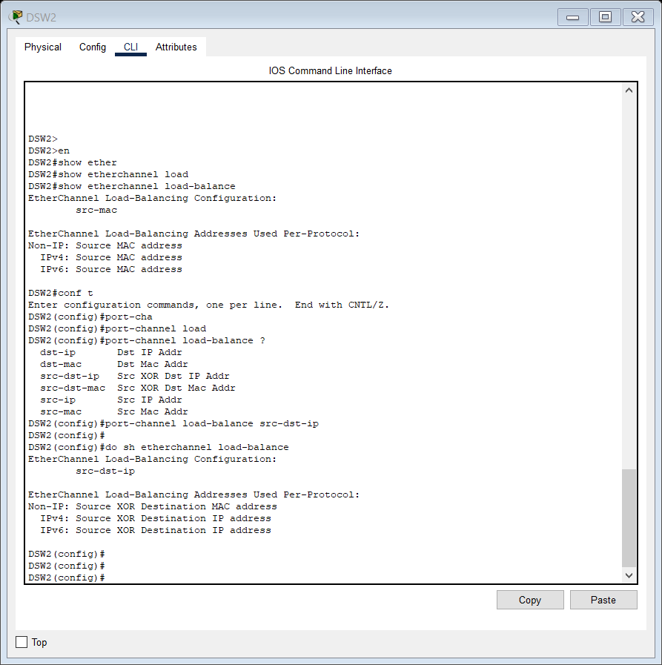

SHOW CDP NEIGHBORS.

16:36

So, CDP is Cisco Discovery Protocol.

16:40

It's a Cisco proprietary protocol that is used to gather information about connected

16:45

devices.

16:46

So, when I enter this command here on DSW1 we'll get some basic information about all

16:51

of these switches it's connected to.

16:53

There we go.

16:55

So, DSW2 is here.

**DAY 24 LAB FLOATING STATIC ROUTES:**

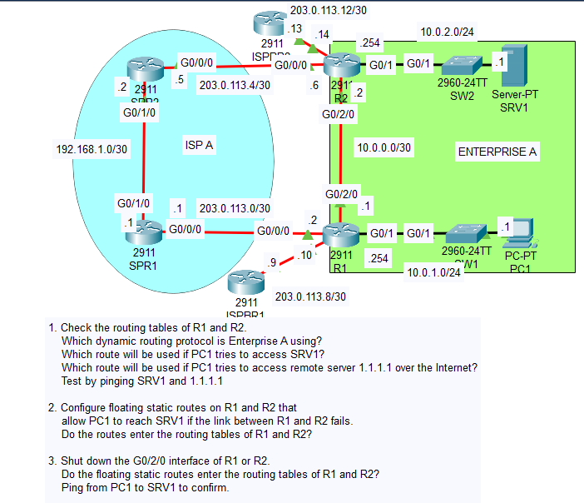

1. Enterprise A is using OSPF.

PC1 will take the route via R2 to SRV1.

PC1 will take the route via ISPBR1 to 1.1.1.1. 1.1.1.1 isn’t a remote destination over the internet as simulating that is not possible in packet tracer. It’s a virtual interface on the router called Loopback interface that you are pinging to simulate a remote destination over the network.

2.

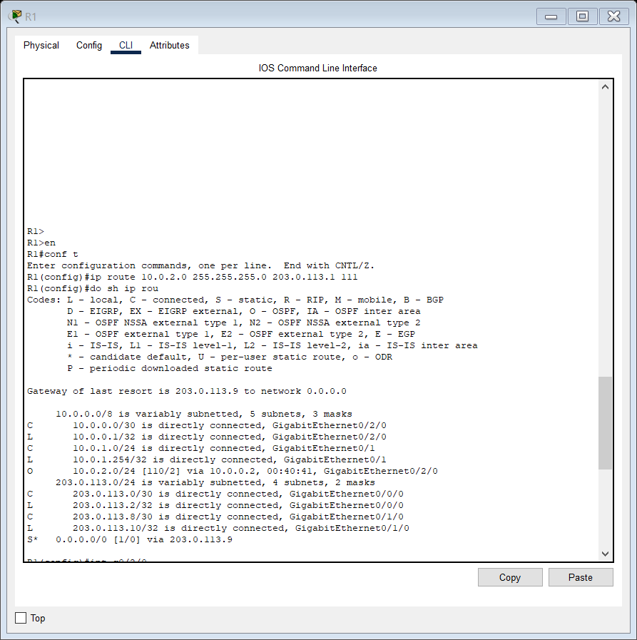

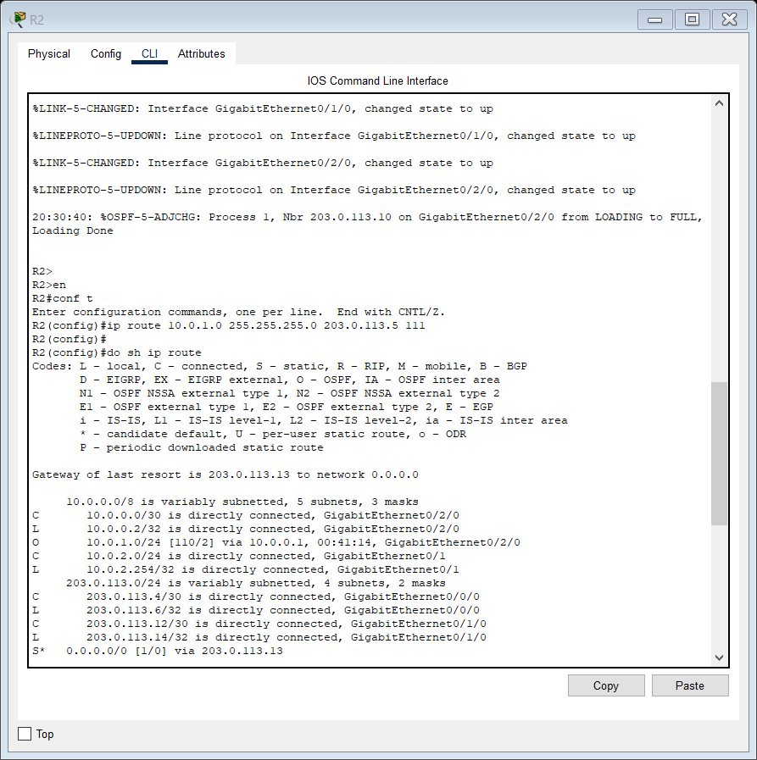

3.

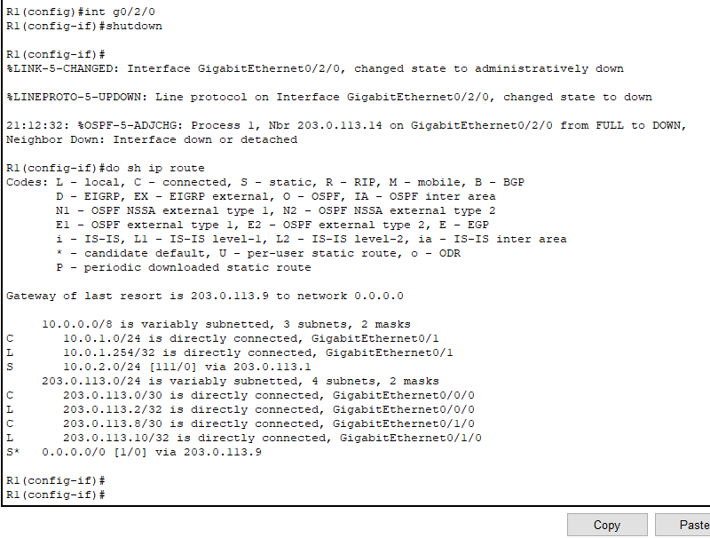

Now traffic takes the path via ISPR1 and ISPR2 to 10.0.2.0/24 network.

Heres a look at ISPR1s routing table which is similar to ISPR2s routing table.

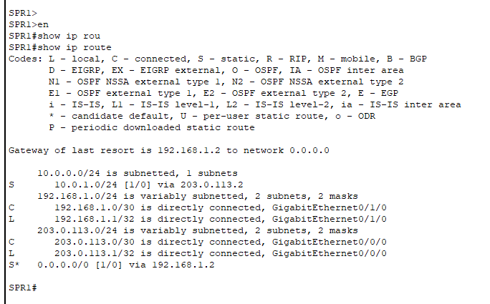

To confirm that the ping from PC1 to SRV1 is taking this route, we will use the TRACEROUTE command.

**Traceroute command introduction:**

In a real network you can’t just turn on simulation mode like in packet tracer to see

the path traffic takes.

Instead, you can use the traceroute tool.

In Cisco IOS the command is TRACEROUTE spelled out like this, however on a Windows PC it’s

TRACERT, then the destination IP address, which is 10.0.2.1.

There it is.

So, what does traceroute do?

It’s like a ping, except every Layer 3 ‘hop’ along the route to the destination sends a

message back to the source.

First is 10.0.1.254, R1’s G0/1 interface.

Next 203.0.113.1, SPR1’s G0/0/0 interface.

Then 192.168.1.2, SPR2’s G0/1/0 interface.

Then 203.0.113.6, R2’s G0/0/0 interface, and finally the reply from 10.0.2.1, SRV1.

Traceroute is a very useful tool for troubleshooting and making sure traffic is following the intended path.

Make sure you’re aware of it for the exam, and try it out in packet tracer labs!

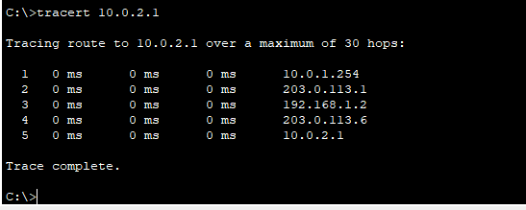

Lab completed.

RIP AND EIGRP:

Remember what I said in the previous video about EIGRP’s metric? It uses interface bandwidth and delay by default, those are the ‘K1’ and ‘K3’ values

30:22

that are set to 1 here. The bandwidth of the SLOWEST link in the path, plus the sum of the delay values of all the

30:29

links in the path, are used to calculate the metric. The other k-values, K2, K4, and K5 are set to 0 by default and are not used to calculate

30:40

metric, however that can be changed with configuration. Next up is the router-ID.

30:47

In EIGRP and OSPF, the router has a unique router ID which identifies it within the AS.

30:54

Notice that the default on R1 is 172.16.1.14. Why is that?

30:59

Well, the router ID is determined like this. First up, if the router ID is manually configured, that will be the router ID.

31:09

If the router ID isn’t manually configured, the highest IP address on any of the router’s

31:14

loopback interfaces will be the router ID. Loopback interfaces are virtual interfaces inside the router, I’ll talk about them

31:22

more in the OSPF videos. Finally, if there are no loopback interfaces configured, as is the case here, the highest

31:30

IP address on any of the router’s physical interfaces will become the router ID.

31:35

So, G2/0’s 172.16.1.14 became the router ID.

31:42

Note that the router ID isn’t actually an IP address, it’s just a 32-bit number formatted

31:47

like a dotted-decimal IP address, and you can change it to any 32 bit number.

**DAY 25 LAB CONFIGURING EIGRP:**

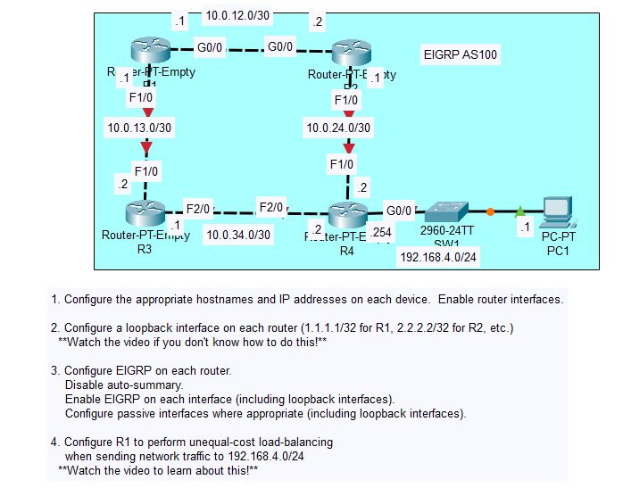

1.

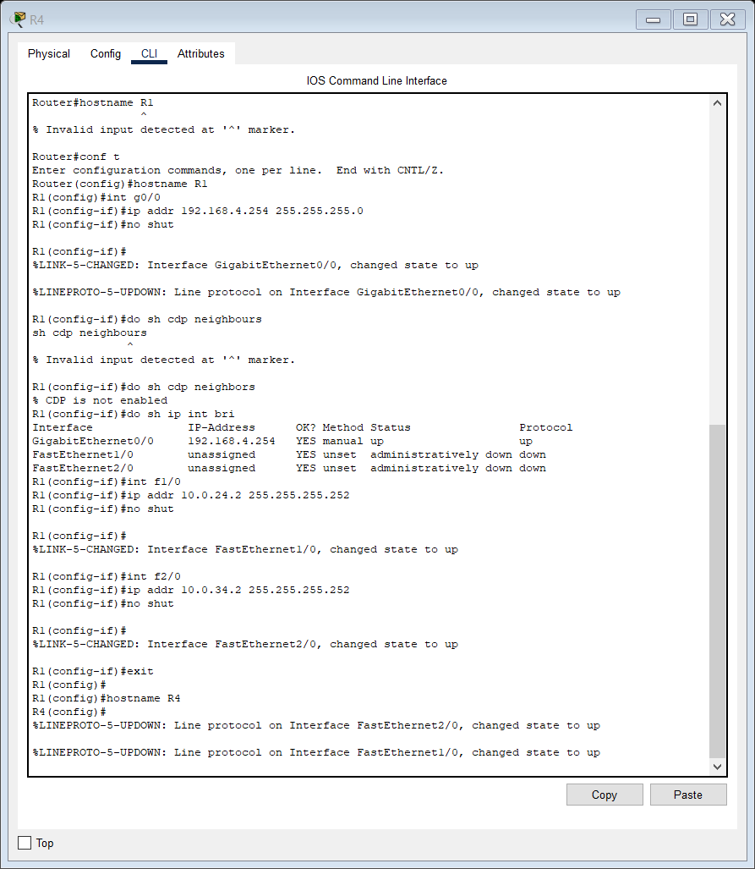

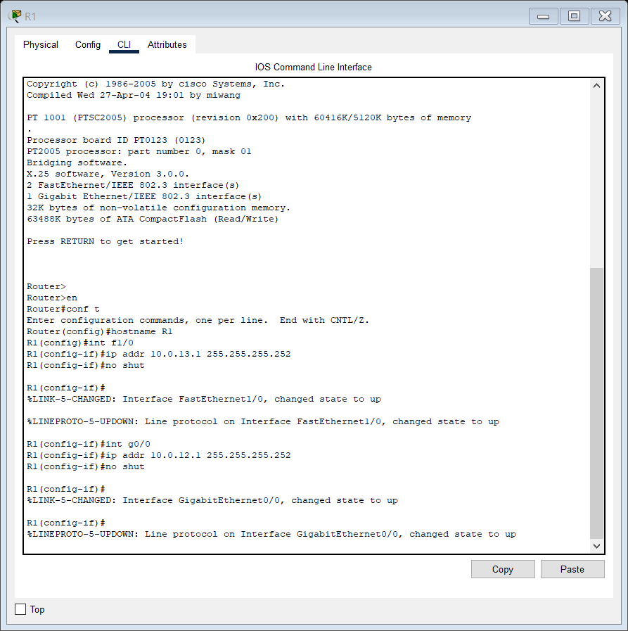

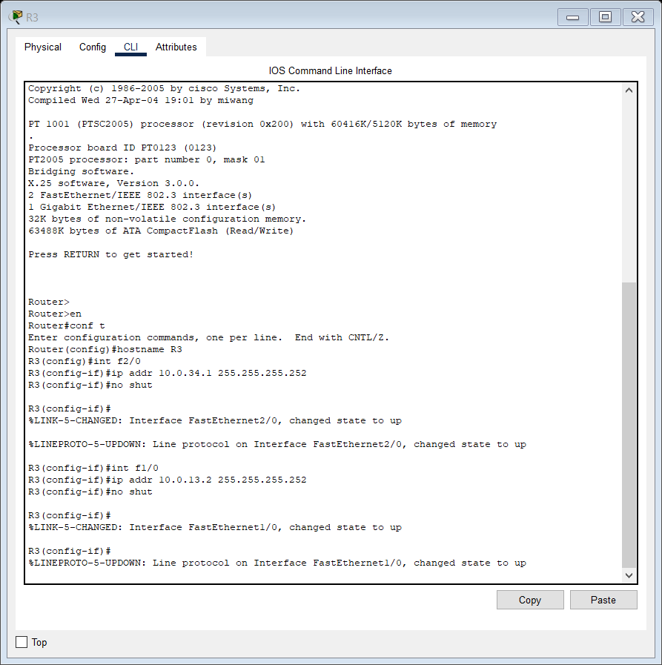

2. Configuring Loopback addresses on router interfaces:

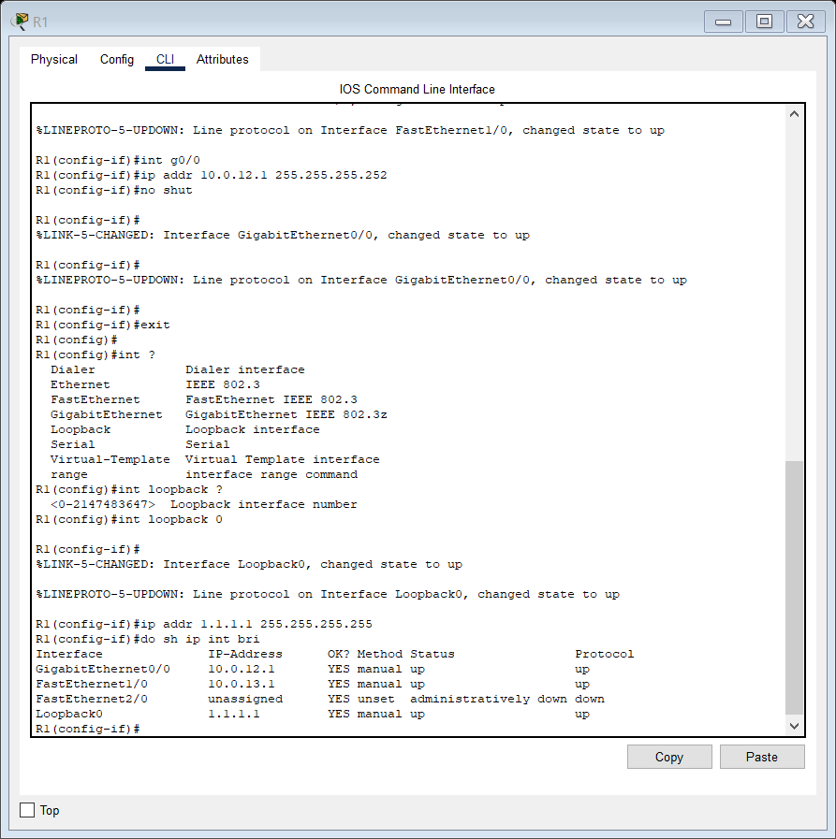

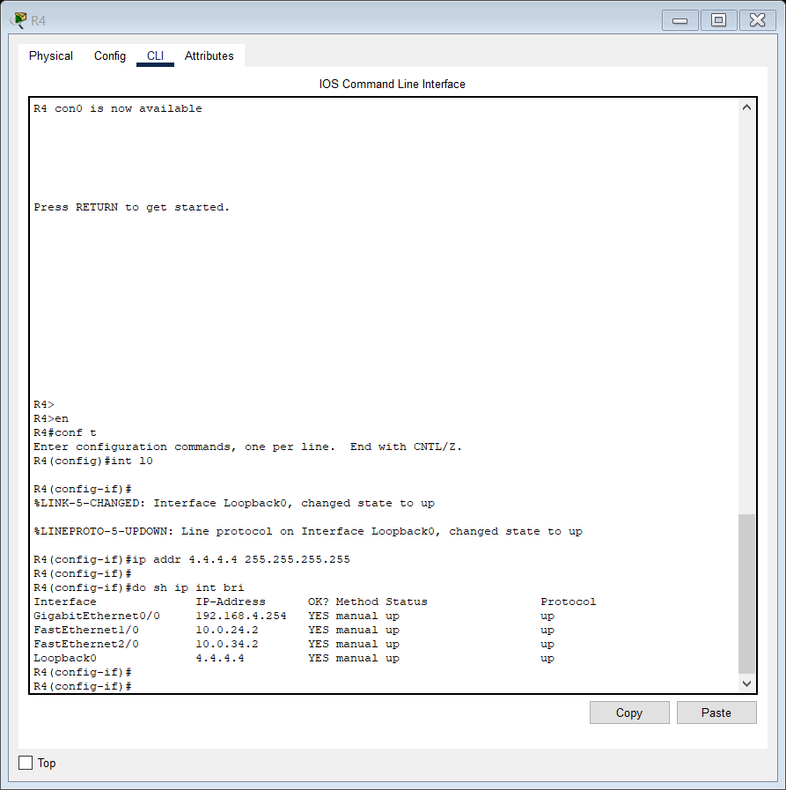

3.

Now for Step 3, we will configure EIGRP.

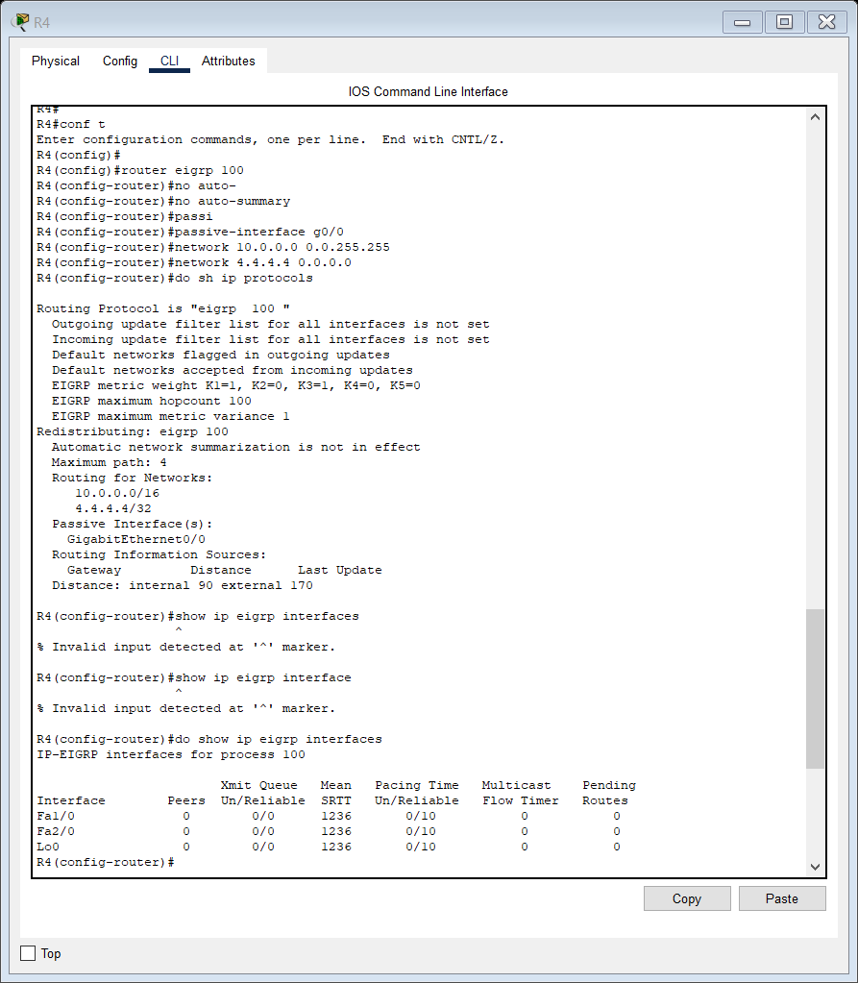

Note:

If you want to enable EIGRP on all interfaces, use the following command:

Router(config-router)# network 0.0.0.0 255.255.255.255

Do show ip eigrp interfaces

we should make interfaces like G0/0, not connected to

any EIGRP neighbors,

a passive interface.

However, it’s a good idea to do it on loopback interfaces also.

Why?

Well, the router will treat the loopback interface like any other interface and try to send EIGRP messages out of it, even though the loopback interface isn’t connected to any device.

It’s just a waste of resources on the router, so we should make it a passive interface.

LETS DO IT

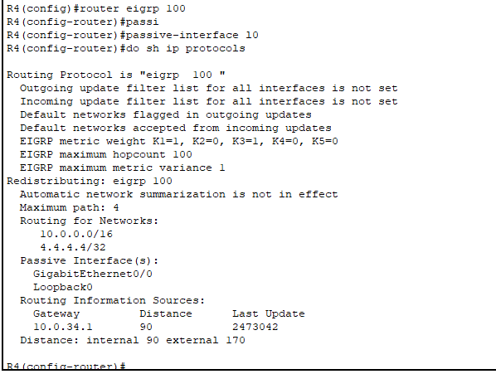

R1

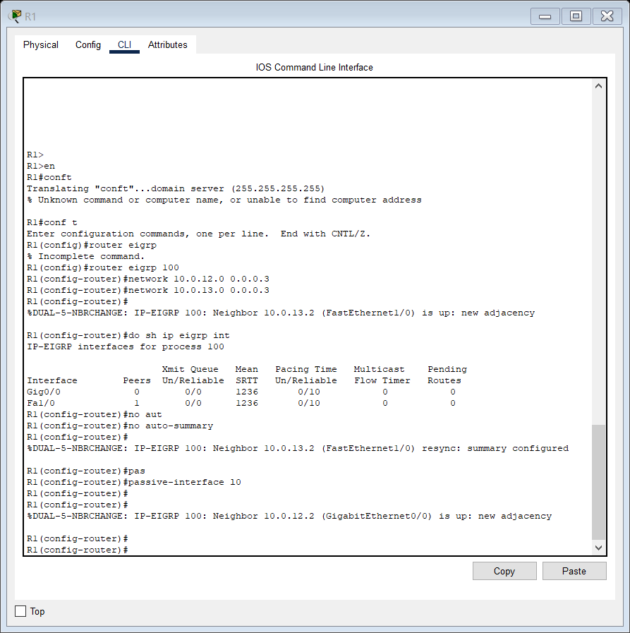

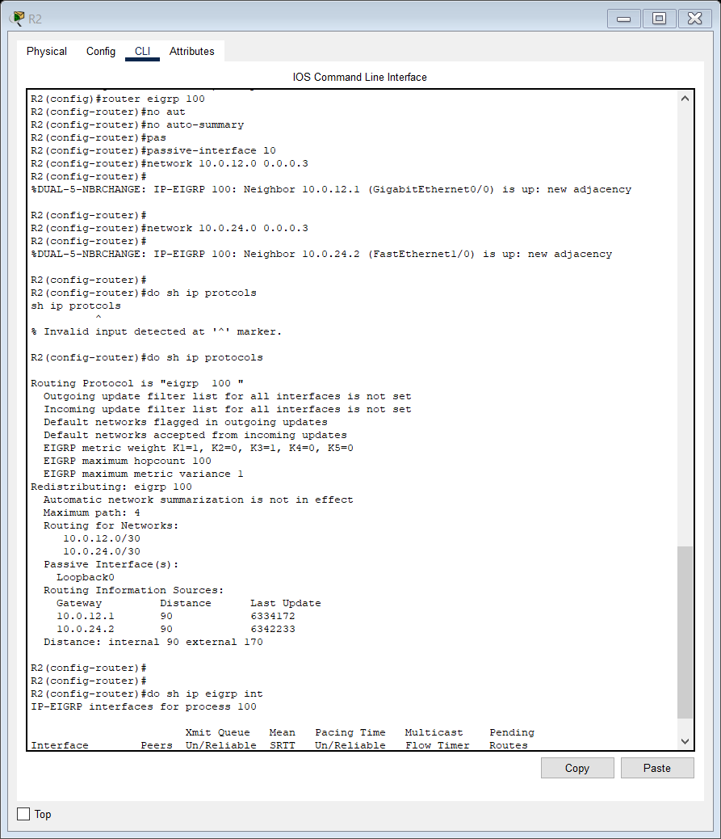

Important commands AND ways to filter show ip route command

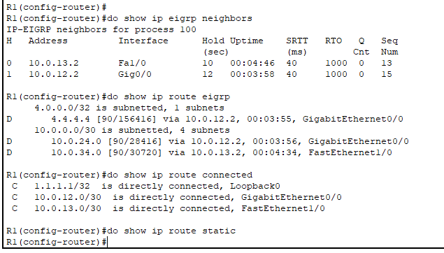

Do show ip eigrp topology

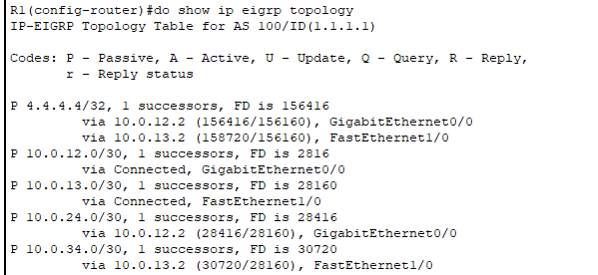

4.

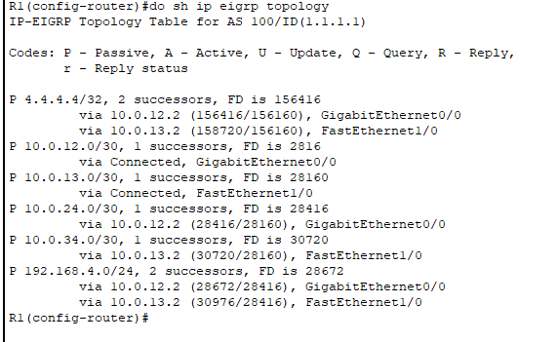’

Successors Feasible Distance is 28672 and Reported distance is 28416 and the other route that is via 10.0.13.2 is a feasible successor as its reported distance has a value of 28416 which is less than the feasible distance successor value of 28672 making it is a feasible successor.

So now we can configure R1 to do unequal cost load balancing by tweaking the value of variance in CLI.

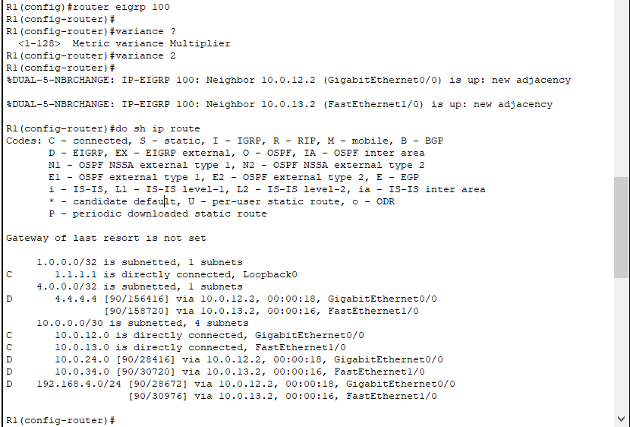

**EIGRP LECTURE:**

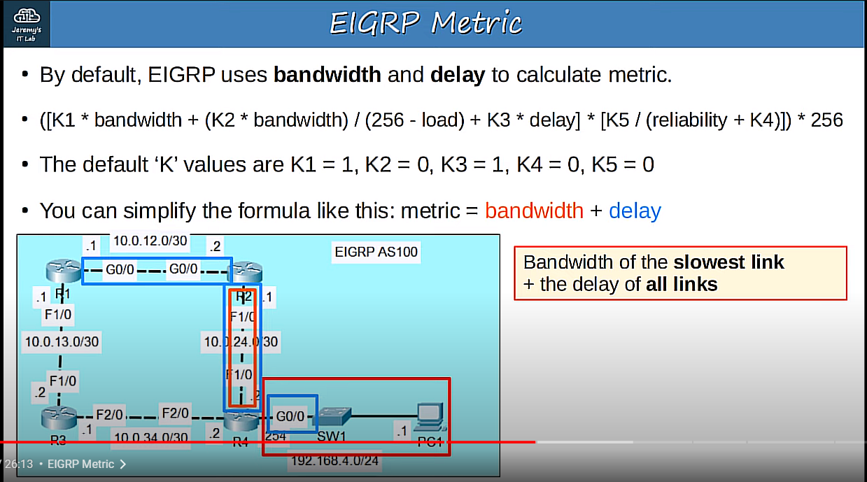

The default K values are K1 = 1, K2 = 0, K3 = 1, K4 = 0, and K5 = 0.

14:01

K1 is multiplied by bandwidth and K3 is multiplied by delay.

14:07

Since you don’t have to worry about memorizing this formula or actually calculating EIGRP

14:11

metric yourself, you can just think of EIGRP metric like this.

14:16

Metric equals bandwidth plus delay.

14:19

But there’s something else you should know, let me demonstrate here.

14:22

It’s not simply bandwidth plus delay, but rather bandwidth of the slowest link in the

14:27

path to the destination, plus the delay of all links in the path to the destination.

14:34

For example, let’s say R1 wants to send traffic to R4’s LAN, 192.168.4.0/24.

14:41

The route via R2 is the best.

14:43

So, the bandwidth of the slowest link, that’s this one here, is added to the delay of all

14:48

links, these three, and then you get the total metric value of the route.

14:54

By the way, the routers don’t actually send ping messages to measure the delay of each

14:57

link, the ‘delay’ value is actually a default value based on the interface bandwidth.

15:03

So, what should you remember about EIGRP metric for the test?

15:08

Remember that it’s calculated by adding the bandwidth of the slowest link to the delay

15:11

of all links.

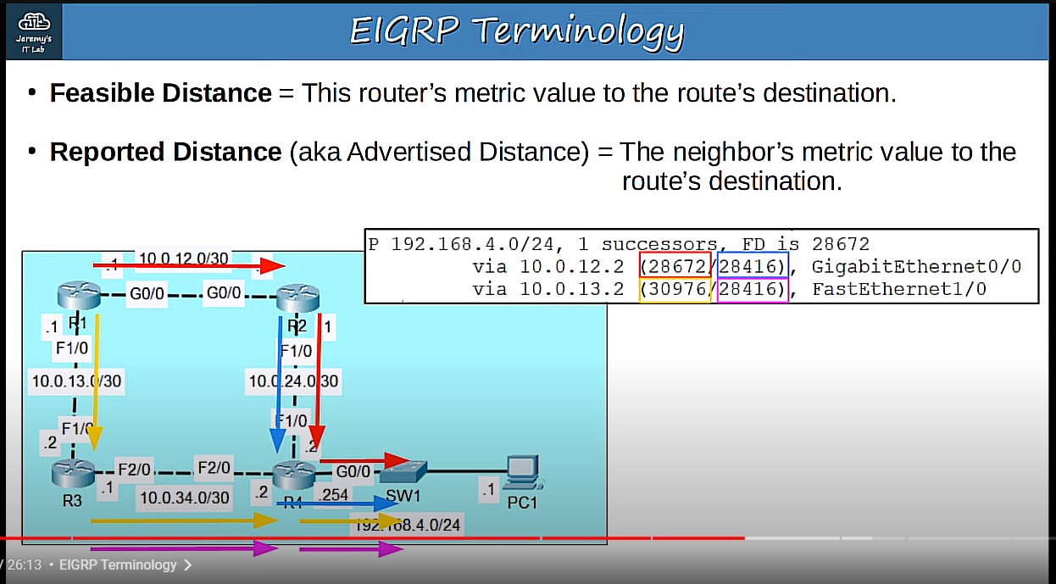

Feasible distance means THIS ROUTER’s metric value to the route’s destination.

15:26

From R1’s perspective, trying to reach 192.168.4.0/24 , that means the metric of the whole route,

15:33

from R1 to R2, then R2 to R4, then for R4 to send the traffic out of its own inteface.

15:40

But, there is another term you should know.

15:43

Reported distance, which is also known as advertised distance.

15:47

This is the neighbor’s metric value to reach the destination.

15:50

So, for this route the neighbor is R2, the reported distance is R2’s metric to the

15:56

destination.

15:58

Note that these terms are NOT related to the concept of administrative distance.

16:02

EIGRP uses the term ‘distance’, but this is the metric used to compare EIGRP routes,

16:09

not the administrative distance which is used to compare routes from different routing protocols.

16:13

Let’s take a look at the real costs in Packet Tracer.

16:18

Here’s the output of the SHOW IP EIGRP TOPOLOGY command, just for the route to the 192.168.4.0/24

16:26

network.

16:28

The number on the left is R1’s metric, the Feasible Distance.

16:32

The number on the right is R1’s neighbor, R2’s metric, the Reported Distance.

16:36

How about the route below it via R3?

16:40

This is the feasible distance, R1’s total metric to reach the destination.

16:45

This is the reported distance, R1’s neighbor R3’s metric to reach the destination.

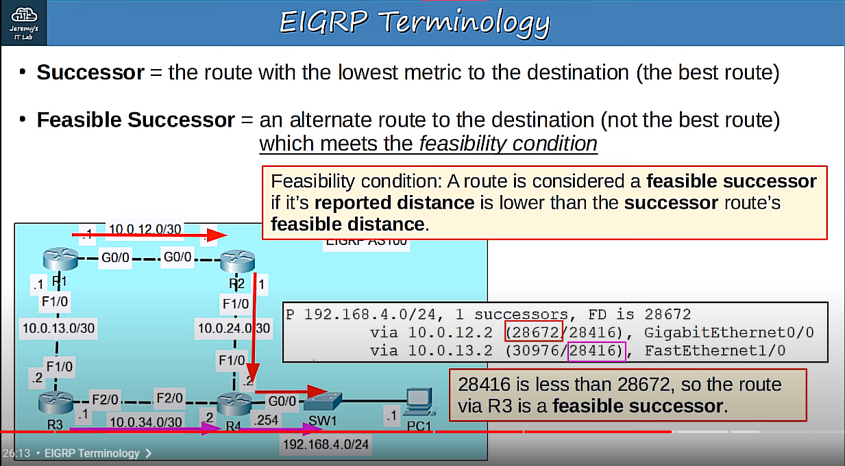

Successor is the term for the route with the lowest metric to the destination, so it’s

17:05

the best route.

17:07

In this case, which route to 192.168.4.0/24 is the successor?

17:12

It’s the route via R2, because it has the lower metric, it’s the best route.

17:18

Next term.

17:19

A Feasible Successor is an alternate route to the destination, it’s not the best route,

17:25

but it must meet the ‘feasibility condition’.

17:28

Okay, pay attention here.

17:30

What is the feasibility condition that must be met?

17:33

A route is considered a feasible successor if it’s reported distance is lower than

17:39

the successor route’s feasible distance.

17:42

So, does the route via R3 meet this feasibility condition?

17:48

It’s reported distance is 28,416.

17:53

The successor route via R2’s feasible distance is 28,672.

17:59

28,416 is less than 28,672, so the route via R3 is a feasible successor.

18:09

Why does EIGRP have this system of feasible successors?

18:12

It’s a kind of loop-prevention.

18:15

If a route meets the feasibility requirement, it is guaranteed not to be a looped route.

18:21

I’m not going to spend time explaining that in depth, but remember that this is a loop-prevention

18:25

mechanism.

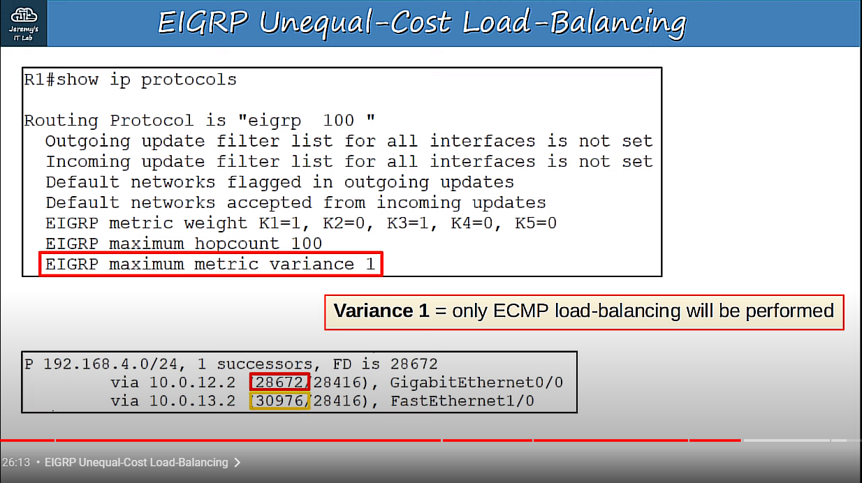

So, here is some output from the SHOW IP PROTOCOLS command.

18:45

Down here it says EIGRP maximum metric variance 1.

18:50

This is the default value, 1.

18:52

With a variance of 1, only equal cost multipath, ECMP, load-balancing will be performed.

19:00

This means a route’s feasible distance must be equal to the successor route to be chosen

19:04

for load-balancing.

19:05

Actually, if another route’s FD is equal to the successor route’s FD, that route

19:11

is a successor too, there can be multiple successors.

19:14

So, with the default settings EIGRP doesn’t do unequal-cost load-balancing.

19:20

For example, these are R1’s routes to 192.168.4.0/24.

19:26

This is the successor route’s FD, and this is the feasible successor’s.

19:30

It’s higher, so it can’t be used to load-balance.

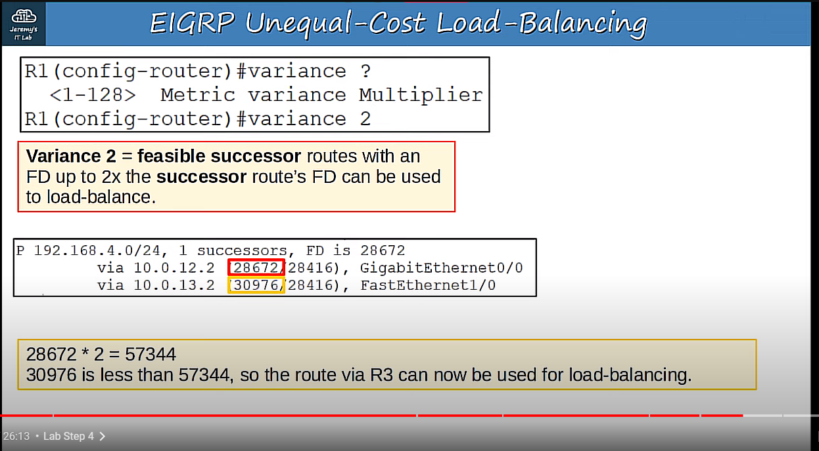

So, from EIGRP configuration mode I used the VARIANCE command, and set it to 2.

19:41

What does that mean?

19:42

Well, it’s basically a multiplier.

19:45

VARIANCE 2 means that feasible successor routes with an FD up to two times the successor route’s

19:51

FD can be used to load-balance.

19:53

Let me explain with our example.

19:56

Here are our routes.

19:58

The successor’s FD is 28,672, but I just configured a variance of 2, so we can double

20:05

that.

20:06

28,672 times 2 equals 57,344.

20:11

The feasible successor’s FD is 30,976.

20:16

30,976 is less than 57,344, so the route via R3 can now be used for load-balancing.

20:26

I’ll show you in the next slide that it has now been entered in the routing table

20:30

of R1.

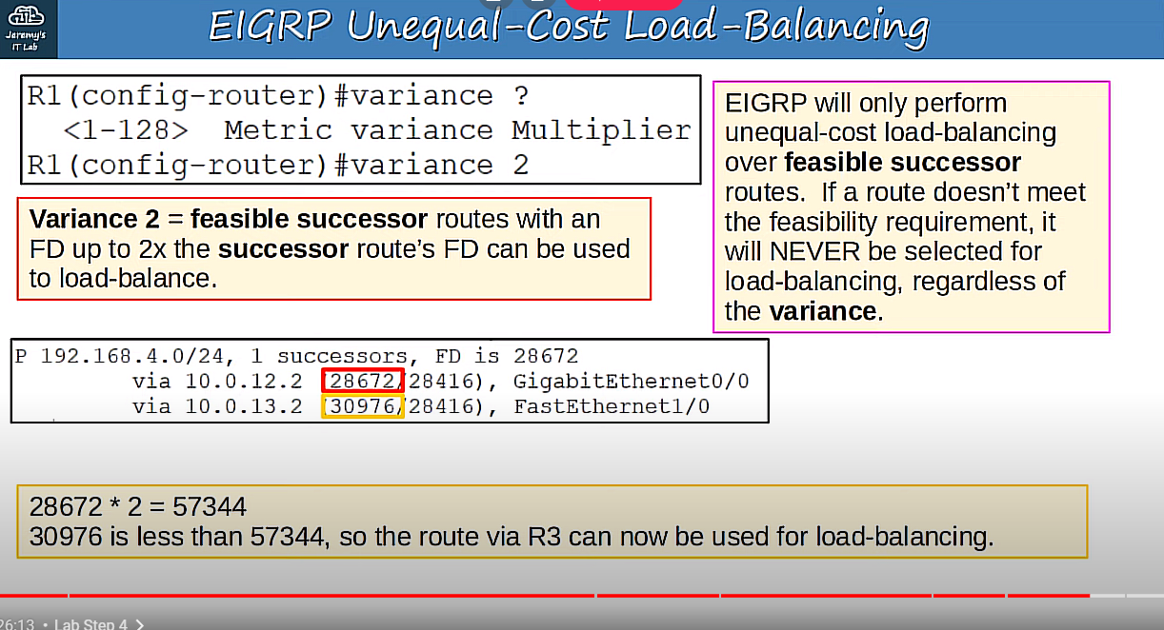

EIGRP will only perform unequal-cost load-balancing over feasible successor routes.

20:40

If a route does’t meet the feasibility requirement, it will NEVER be selected for load-balancing,

20:46

regardless of the variance.

20:48

This is because the feasibility requirement is an important loop-prevention mechanism,

20:53

so the router will never ignore it and put a non-feasible route in the routing table.

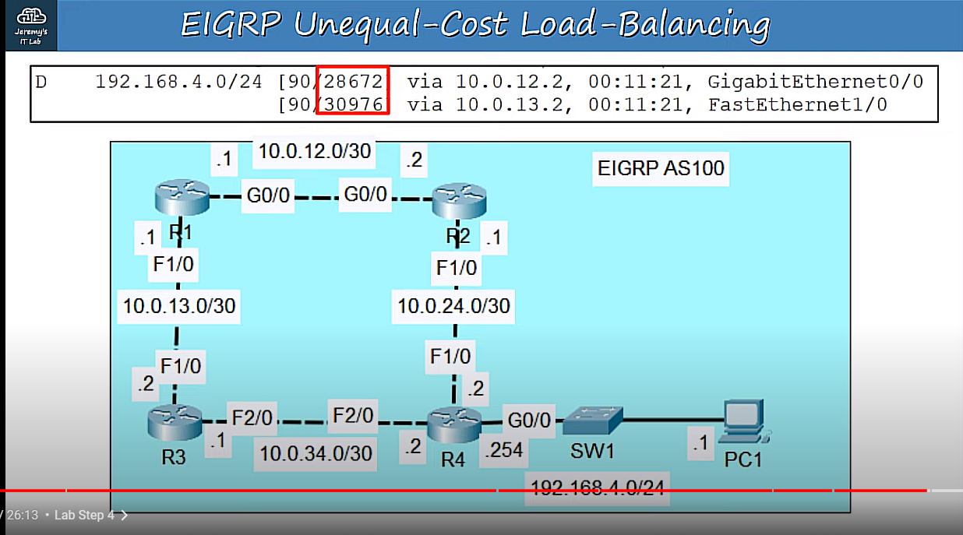

Here is that route to 192.168.4.0/24 as shown in R1’s route table.

21:05

Notice that, even though the two routes have different metric values, R1 now inserts both

21:10

into the routing table.

21:11

However, R1 will send slightly more traffic via R2 than R3, because R2’s path has a

21:18

lower metric, it’s a faster path.

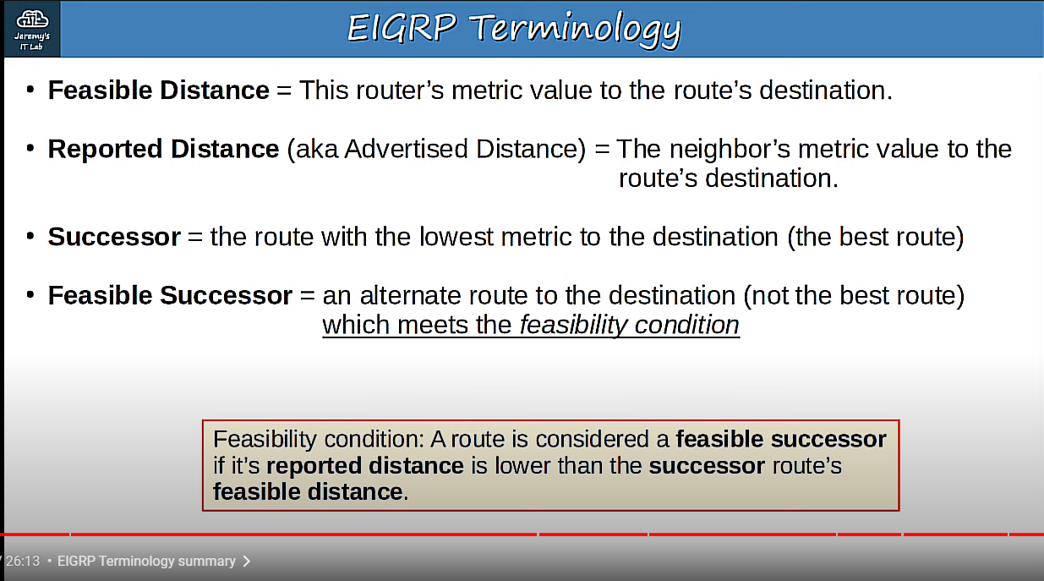

Q.

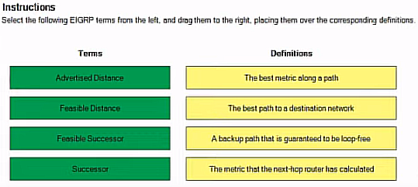

Advertised Distance 🡪 The metric the next-hop router has calculated

Successor 🡪 The best path to a destination network.

Feasible Distance 🡪 The best metric along a path

Feasible Successor 🡪 A backup path that is guaranteed to be loop-free

Loops at Layer 3? -> check this.

**Bonus VLSM Subnetting question:**

Q. You have a subnet of 10.134.0.0/22

I want:

500 end users

200 wireless

55 phones

59 printers

117 databases

VLSM Subnetting:

For 500 end hosts, we have, 10.134.0.0/23

No. of hosts = 2^(32-CIDR) – 2 = 2^9 – 2 = 510 hosts

Also, 256 * 2 = 512 addresses

Next up, 200 wireless

10.134.2.0/24

Next up, we have 117 databases

/25 mask would be okay

10.134.3.0/25

Next up, we have 59 printers.

10.134.3.128/26

Next up, we have 55 phones

10.134.3.192/26

Sort your subnets from largest to smallest, find appropriate subnet mask for each and allocate subnets. (VLSM)

**DAY 26 LAB OSPF PART 1:**

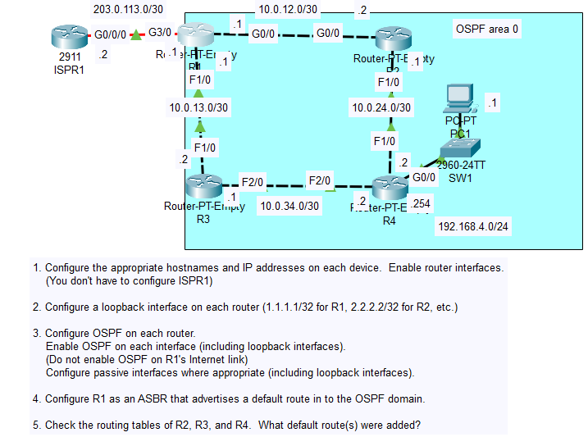

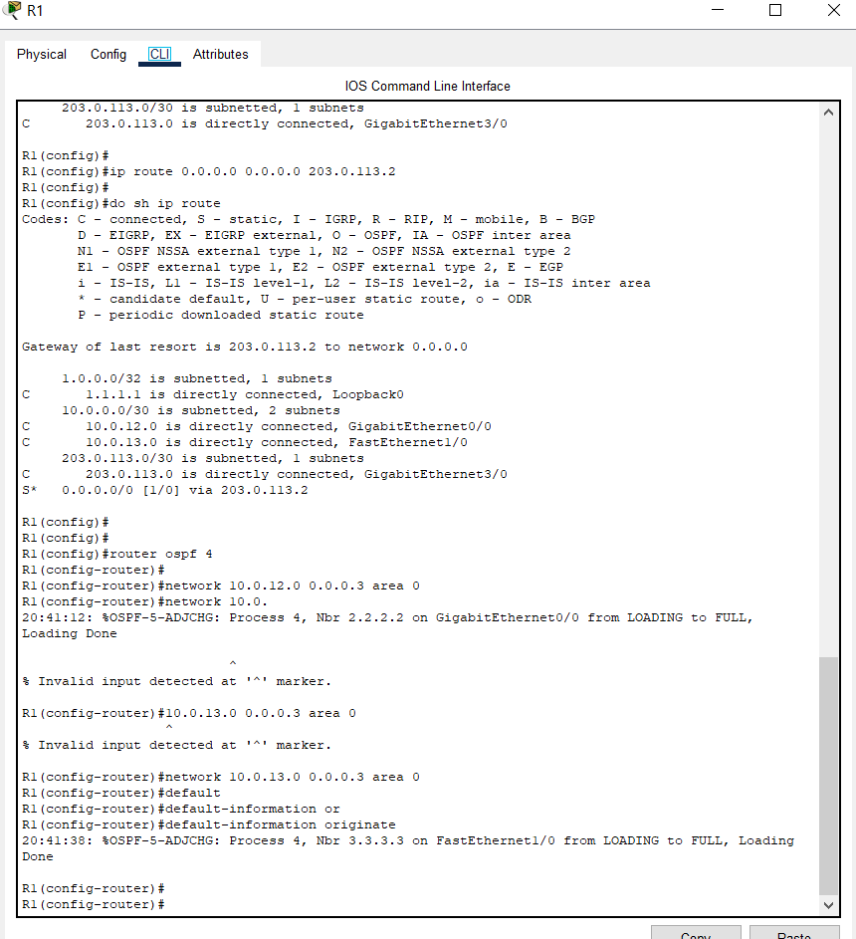

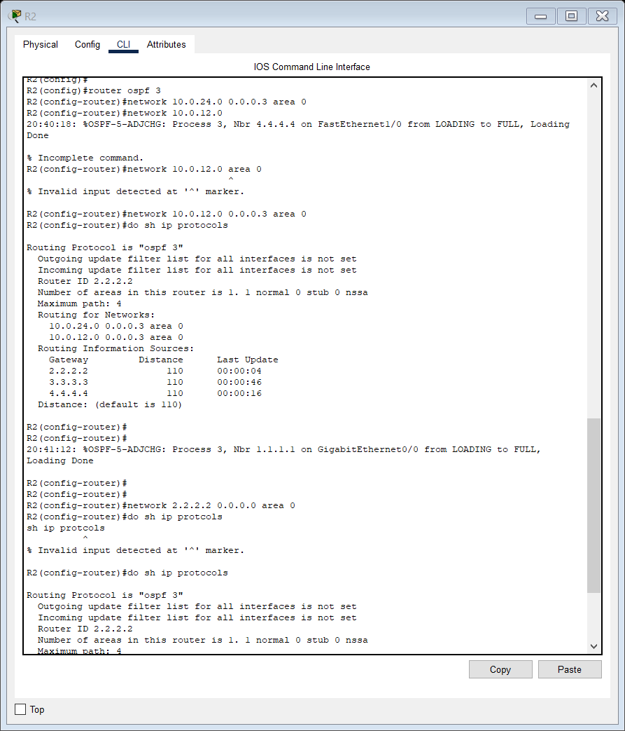

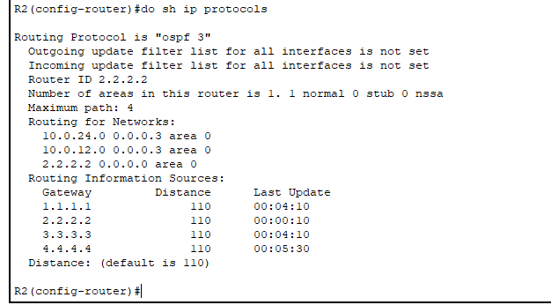

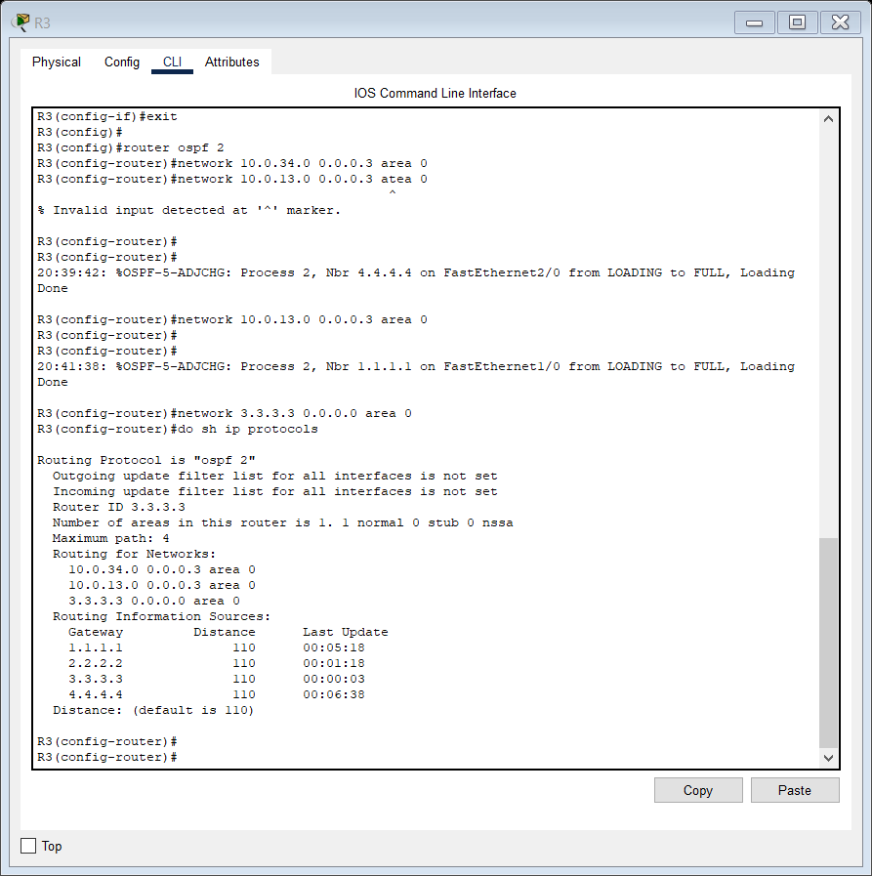

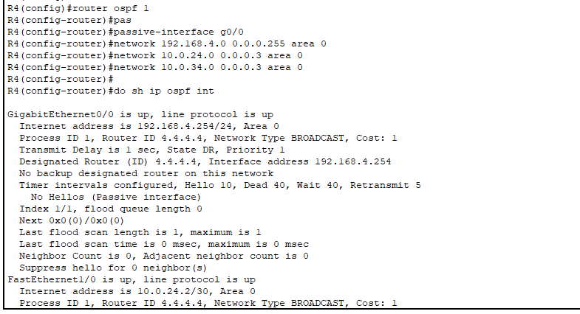

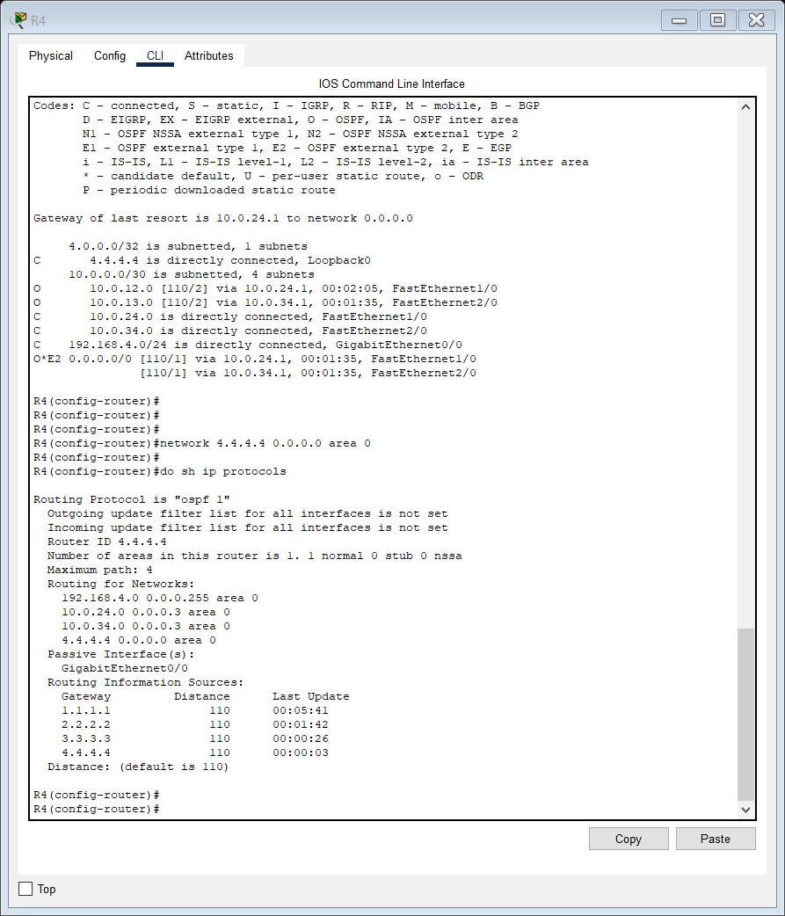

Configured R1 as ASBR and the default route added to R2,R3,R4s routing table.

Some OSPF commands.

If you want to view the OSPF LSDB, show ip ospf database

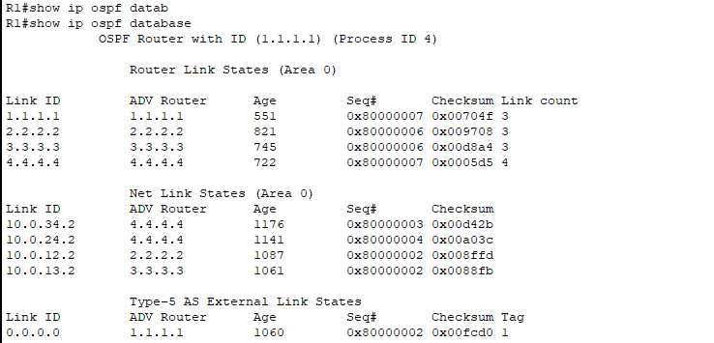’

If you wanna look at OSPF neighbors, use the show ip ospf neighbor command

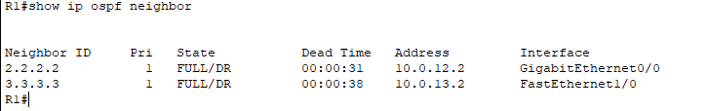

If you want details about the current OSPF settings on the interfaces, show ip ospf interface

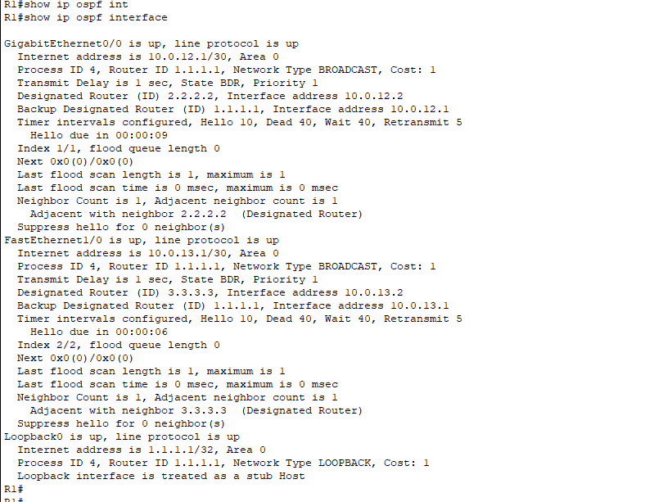

**DAY 27 LAB OSPF PART 2:**

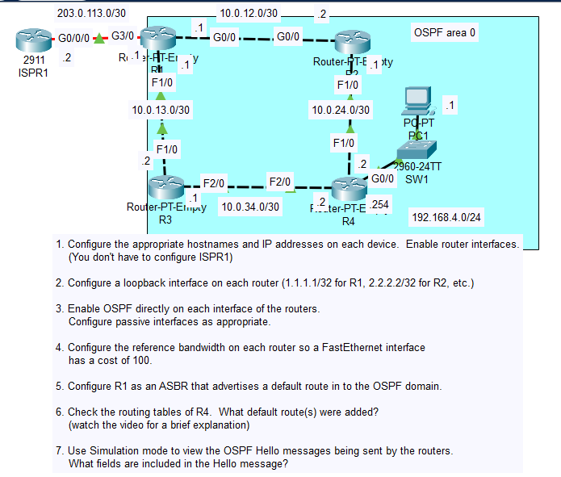

3.

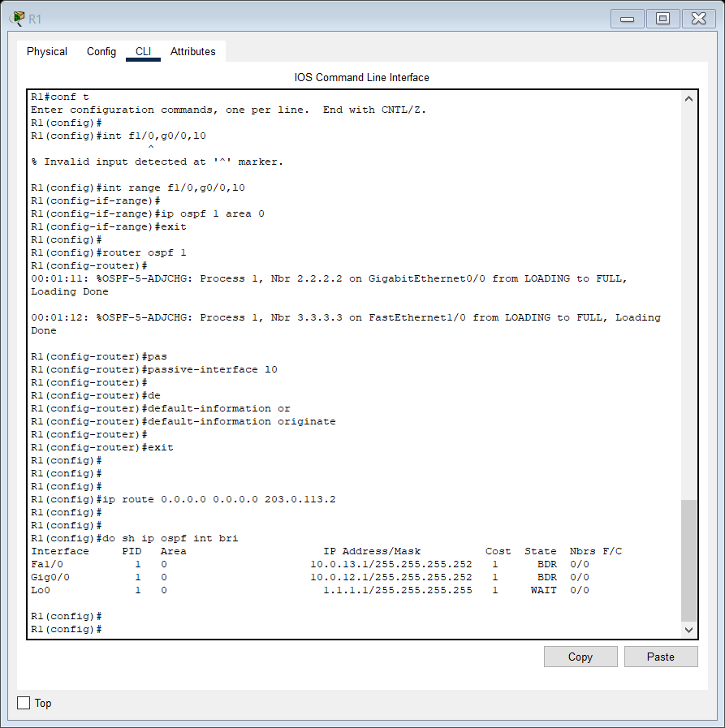

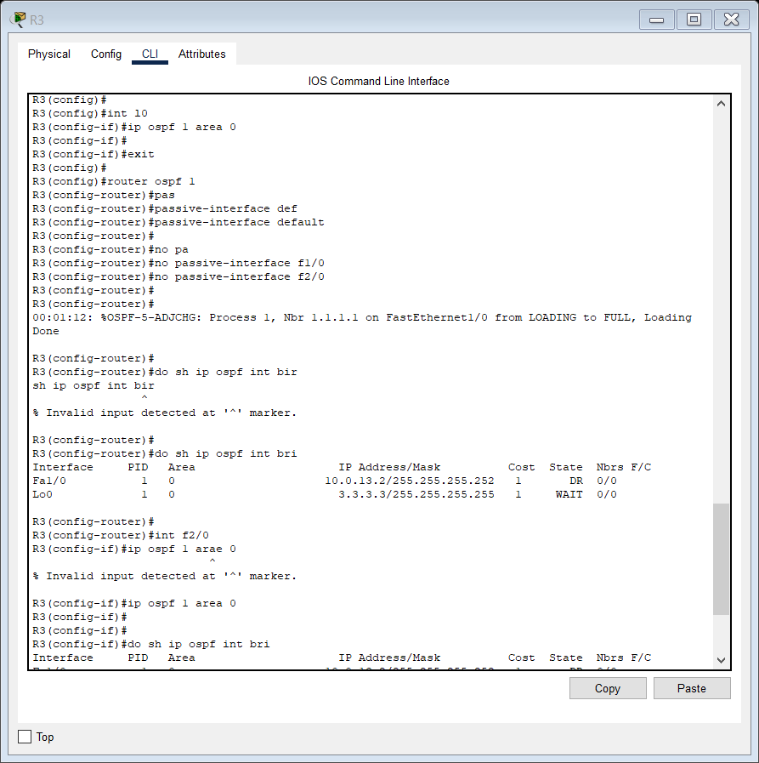

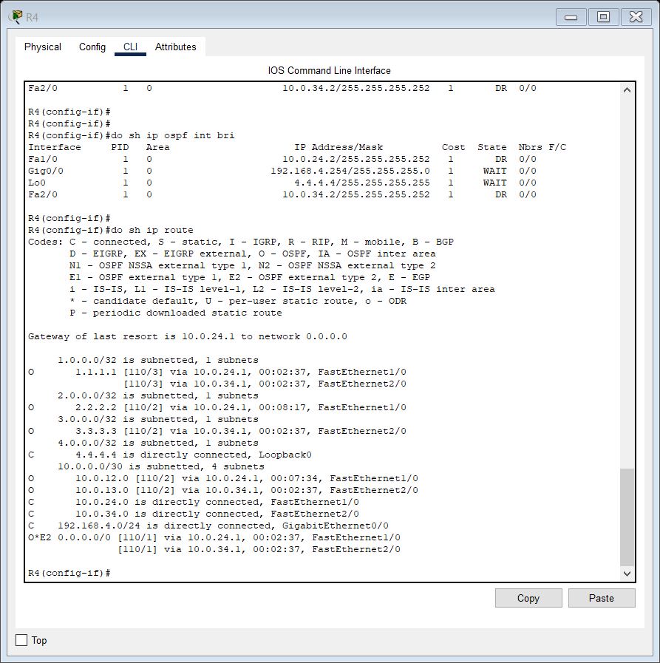

We currently have 2 routes to 203.0.113.2 (default route), one via 10.0.24.1 and one via 10.0.34.1, this is because the cost of both the routes is same as reference bandwidth is 100 Mbps by default and F0/1s cost is 100/100 = 1 and G0/0s cost is 100/1000 = 1 (values less than 1 are converted to 0 in OSPF) and that’s why we have two routes.

4.

Now we will configure reference bandwidth so that F0/0s cost is 100 on the routers.

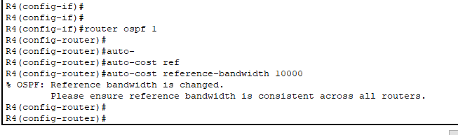

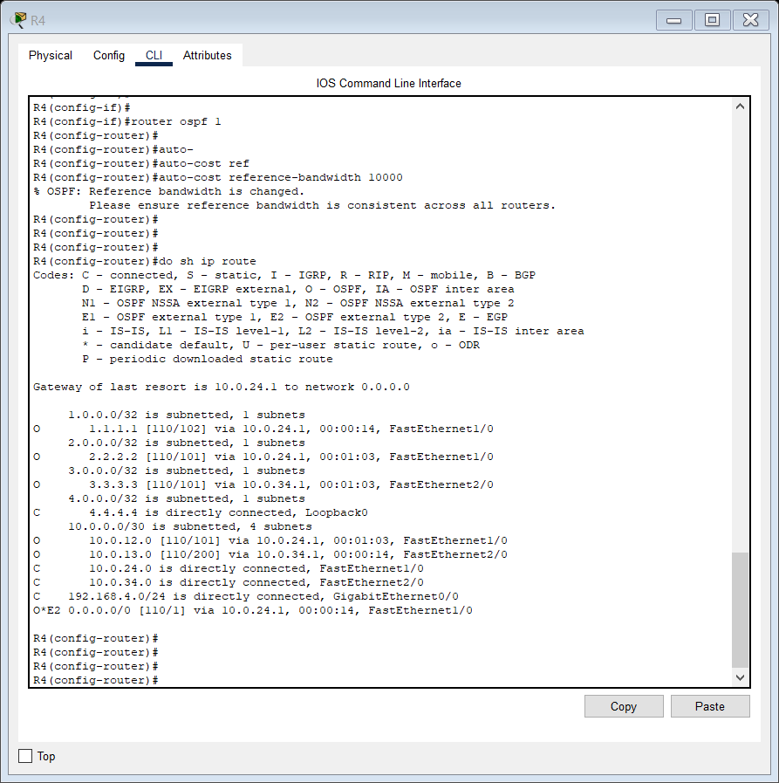

6. As we can see, R4s routing table now only has 1 default route to 203.0.113.2 now as the cost of G0/0 interfaces is now 10000/1000 = 10 and F0/0 interfaces is 10000/100 = 100 and through 10.0.24.1, the cost is lesser as it’s a G0/0 connection.

BUT ACTUALLY,

First off, notice that R4 added the route via R2 to the route table.

You might think that’s correct, because we changed the reference bandwidth so that

fastethernet and gigabit ethernet interfaces have a different cost.

That means the route via R2 is preferred over R3.

However, this is actually another error in Packet Tracer.

BOTH routes, via R2 and via R3, should be added.

Why is that?

Well, look at the cost of this route via R2.

The cost is 1.

With the reference bandwidth we just configured, the cost to reach R2 should be 100, plus 10

for R2 to reach R1, so 110 just to get to R1.

Why is the cost of this default route 1?

The answer is here, this ‘E2’ beside the route.

If you look up at the top here for the meaning of E2, it says ‘OSPF external type 2’.

As I said, this is a CCNP-level topic, so you don’t need to learn it right now.

But basically the ‘external type 2’ means that the ‘internal’ OSPF metric to reach

R1 is ignored.

So, actually the cost via both R2 and R3 will be the same, 1.

To prove that, I’ll shut down R4’s F1/0 interface so the OSPF adjacency with R2 goes down

INTERFACE F1/0.

SHUTDOWN.

We get a message saying the neighbor has gone from FULL to DOWN.

I’ll click this button to skip forward 30 seconds to make sure R4 has updated the routing

table.

And let’s check.

DO SHOW IP ROUTE.

See, now the route via R3, 10.0.34.1, is added, and it also has a cost of 1.

So, for some reason Packet Tracer does not insert both routes at the same time.

Perhaps Packet Tracer’s logic is considering the internal OSPF metric to reach R1 even

though it shouldn’t, but if you try this in GNS3 or on real equipment you’ll see

that both routes are added to the routing table.

Anyway, like I said this is a CCNP topic, don’t worry about learning it yet.

**7.**

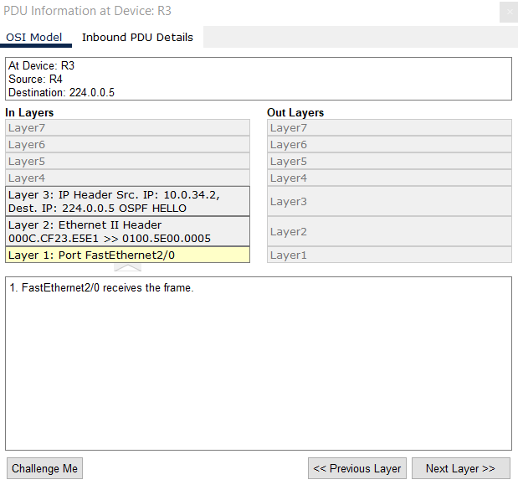

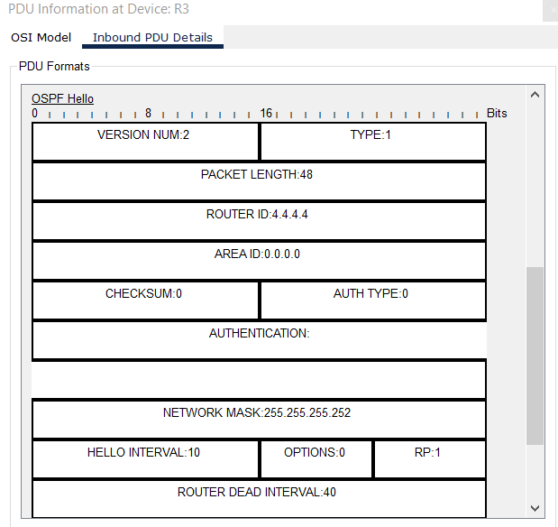

Hello is Type 1, DBD is Type 2, etc etc.

Also Area ID is also a 32 bit number and Area 0 can be written as 0.0.0.0 like a 32-bit number

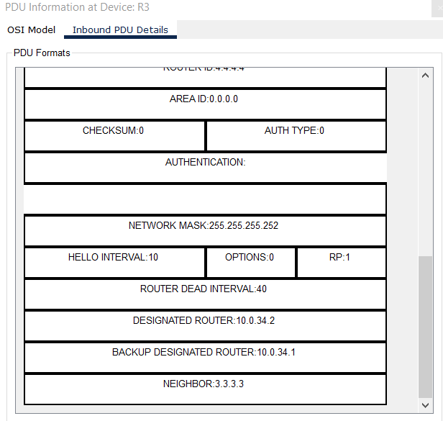

Some cool useful commands:

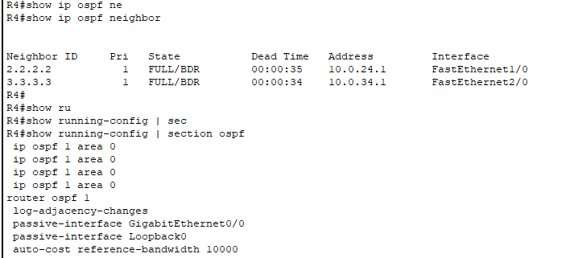

DAY 34 STANDARD ACL

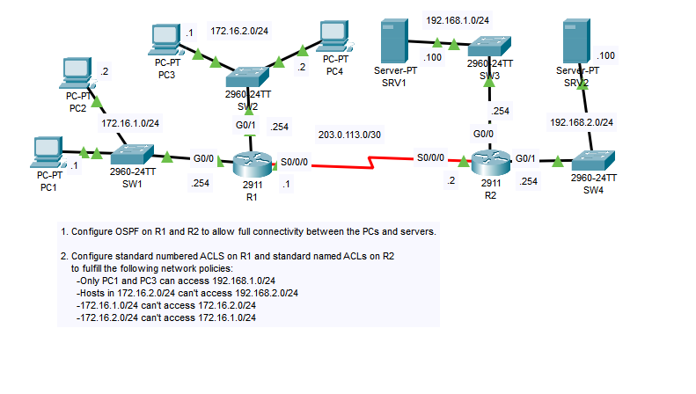

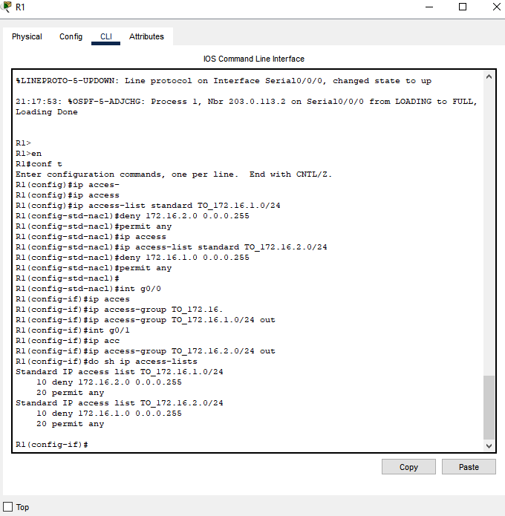

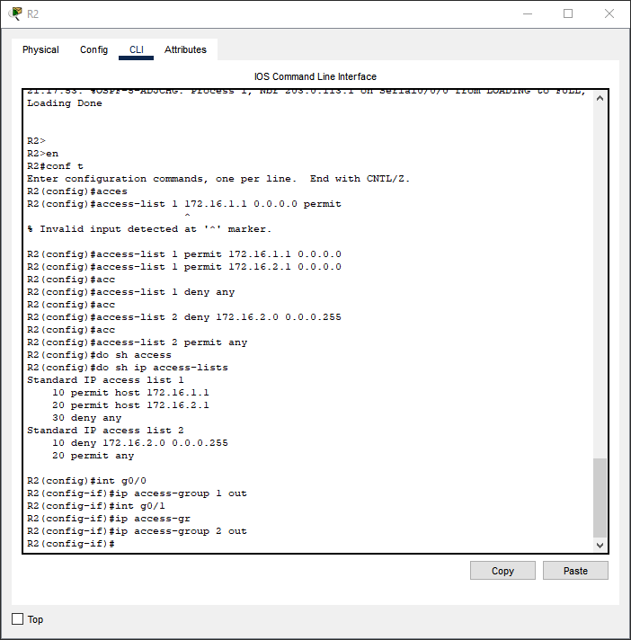

In the previous examples of queuing and scheduling we assumed that the interfaces are operating at full capacity, or beyond full capacity which is why packets need to be queued. However

31:30

there are situations in which it is desirable to limit the rate of traffic to below the actual maximum capacity of the link. Shaping buffers traffic in a queue if the traffic

31:40

rate goes over the configured rate. So, this is the same concept I just demonstrated, however

31:46

instead of the actual capacity of the link being the limiting factor, it’s a maximum traffic rate configured on the link. Policing isn’t as polite as shaping. It drops traffic

31:57

if the traffic rate goes over the configured rate. However there is some flexibility. Burst

32:03

traffic over the configured rate is allowed for a short period of time. This accommodates data applications which are ‘bursty’ in nature. Instead of a constant stream of data,

32:14

they tend to send data in bursts. Just like the policed data rate, the amount of burst traffic allowed is also configurable. And in both cases, classification can be used

32:24

to allow for different rates for different kinds of traffic. Now, why would you want

32:29

to limit the rate traffic is sent or received? To demonstrate one common case, here’s a

32:35

sample network. A customer router is connected to an ISP, Internet Service Provider, router.

32:42

The customer configures shaping outbound on the G0/0 interface of the router, and the

32:47

ISP configures policing inbound on the G0/0 interface of the ISP router. Can you think

32:53

of a reason why this might be done? Although the physical interfaces are gigabit ethernet,

32:58

1000 megabits per second, perhaps this customer is paying for a 300 megabit per second connection.

33:05

So the ISP says, you paid for a 300 megabit per second connection, so I’m going to police

33:11

incoming traffic to 300 megabits per second. The customer then decides, if I send traffic

33:17

faster than 300 megabits per second it will be dropped by the ISP, so I will shape the

33:22

outgoing traffic to 300 megabits per second. There are various possible uses for shaping

33:28

and policing, but this is a common use of these tools.

First, we covered classification and marking. Classification means identifying

33:44

different kinds of traffic so that you can then treat it with an appropriate level of priority. Marking refers to setting the values of certain fields in the Layer 2 and Layer

33:53

3 headers for use in classification. We covered the CoS field in the dot1q tag, then the ToS

34:00

byte in the IP header, including IP Precedence and differentiated services code point. I

34:06

also introduced the concept of trust boundaries. I then expanded on queuing and congestion

34:12

management, which I introduced in the last video. I introduced the concept of multiples

34:17

queues, weighted round-robin scheduling, CBWFQ, and LLQ. Marking a packet as EF, for example,

34:26

doesn’t actually do anything on its own. You have to configure tools like CBWFQ and

34:31

LLQ to make the devices treat those packets as high priority. Finally I introduced shaping

34:37

and policing, which are both tools to control the rate traffic is sent or received

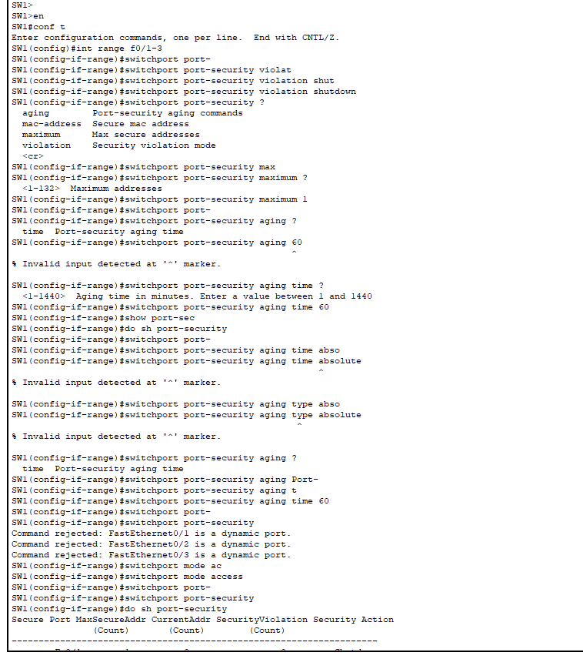

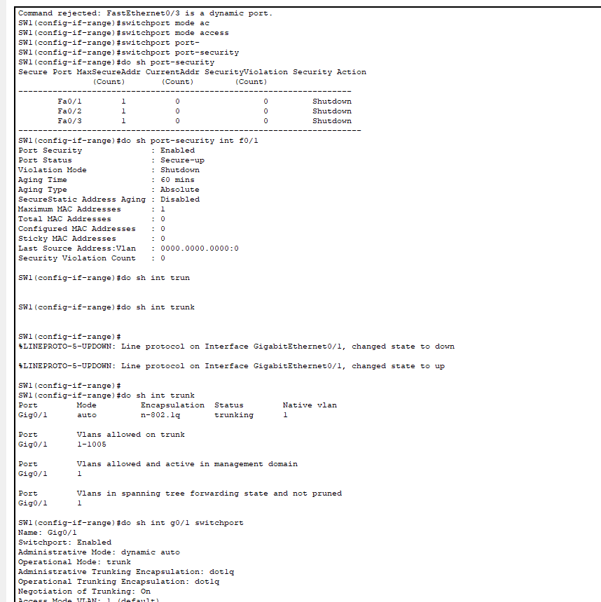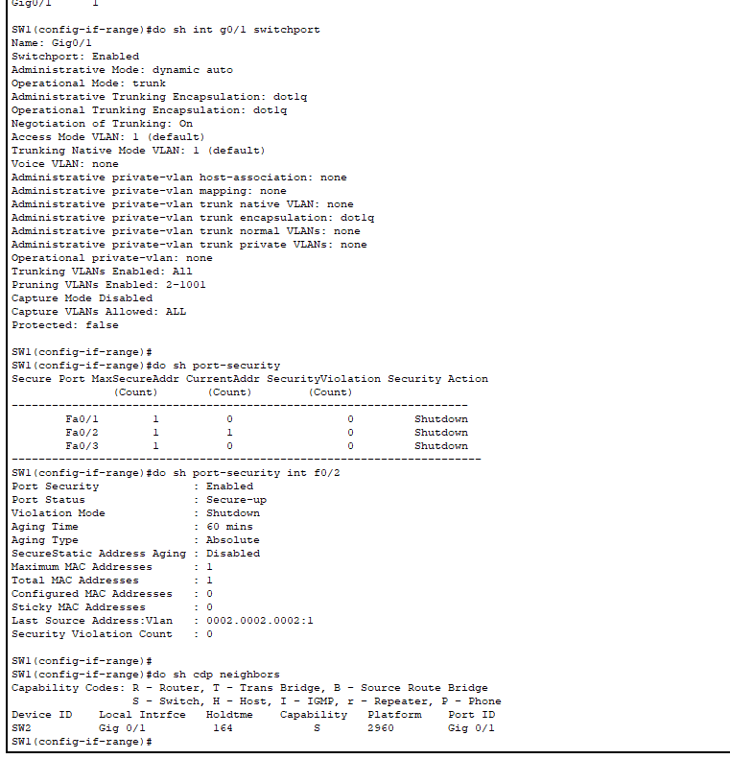

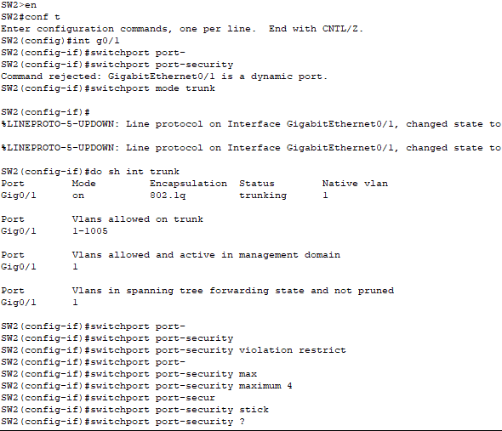

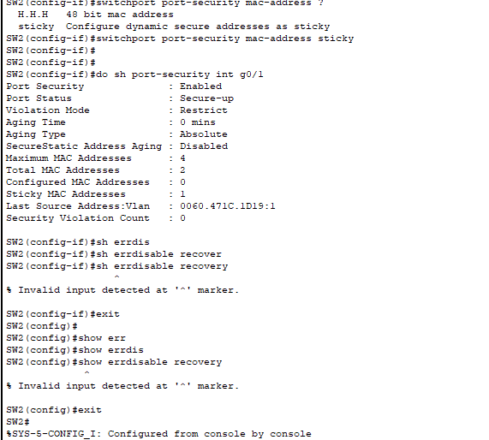

DHCP SNOOPING LAB

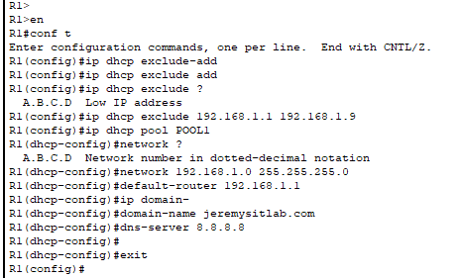

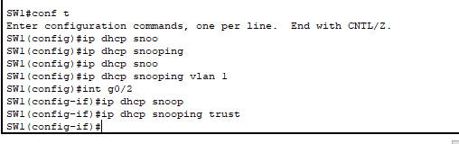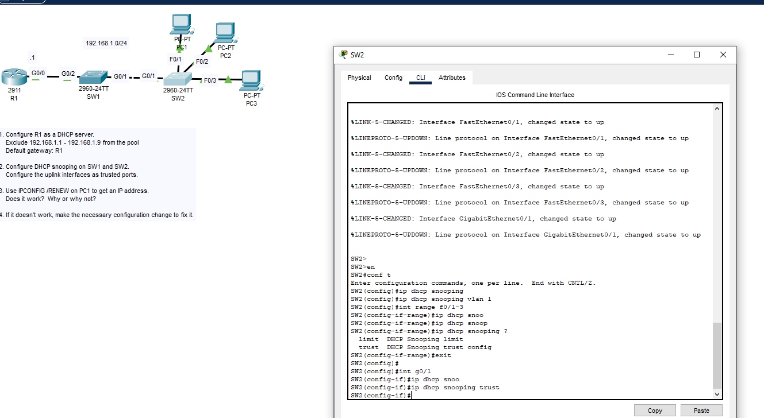

Note that this is a simplification of the process, and there is an optional feature in which the transmitting device sends a ‘request to send’, RTS, packet and waits for a ‘clear

5:57

to send’, CTS, packet from the receiver before actually sending the data packet.

Another issue that we must deal with is that wireless communications are regulated by various

6:20

international and national bodies. You aren’t allowed to transmit data on any channel you want, and which channels you are

6:27

allowed to use can vary depending on the country. Fortunately, the 802.11 standard outlines which frequencies can be used for wireless

6:36

LANs, and devices are designed to use those frequencies.

This PAC is like a shared key and is used in the next phase, to establish a secure TLS

15:18

tunnel between the client and authentication server. So, now there is a secure tunnel established that can be used for secure encrypted communications.